**2022 Kansas Noxious Weeds**

**Category A Weeds**

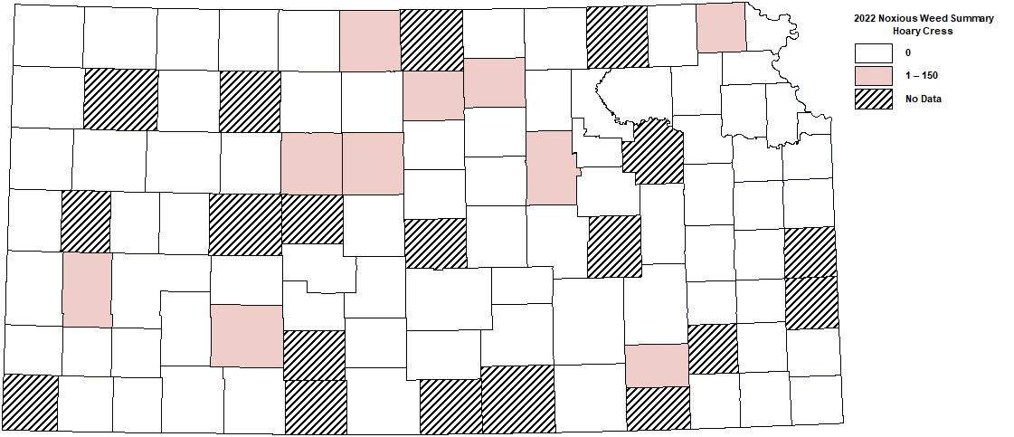

**Hoary Cress**

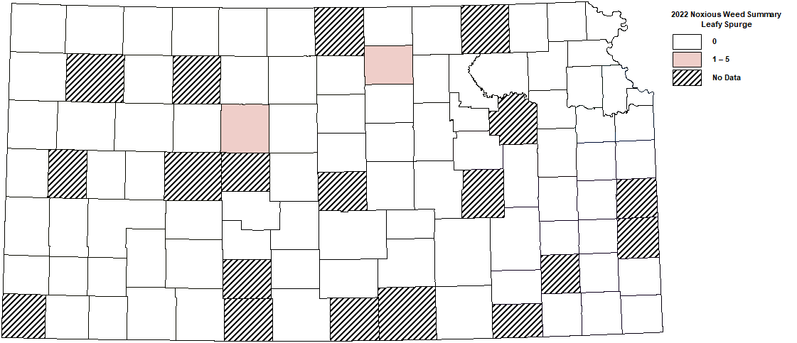

**Leafy Spurge**

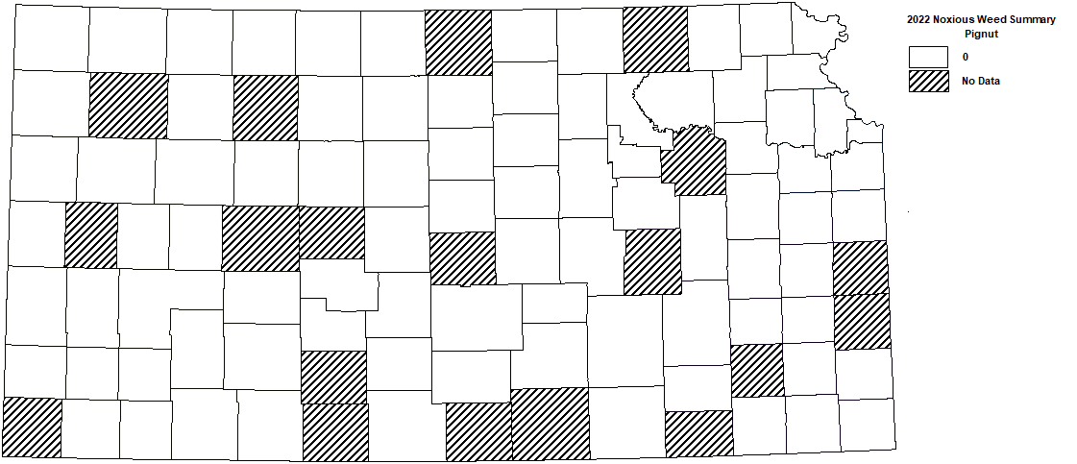

**Pignut**

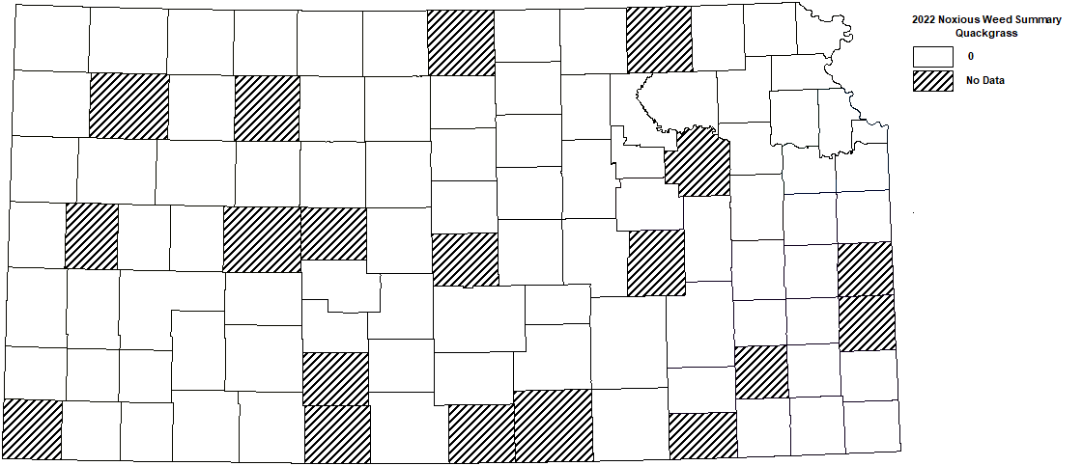

**Quackgrass**

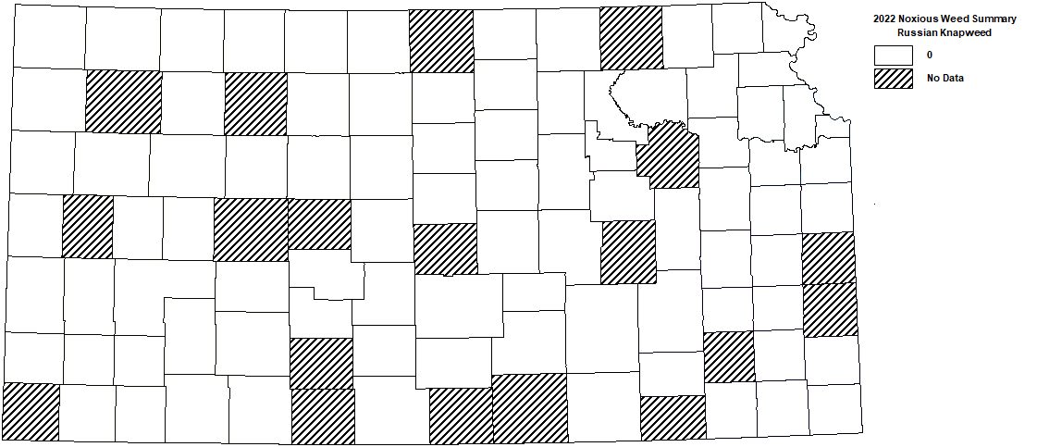

**Russian knapweed**

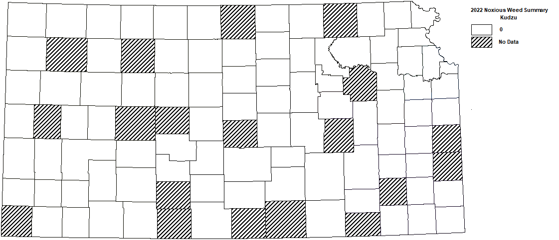

**Kudzu**

**Category B Weed**

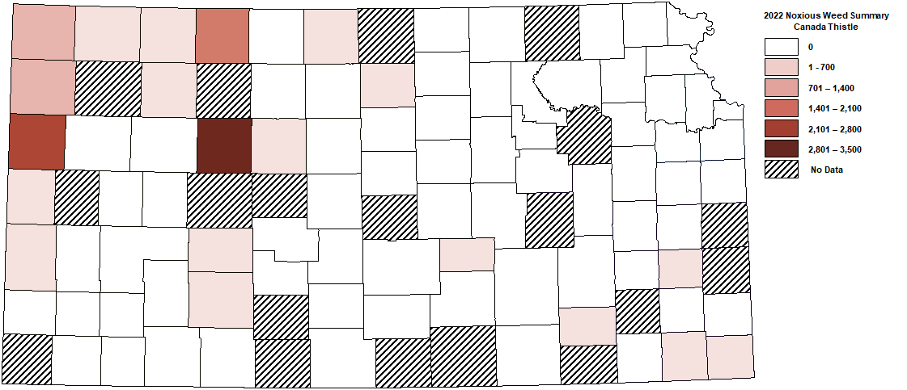

**Canada thistle**

**Category C Weeds**

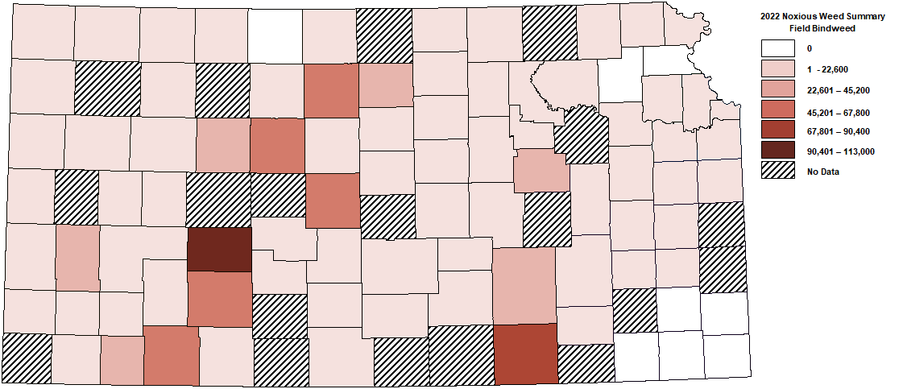

**Field bindweed**

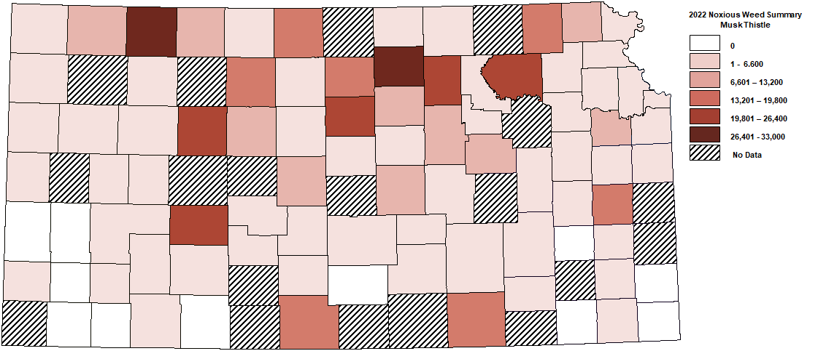

**Musk thistle**

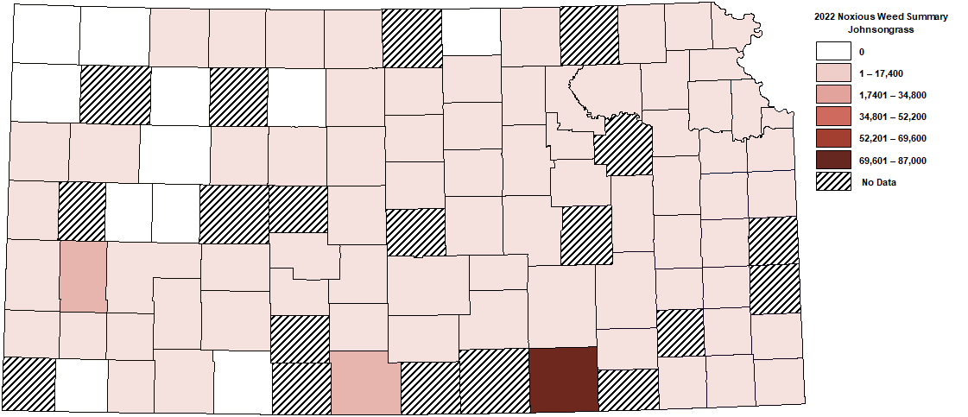

**Johnsongrass**

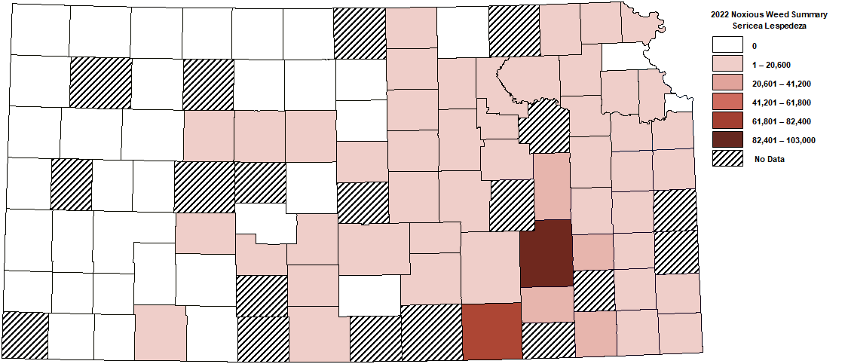

**Sericea lespedeza**

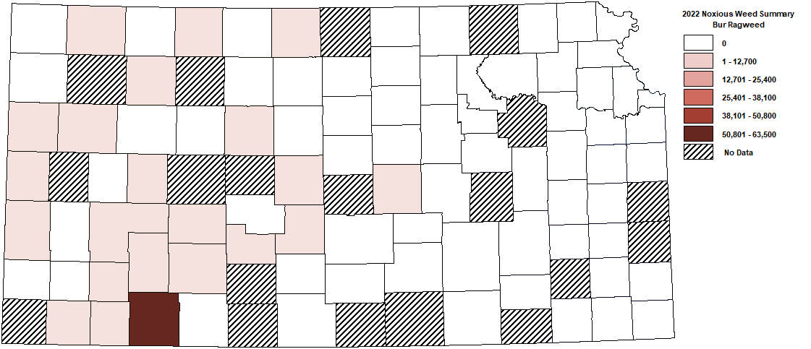

**Bur Ragweed**