**Minutes from CAPS Committee Meeting on May 21, 2013**

The state CAPS Committee met on June 18, 2014 at 9:00 am at the Kansas Department of Agriculture, 1320 Research Park Drive, Manhattan. In attendance were: Craig Webb-USDA-APHIS-PPQ, Barry Cole-USDA-APHIS-PPQ, Judy O’Mara-KSU Plant Pathology, Megan Kennelly-KSU Plant Pathology, Eva Zurek-KSU Entomology, Doug Jardine-KSU, Jessica Howell-KDWPT, Ryan Armbrust-KFS, Chad Bontrager-KDA, Jon Appel-KDA, Jeff Vogel-KDA, Greg Chrislip-KDA and Laurinda Ramonda-KDA.

Introductions were made.

2013 Surveys:

CAPS and line items:

* Karnal bunt – 146 samples in 39 western counties were planned to be collected. 127 samples in 36 western counties were actually collected. Collection of samples occurred from June 24 – July 9. All samples sent to lab in Arizona and all were negative.
* 2012 Continued walnut twig beetle/thousand cankers disease – 2012, 68 sites in 23 counties with 134 traps, August 20 – October 31, 2012. 2013, 49 sites in 13 counties with 82 traps, May 6 – July 12, 2013. This was done in the northeastern part of the state. 6 specimens sent Colorado in 2012. Negative for all specimens.
* Emerald ash borer – Trapping began March 8 – August 30, 2013 in 9 counties. 65 traps were placed – 41 traps remained by the end of the survey - (36.9% of traps were gone). All traps negative.

|  |  |  |  |
| --- | --- | --- | --- |
| **Surveyor/County** | **% traps set in primary pre-assigned locations** | **% traps set in secondary**  **pre-assigned locations** | **% traps set in all**  **pre-assigned locations** |
| **Bob Buhler -** Jewell, Osborne, Russell, Smith | 30% | 50% | 40% |
| **Jeremy Maples -** Neosho | 0% | 66% | 20% |
| **Tom Sanders** - Shawnee | 60% | 0% | 60% |
| **Laurinda Ramonda/ Greg Chrislip** - Pottawatomie | 8% | 0% | 8% |
| **Cherie Copeland -** Butler | 0% | 0% | 0% |
| **Jesse Ostrander -** Leavenworth | 46% | 66% | 62% |
|  |  |  |  |
| **Average % Traps set in Pre-Assigned Locations** | 24% | 30% | 32% |

**\*** The average percentage for traps hung in pre-assigned locations was down by 5% from 2012.

* Oak Pest Commodity – Survey will be in western Kansas and was approved for extension to be done in 2014. Trapping will begin May 2014.
* Purple loosestrife Bio-control – 2nd year. Approved for extension to be done in 2014. Scott has set up release dates.

2013 Farmbill:

* Khapra beetle – Trapping began August 5 – September 26 at 41 sites with 2 traps per site (82). Cities trapped: Junction City, Lawrence, Leavenworth, Kansas City, Manhattan, Salina, Topeka and Wichita. International food stores and warehouses were trapped. Specimens were negative.
* Walnut twig beetle/thousand cankers disease – Trapping began June 3 – August 2 in 35 locations with 35 traps in 12 southeastern counties. All traps negative.
* Grape commodity – Trapping began May 31- December 4 in 53 sites in 23 counties with 6 different traps set for summer fruit tortrix, silver y moth, European grape berry moth, European grape vine moth (required to trap for), Egyptian cottonworm, cotton cutworm. 2 disease also looked for – Pierce’s disease and Australian grape vine yellows. 39 samples were sent to Agdia for Pierce’s disease. All were negative except 1 was a really low positive but it was resampled several times and came up negative. 14 samples were tested for Australian grape vine yellows and all were negative. Because of the government shutdown, 6 samples were sent to USDA and 8 were sent to Agdia for testing. Negative for targets.

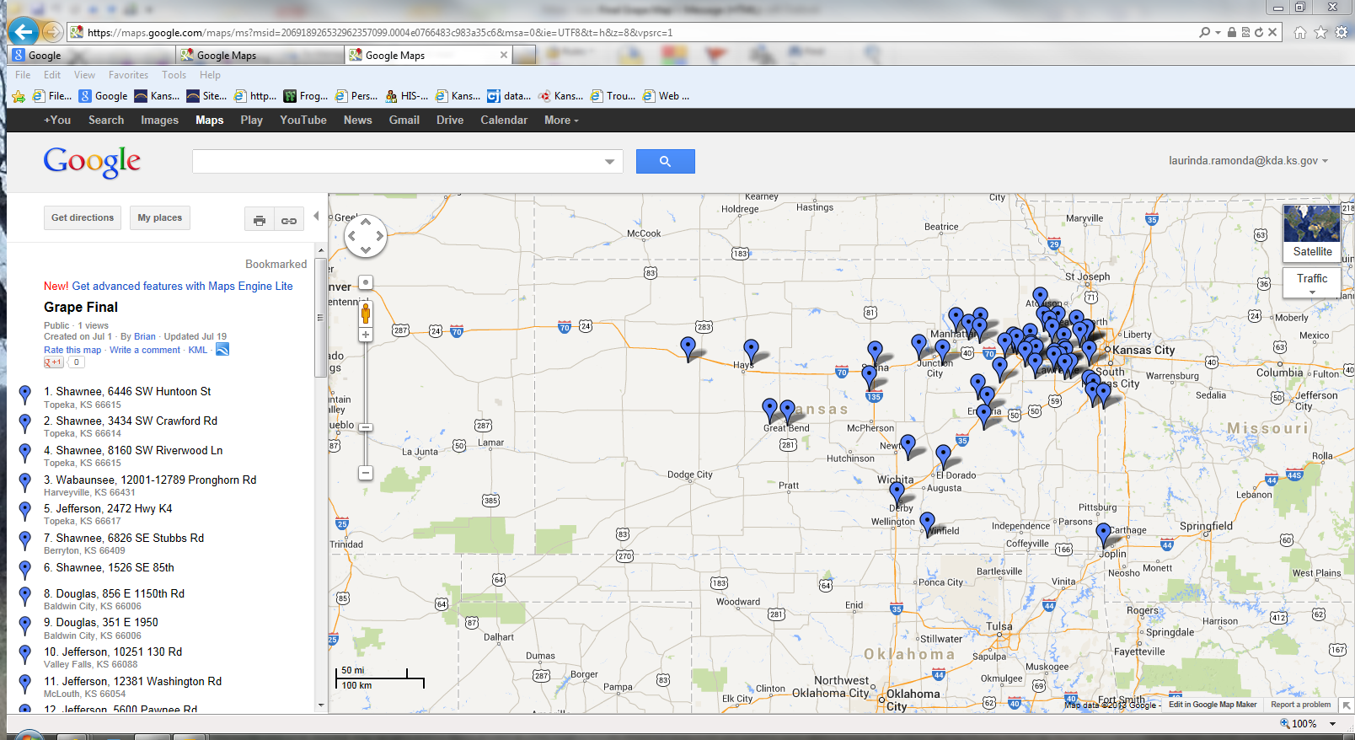

**Grape Trap Locations**

2014 CAPS and line items plan:

* Emerald ash borer – 82 traps in 7 counties for KDA – done by KDA staff - Barton, Bourbon, Douglas, Ellsworth, Leavenworth, Marion, Osage – traps placed in March and April - Total number of traps planned by grid for state is 568 traps – USDA to do 488
* Karnal bunt – 134 samples planned for in central part of the state – survey done by KDA staff

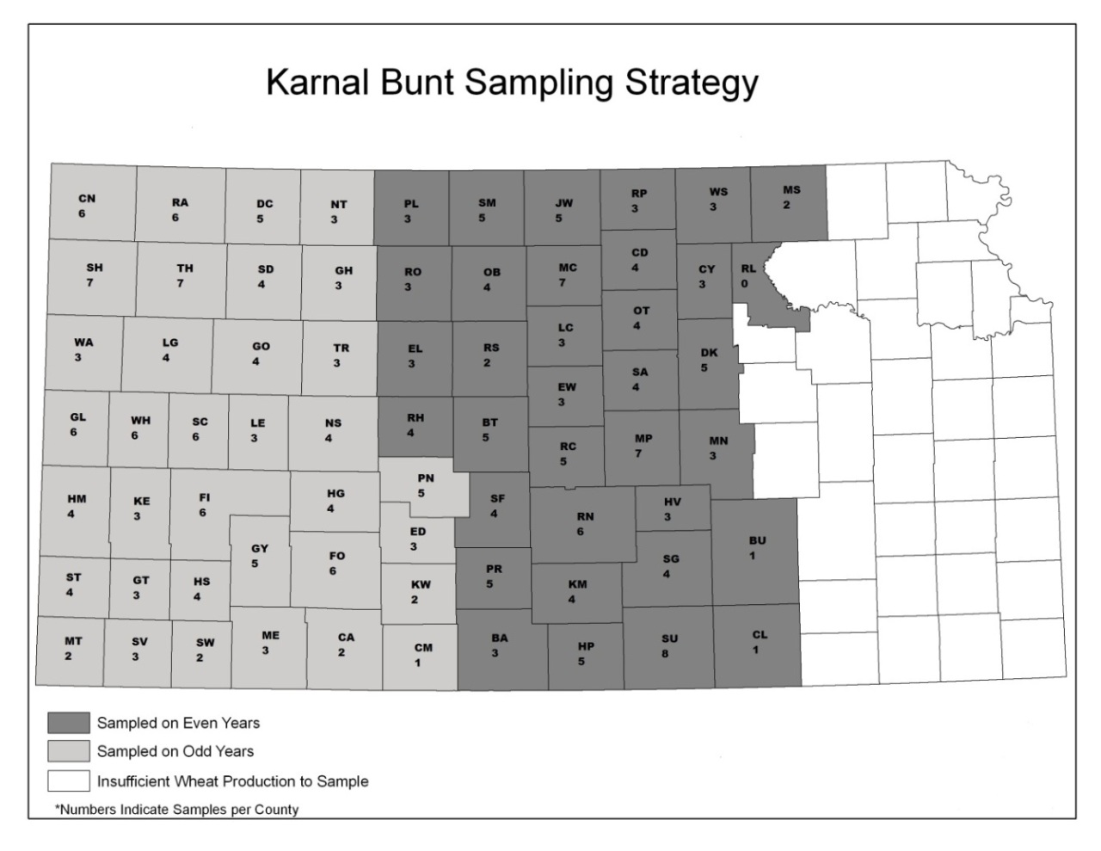

* Soybean Commodity – May-August - Proposed: 79 sites in 38 counties in eastern part of state - 2 seasonal staff

Pests: summer fruit tortrix, silver y moth, golden twin-spot moth, old world bollworm, Egyptian cottonworm

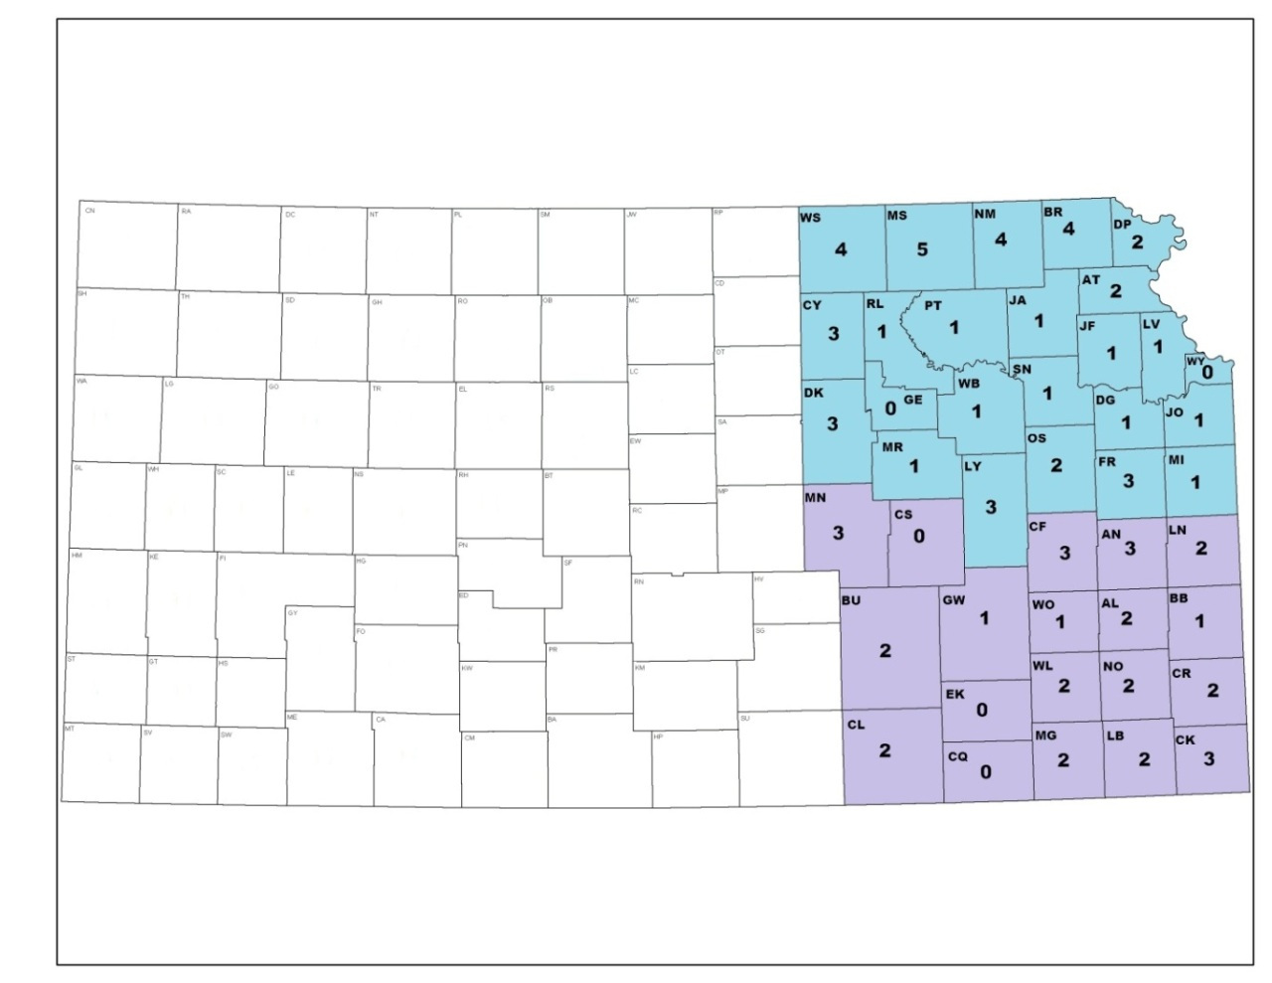

SE KS –  33 Fields

NE KS –  46 Fields

**Soybean – 1 field per 25,000 acres**

2014 Farmbill:

* Grape Commodity – Goal 1 – Enhance Plant Pest/Disease Survey - 2nd year of survey. Pests: summer fruit tortrix (*Adoxophyes orana*), silver Y moth (*Autographa gamma*), European grape berry moth (*Eupoecilia ambiguella*), European grape vine moth (*Lobesia botrana*) and Egyptian cottonworm (*Spodoptera littoralis*), Cotton cutworm (*Spodoptera Litura),* Pierce’s Disease (*Xylella fastidiosa*) and Australian grapevine yellows *(Candidatus Phytoplasma australiense*). July-September ~ 11 weeks

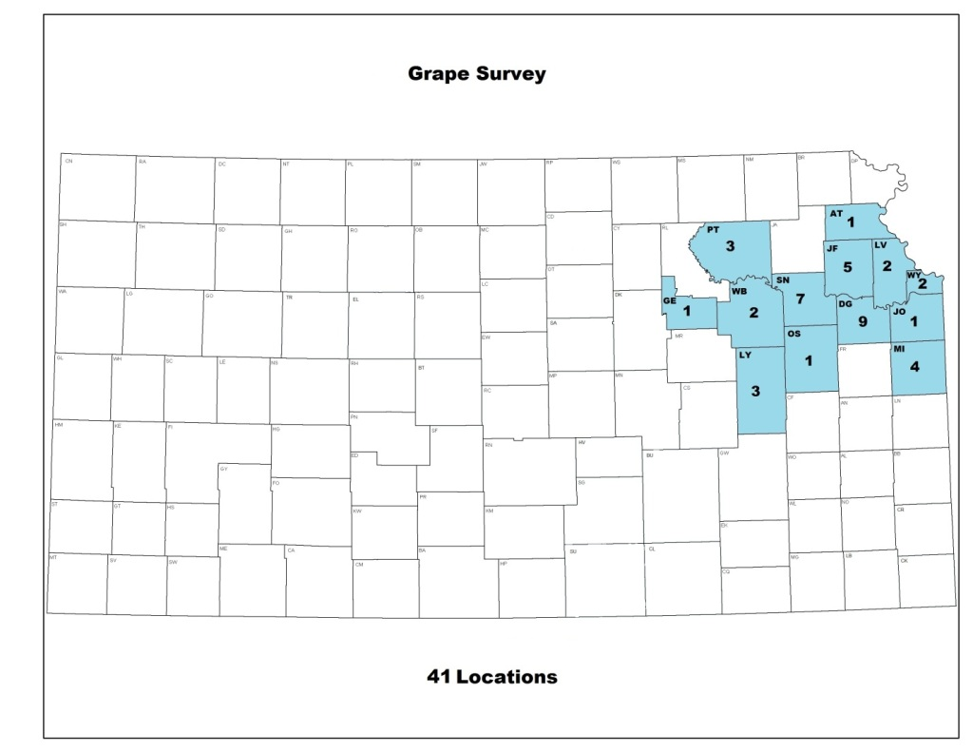

* Agroforestry pest survey - Goal 1 – Enhance Plant Pest/Disease Survey. North central and central part of the state. Conducted by seasonal employee. Trap for oak ambrosia beetle (*Platypus quercivorus*), oak processionary moth (*Thaumetopoea processionea*) and Walnut twig beetle (*Pityophthorus juglandis*). Trapping: July-October at 35 sites in 21 counties. ~ 16 weeks

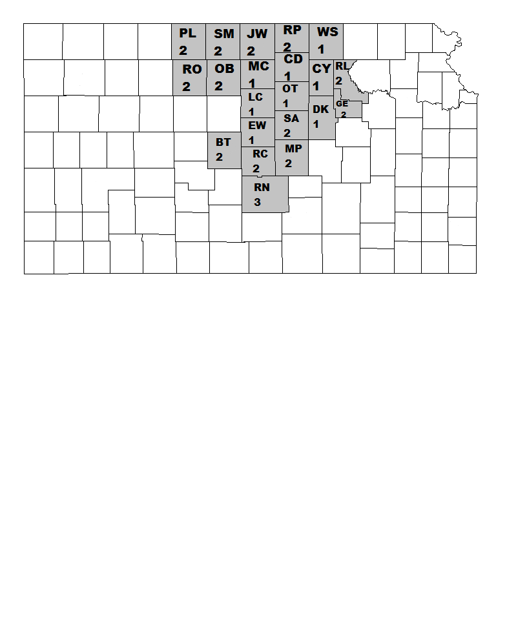

Other:

* Tree Girdling – 10 trees, 3 in Douglas, 2 in Leavenworth, 4 in Johnson and 1 in Wyandotte county. These are being checked and serviced Jeff Vogel. They will be serviced through the summer and then taken down and bark peeled in the fall.

State Specialist Updates:

Jeff Vogel – program manager:

* Bio control release for purple loosestrife:

June 6, 2014 – Released 100 *Hylobius transversovittus* at Troy City Lake in Doniphan County

June 10, 2014 – Released 100 *Hylobius transversovittus* at Reynold’s Ranch in Bourbon County

* Hydrilla eradication is ongoing at Black Bob Lake – KDA reimburses cost for chemical to treat pond - $1200-$1500 for the lake treatment
* Salt Cedar – Diorhabda (biocontrol) is in Clark county and populations are increasing.
* Missouri is releasing biocontrol of 3 species for EAB in the Parkville area.

Greg Chrislip – state entomologist:

* Oak pest survey specimens are being brought in
* 7 presumptive EAB specimens from already quarantined locations have been brought in
* Sharon Dobesh brought in bees from Cherokee county that were sent to Arizona for Africanized bee identification – preliminary test was inconclusive so a morphometric study will be done.

Jon Appel – state plant pathologist:

* Surveys for Karnal Bunt will begin the week of June 23.
* Seeing greenhouse viruses
* 1 positive Pierce’s disease in grape last year but unable to repeat it. Will recheck this year.
* WTB map is available for all surveys over the years.

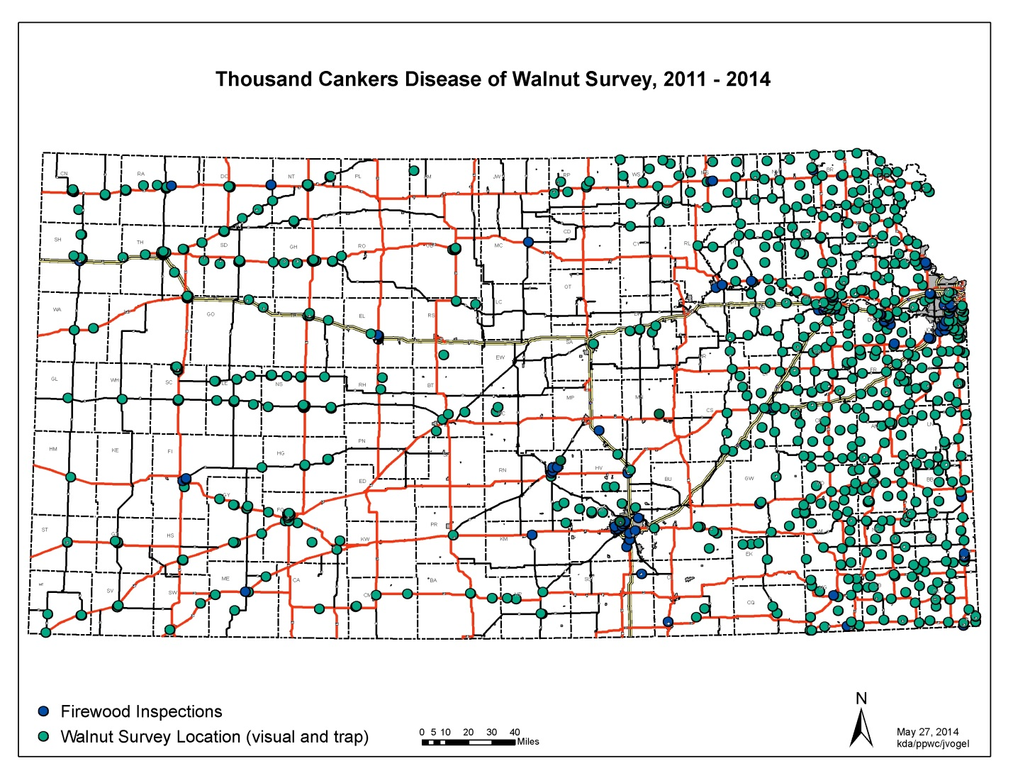

USDA-APHIS-PPQ Updates:

Barry Cole:

* Trapping: EAB – 313 traps in 58 counties, 212 (46%) of the traps were in grid areas (preselected sites), rest of the traps were set in selected sites.
* 660 gypsy moth traps in 48 counties
* Trapping for Japanese beetle are at airports

State Specialists Updates:

Jessica Howell:

- Working with KDA on Tamarisk and Hydrilla

Craig Webb:

- Working on trace forwards for P. ramorum

- Testing for grapevine yellows for the Kansas grape survey

Eva Zurek:

- Rice water weevil - 1st incidence in Kansas – damage was significant in Geary county

Doug Jardine:

- Soybean cyst nematode survey in 2012 - 5 new counties – a minimum of 3000 acres to be sampled, Cherokee and Doniphan county were highly infested.

- Goss’s Wilt of Corn found was found last week. Seems to be increasing.

- Weather could be conducive to soybean sudden death syndrome in August if it is cool and wet.

Megan Kennelly:

- Working with Jon on TCD, pine wilt and TMV (lots of samples being done)

- Tree and shrub publication finished

- Suggested vegetable commodities survey

Judy O’Mara:

- Chemical damage being seen on plants

- Biggest issues are environmental

- Hypoxylin cankers in oak

- Fescue endophyte – samples being sent in are high for this

Ryan Armbrust:

- Herbacide drift issues

- Drought and winter kill issues

- Ash utilization effort underway

- Bush honeysuckle

- Outreach: WTB/TCD – map that KDA did is helping effort, Great Plains Tree Pest Council – WTB/TCD field trip, Wood workers show in KC – Don’t move firewood

Phytoplasma training:

Bob Davis is wanting to come give a one day training on phytoplasma identification, sample collection and field trip this fall. We can invite as many as we like but need to come up with logistics and field trip area. Megan, Judy, Jon, Craig and Laurinda will work on this.

Unmanned aerial vehicles (drones) were brought up to help in survey. How to get funding?

**Thanks to all who attended and the information shared.**