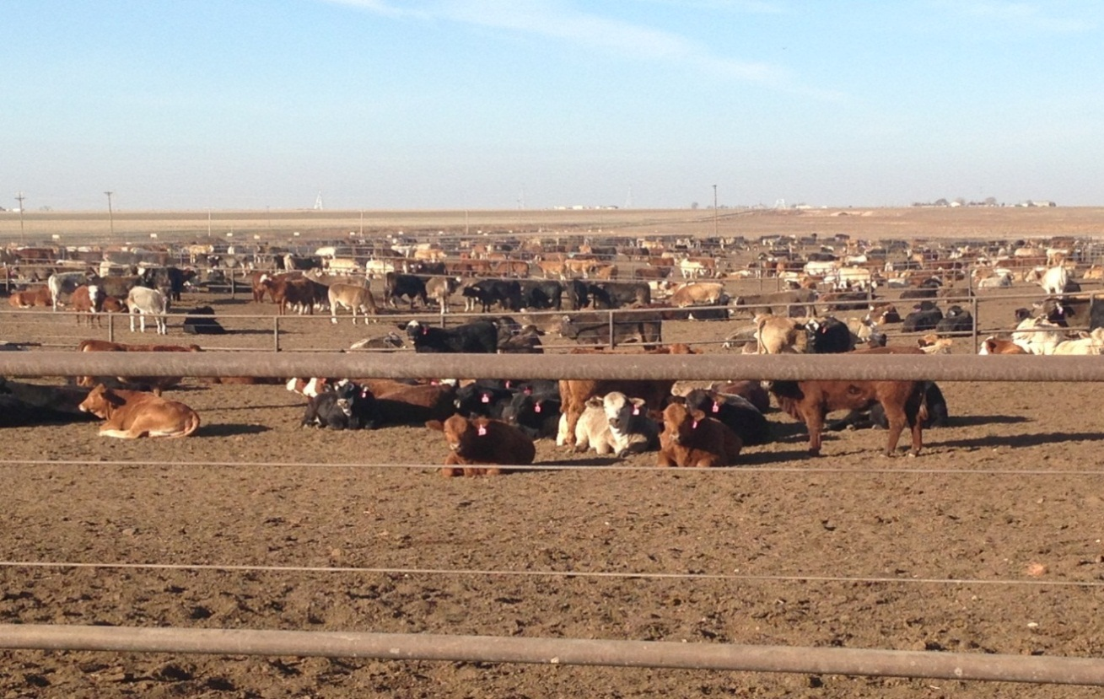

Kansas Cattle Feedyard  
Biosecurity Guide

**Acknowledgements:**

The authors acknowledge and thank the Panhandle Regional Planning Commission (PRPC), and cattle feeding facilities and companies that participated, and the project steering committee members for their assistance with the development of this document. Their operational and technical contributions were invaluable. The authors also acknowledge the U.S. Department of Homeland Security for funding this effort.

**Disclaimer:**

Every effort is made to provide accurate and useful information. However, the PRPC and contractors assume no legal liability for the accuracy, completeness, or usefulness of any information, apparatus, product, or process disclosed herein. Neither the PRPC, nor their employees and contractors, make any warranty (express or implied), including the warranties of merchantability and fitness for a particular purpose with respect to documents or information available in these guidelines. All indirect, consequential, implied, punitive, and special damages are deemed waived if you use the information in these guidelines in any manner. The sole remedy is the price paid or, at the seller’s choice, replacement or repair of the defective information. Trade names are used solely for the purpose of providing specific information. Mention of a trade name does not constitute a guarantee or warranty of the product by the PRPC or an endorsement over other products not mentioned.

This work was performed under the U.S. Department of Homeland Security under Contract 2010-BF-T0-0015.

**Cautionary note:**   
At various points in this guide, the authors have attempted to accurately summarize available requirements or best practices of industry standards, state and federal statutes or regulations. This is not intended as legal advice. Moreover, the guide is not intended to be a comprehensive study of these legal provisions. While these summaries have been compiled with the intent that they be as accurate as possible, PRPC does not warrant accuracy or completeness. For more specific information or for legal guidance, the user of this guide should consult independent counsel.

**Contributing authors:**

|  |  |  |
| --- | --- | --- |
| **Stacey Tyler**  Cubic Applications Inc.  stacey.tyler@cubic.com | **Brooke Pearson**  Cubic Applications Inc.  Brooke.Pearson@cubic.com | **Emilie Hill**  Cubic Applications Inc.  Emilie.hill@cubic.com |

Contents

Executive Summary 1

Acronyms 1

Instructions iii

Guide Objectives v

Guide Organization v

Chapter Sections 1

Plan Elements 1

Chapter 1: Biosecurity Overview 2

Biosecurity Background 2

Goal of Biosecurity 3

Objectives of Biosecurity 3

Training 3

Chapter 2: Biosecurity Assessment 8

Chapter 3: Employee Policies 22

Chapter 4: Crisis and Risk Communication 42

Chapter 5: Coordination with Animal Health Agencies and Local Government 56

Chapter 6: Visitor Control 68

Chapter 7: Foreign Travel 92

Chapter 8: Movement On and Off the Property 104

Chapter 9: Zoonotic Diseases 120

Chapter 10: Record Keeping 130

Chapter 11: Animal Handling and Contact 156

Chapter 12: Disease Detection and Surveillance 170

Chapter 13: Feral Animals and Wildlife Management 188

Chapter 14: Physical Security 198

Chapter 15: Vector Control 216

Chapter 16: Cleaning and Disinfection 230

Glossary 244

References 249

Annex A: Disease Table 256

Annex B: Sample Disease Assessment Reports 265

Annex C: Seven Cardinal Rules of Risk Communication 274

Annex D: Foot and Mouth Disease Fact Sheet 279

**Page Intentionally Left Blank**

# Executive Summary

The cattle feeding industry is a major contributor to the economy of Kansas. On January 1, 2015, approximately 7 percent of all cattle and calves in the United States were located in Kansas. Approximately 17 percent of cattle on feed in the nation were located in Kansas, making Kansas the third ranking cattle feeding state. In 2014, there were approximately 5 million head of cattle slaughtered in Kansas or 19 percent of all cattle slaughtered in the United States, making Kansas the second ranking beef harvest state in the United States. The livestock industry’s $9.1 billion in revenue in 2013 represented 55 percent of total state agricultural revenue.

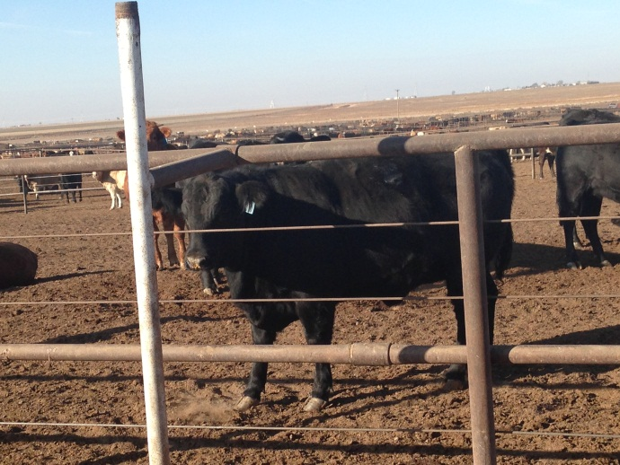Facility biosecurity is an important element of any disease prevention program. Biosecurity means doing everything possible to reduce the likelihood of an infectious disease from being introduced to or carried away from a feedyard by people, animals, equipment, or vehicles.

At the national level, the United States relies on import regulations, point-of-entry surveillance, customs and border inspections, and trade restrictions with Foreign Animal Disease (FAD) affected nations to prevent FADs from entering the country. Locally, facility biosecurity measures prevent the introduction and spread of disease by minimizing movement of harmful organisms onto and off a facility. If an outbreak occurs in North America, individual facilities should be prepared. Pre-disaster mitigation actions will lessen the impact of any FAD and enhance preparedness at facility, regional, and national levels.

This *Cattle Feedyard Biosecurity Guide* contains cattle feedyard biosecurity information, and provides templates to help feedyard facilities prepare and implement biosecurity plans.

**Page Intentionally Left Blank**

# Acronyms

AD Area Director (USDA APHIS VS – replaces old AVIC)

AIDS Acquired Immune Deficiency Syndrome

ATVs All-Terrain Vehicles

BSE Bovine Spongiform Encephalitis

bTB Bovine Tuberculosis

Bt *Bacillus thuringiensis*

CBP U.S. Customs and Border Protection

C&D Cleaning and Disinfection

CDC The Centers for Disease Control and Prevention

CERC Crisis and Emergency Risk Communication Manual

CWD Chronic Wasting Disease

DEET N, N-Diethyl-meta-toluamide

EPA U.S. Environmental Protection Agency

FAD Foreign Animal Disease

FADD Foreign Animal Disease Diagnostician

FAD PReP Foreign Animal Disease Preparedness & Response Plan

FAST First Assessment and Sampling Team

FDA Food and Drug Administration

FMD Foot and Mouth Disease

HIV Human Immunodeficiency Virus

HVAC Heating, Ventilation, Air Conditioning

IPM Integrated Pest Management

IT Information Technology

KCA Kansas Cattlemen’s Association

KDA Kansas Department of Agriculture

KDA-DAH Kansas Department of Agriculture – Division of Animal Health

KDHE Kansas Department of Health and Environment

KDWPT Kansas Department of Wildlife, Parks and Tourism

KLA Kansas Livestock Association

MSDS Material Safety Data Sheets

NAHEMS National Animal Health Emergency Management System

NCBA National Cattleman’s Beef Association

NPDES EPA National Pollutant Discharge Elimination System

OIE World Organization for Animal Health

PPE Personal Protective Equipment

PRPC Panhandle Region Planning Commission

RFID Radio Frequency Identification

RVF Rift Valley Fever

SOPs Standard Operating Procedures

USDA U.S. Department of Agriculture

USDA-APHIS U.S. Department of Agriculture – Animal and Plant Health Inspection

Service

USDA-VS U.S. Department of Agriculture – Veterinary Services

WNV West Nile Virus

# Instructions

The goal of this guide is to assist feedyard owners and managers with developing and implementing cattle feedyard biosecurity plans. Diseased animals reduce profitability. Thus, it is in the producer’s best interest to adopt a biosecurity plan designed to prevent and control diseases whether they are dealing with routine bovine respiratory disease, Foot and Mouth Disease (FMD), or anything in between. Feedyard management is responsible for feedyard health and production and thus is responsible for deciding the final content of this biosecurity plan. The provided plans help reduce or eliminate the introduction and spread of disease on a feedyard.

## Guide Objectives

1. Establish operational standards for biosecurity
2. Create data retention and recordkeeping systems
3. Provide training and education to improve the biosecurity
4. Provide disease-specific information to help prevent or limit disease impact

## Guide Organization

The *Cattle Feedyard Biosecurity Guide* contains sixteen chapters detailing the following operational areas:

1. Biosecurity Overview
2. Biosecurity Assessment
3. Employee Policies
4. Crisis and Risk Communication
5. Coordination with Animal Health Agencies and Local Government
6. Visitor Control
7. Foreign Travel
8. Movement on and off the Property
9. Zoonotic Diseases
10. Record Keeping
11. Animal Handling and Contact
12. Disease Detections and Surveillance
13. Feral Animals and Wildlife Management
14. Physical Security
15. Vector Control
16. Cleaning and Disinfection

## Chapter Sections

The Biosecurity Overview chapter provides background on biosecurity, goals of biosecurity measures, and key objectives of biosecurity.

Remaining chapters help feedyard managers develop a plan that addresses both routine and heightened biosecurity operations. Each chapter begins with a Background section followed by a customizable Plan section. Some chapters also contain a Forms section.

The **Background** section is identifiable by a blue banner in the header. It provides a general topic overview including management best practices to help eliminate, reduce, or identify biosecurity risks. Use this information as employee training material.

The **Plan** section is distinguishable from the background information by a clear banner in the header and the year it was implemented. Feedyard managers can customize a plan by checking the box next to the recommended biosecurity measures they choose to implement. Boxes that are marked become the specific feedyard biosecurity plan. Measures that are not marked will remain in the plan for potential future consideration of good biosecurity practices.

The **Forms** section is formatted without headers or footers so they can be printed and used. The forms are designed to aid management with collecting and/or dissemination of information. These documents can be customized for a specific feedyard. Alternatively, if the feedyard already is using similar forms to collect information, those existing forms can be inserted into the appropriate section of the guide.

## Plan Elements

An effective biosecurity plan includes these elements:

* How to receive and manage new animals
* How to regulate movement on and off feedyard
* How to clean and disinfect equipment to reduce pathogen levels
* How to monitor animal health

A comprehensive biosecurity plan addresses both routine biosecurity and heightened biosecurity.

**Routine** biosecurity measures apply during normal day-to-day operations and lower the risk of a disease being brought onto a facility.

**Heightened** biosecurity measures supplement routine biosecurity measures and apply when confirmed or suspected highly contagious diseases, such as FMD, occur in the region or in the country. Heightened measures provide a greater level of protection for the feedyard.

**Chapter 1: Biosecurity Overview**

Chapter 2: Biosecurity Assessment

Chapter 3: Employee Policies

Chapter 4: Crisis and Risk Communications

Chapter 5: Coordination with Animal Health Agencies and Local Government

Chapter 6: Visitor Control

Chapter 7: Foreign Travel

Chapter 8: Movement On and Off the Property

Chapter 9: Zoonotic Diseases

Chapter 10: Record Keeping

Chapter 11: Animal Handling and Contact

Chapter 12: Disease Detection and Surveillance

Chapter 13: Feral Animal and Wildlife Management

Chapter 14: Physical Security

Chapter 15: Vector Control

Chapter 16: Cleaning and Disinfection

**Page Intentionally Left Blank**

# Chapter 1: Biosecurity Overview

## Biosecurity Background

Biosecurity is a collection of management practices designed to minimize the risk of disease introduction and spread within an operation. Such practices may include, but are not limited to: new arrival management, wildlife and rodent control, equipment cleaning and disinfection, and minimizing visitor interaction with cattle. Because feedyards routinely obtain calves from multiple sources, biosecurity practices are especially important for preventing the introduction and spread of diseases.

*“Kansas is a net importer of cattle, and we are located in middle of the nation’s most densely populated cattle region.  Foot and Mouth Disease will move through the cattle population at a rapid pace, and producers should always be aware of who is coming in contact with their livestock and where those people and animals may have been previously.”*

*- Dr. Bill Brown, Kansas Animal Health Commissioner*

Responsibility for feedyard biosecurity rests with the feedyard owner and/or management team, through the implementation of measures designed to prevent introduction of any disease which is not already present on the yard as well as limiting the spread of existing diseases. Personnel working with livestock must take steps to ensure a reasonable level of biosecurity is practiced to protect themselves, other producers, and the livestock industry. **It is essential that all personnel exercise the utmost thought, patience, persistence, and care in carrying out a biosecurity plan—both under normal circumstances and during an outbreak.**

Due to the high volume of movement of animals throughout North America and the time it takes to diagnose disease, a positive diagnosis of a FAD anywhere in the country should trigger a reevaluation of the biosecurity risk and heighten operative biosecurity measures. More stringent measures may seem costly and inconvenient but implementation of these measures can help protect operations and prevent potentially major financial loses.

If disease enters the feedyard despite precautionary measures, government officials and regulations may require even greater biosecurity measures to prevent disease spread from the feedyard to other facilities with susceptible livestock. These measures and procedures become part of a FAD response plan; a template for this is not contained in this guide, but is included as a part of the state and/or federal government’s response plans.

Every feedyard management team has the ultimate responsibility to protect the health of the animals under its control. Diagnosing certain infectious diseases can be time consuming and difficult; the loss in production, and the expense of eradicating disease can be financially devastating and emotionally exhausting. Biosecurity is only useful if all feedyard personnel strictly adhere to the guidance as written.

A proactive approach to biosecurity that prevents the introduction of disease onto the feedyard, rather than reacting to an outbreak, is the safest and least costly method of protecting cattle and business.

## Goal of Biosecurity

The goal of biosecurity planning is to minimize the risk of a disease from being introduced and spread on a feedyard.

Development of a biosecurity plan is voluntary. However, it demonstrates to customers, packers, consumers, and government regulators that cattle feeders are actively working to assure a safe beef supply. The authors encourage feedyard management to study this guide, to adapt its suggestions, and to employ the practices recommended.

## Objectives of Biosecurity

1. Prevent the introduction of infectious disease agents to cattle
2. Prevent the spread of disease agents from affected areas to unaffected areas
3. Minimize the potential impact of disease on cattle productivity and business operations

## Training

The goal of biosecurity training is to make employees and feedyard management aware of the risks to feedyard operations and the role in preventing and responding to a disease outbreak. Training the material contained within the biosecurity guide is important to both employees and management and will help achieve operational effectiveness, efficiency, and organizational knowledge.

Use the Cattle *Feedyard Biosecurity Guide* to train at least one chapter per month for about an hour of time. Following these guidelines, training will be completed in a little over a year. After training is completed, begin the cycle again. Repeat training as needed, when aspects of the routine or heightened biosecurity plan are changed, and for new personnel. The authors recommend the feedyard manager review a specific chapter of the *Cattle Feedyard Biosecurity Guide* with all personnel including which specific measures the feedyard will implement in routine and heightened situations. It is encouraged that the manager refer to additional references contained on the CD/website to learn about biosecurity practices. This will offer more depth and breadth of biosecurity training for staff.

Training can be implemented using several methods. The authors recommend using paper based handouts, if needed, outdoor (hands-on) training and interactive question asking to ensure employees are engaged in the discussion. Use the following recommended training schedule in Table 1.1 to implement training on site. Record individual training attendance using the Employee Training Log in Chapter 10: Record Keeping.

#### Table 1.1 Training Schedule

| **Biosecurity Chapters** | **Date Completed** | **Signature** |
| --- | --- | --- |
| Chapter 3: Employee Policies |  |  |
| Chapter 4: Crisis and Risk Communications |  |  |
| Chapter 5: Coordination with Animal Health Agencies and Local Government |  |  |
| Chapter 6: Visitor Control |  |  |
| Chapter 7: Foreign Travel |  |  |
| Chapter 8: Movement On and Off the Property |  |  |
| Chapter 9: Zoonotic Diseases |  |  |
| Chapter 10: Record Keeping |  |  |
| Chapter 11: Animal Handling and Contact |  |  |
| Chapter 12: Disease Detection and Surveillance |  |  |
| Chapter 13: Feral Animals and Wildlife Management |  |  |
| Chapter 14: Physical Security |  |  |
| Chapter 15: Vector Control |  |  |
| Chapter16: Cleaning and Disinfection |  |  |

Chapter 1: Biosecurity Overview

**Chapter 2: Biosecurity Assessment**

Chapter 3: Employee Policies

Chapter 4: Crisis and Risk Communications

Chapter 5: Coordination with Animal Health Agencies and Local Government

Chapter 6: Visitor Control

Chapter 7: Foreign Travel

Chapter 8: Movement On and Off the Property

Chapter 9: Zoonotic Diseases

Chapter 10: Record Keeping

Chapter 11: Animal Handling and Contact

Chapter 12: Disease Detection and Surveillance

Chapter 13: Feral Animal and Wildlife Management

Chapter 14: Physical Security

Chapter 15: Vector Control

Chapter 16: Cleaning and Disinfection

**Page Intentionally Left Blank**

# Chapter 2: Optional Biosecurity Assessment

**The purpose of this self-assessment** is to help operations involved in the livestock industry assess operational risk to FAD. It contains a list of biosecurity measures that may affect biosecurity risk during routine and heightened operations. This assessment is optional as it just gives a quick assessment of current vulnerabilities; however, all aspects are important for optimum biosecurity practices.

If you choose not to complete this self-assessment, proceed to Chapter 3: Employee Policies.

**This self-assessment is designed for cattle feedyard operations and their facility managers** to take as the first step toward developing a biosecurity plan. It will give feedyard management a quick overview of biosecurity and facility risk. The results of this self-assessment do not need to be shared or distributed.

For each of the measures, select a response (yes or no) that best describes current operational practices. Select Not Applicable (N/A) if the statement does not apply.

**The next step after completing this self-assessment** is to write a customized biosecurity plan. Chapters 3-16 will provide more details to consider.

Employee Policies

| # | Measures | Yes | No | N/A |
| --- | --- | --- | --- | --- |
| 1 | References are checked for all new employees to 1) ensure appropriate skills, responsibility and aptitude and 2) to exclude applicants with a history of inappropriate workplace behavior |  |  |  |
| 2 | Employees are trained regularly about the importance of biosecurity and the role they play in maintaining the health and safety of the animals |  |  |  |
| 3 | Employees are required to inform management if they own livestock at their homes |  |  |  |
| 4 | Employees, other than veterinarians, are required to report when they visit other animal facilities |  |  |  |

Crisis and Risk Communication

| # | Measures | Yes | No | N/A |
| --- | --- | --- | --- | --- |
| 5 | Facility/operation has identified communication spokesperson and communication resources |  |  |  |
| 6 | Employees have been advised not to speak to the media unless authorized to do so |  |  |  |
| 7 | Facility/operation has prepared crisis communication scripts for a FMD incident |  |  |  |
| 8 | Facility/operation knows the key industry groups, law enforcement, emergency management, and animal health officials |  |  |  |

Coordination with Animal Health Agencies and Local Government

| # | Measures | Yes | No | N/A |
| --- | --- | --- | --- | --- |
| 9 | Facility management knows local emergency management, law enforcement, and animal health officials |  |  |  |
| 10 | Facility management has a facility map and it is posted for use of employees and first responders |  |  |  |
| 11 | Facility management has an emergency contact list with phone numbers that have been updated in the last year |  |  |  |

Visitor Control

| # | Measures | Yes | No | N/A |
| --- | --- | --- | --- | --- |
| 12 | Feedyard visitors enter at the main entrance |  |  |  |
| 13 | The feedyard entrance is clearly marked |  |  |  |
| 14 | All visitors are required to sign in and out when visiting the feedyard |  |  |  |
| 15 | There is a designated parking area for visitors |  |  |  |
| 16 | Visitors are prevented from driving through manure hauling or feed delivery lanes |  |  |  |
| 17 | Visitors are prevented from having contact with livestock, and feed unless necessary (e.g., veterinarians and other animal service providers) |  |  |  |
| 18 | Veterinarians and other animal service providers who have contact with animals organize their work from healthy to sick, and youngest to oldest, in addition to wearing Personal Protective Equipment (PPE) if warranted |  |  |  |

Foreign Travel

| # | Measures | Yes | No | N/A |
| --- | --- | --- | --- | --- |
| 19 | Employees are required to notify management when they travel outside of the United States |  |  |  |
| 20 | There is a written employee policy regarding international travel |  |  |  |
| 21 | There are measures in place to control access to visitors and staff who have recently visited at risk foreign countries |  |  |  |
| 22 | Visitors are asked about recent travel |  |  |  |
| 23 | Employees are aware of what countries’ visitors pose a high risk for bringing FAD into the feedyard |  |  |  |

Movement On and Off the Property

| # | Measures | Yes | No | N/A |
| --- | --- | --- | --- | --- |
| 24 | Staff is aware of the potential for introduction and transmission of disease by vehicles, machinery, and equipment |  |  |  |
| 25 | All vehicles, machinery, and equipment entering the facility are directed to specified locations based on the function of the vehicle |  |  |  |
| 26 | Dedicated equipment is used (e.g., shovels, skid steer, dump buckets) for manure management |  |  |  |
| 27 | Third party contractors coming onto the facility/operation are required to clean and disinfect their equipment prior to working at the facility |  |  |  |
| 28 | There is manure management plan in place to control and prevent overflow |  |  |  |
| 29 | Dedicated equipment is used (e.g., shovels, skid steer, dump buckets) for feed handling and distribution |  |  |  |
| 30 | Deadstock is disposed of and properly documented in accordance with established procedures |  |  |  |
| 31 | There is an established dead animal pickup point away from pen areas and not in yard vehicle traffic patterns so that rendering trucks do not contaminate the operation |  |  |  |
| 32 | A veterinarian, or other trained professional, performs a necropsy on any animals that die from suspicious causes |  |  |  |

Zoonotic Diseases

| # | Measures | Yes | No | N/A |
| --- | --- | --- | --- | --- |
| 33 | Employees are educated about zoonotic disease risks |  |  |  |
| 34 | Zoonotic disease information handouts are provided to employees |  |  |  |
| 35 | Employees are trained to report any suspicious illness or symptoms in themselves or their families to management |  |  |  |
| 36 | Staff are reminded to wash their hands before and after coming into contact with animals |  |  |  |
| 37 | Employees are provided with appropriate PPE and trained how and when to use it |  |  |  |

Record Keeping

| # | Measures | Yes | No | N/A |
| --- | --- | --- | --- | --- |
| 38 | Accurate records are maintained to facilitate tracing to determine the possible source and spread of a disease |  |  |  |
| 39 | An access log is maintained for product storage areas and employees are required to sign in when accessing the storage area |  |  |  |
| 40 | Records are kept of all sales, transfers, and purchases of commodities and equipment at the facility/operation |  |  |  |
| 41 | Inventory records are kept of all supplies brought onto the premises |  |  |  |
| 42 | Records are kept of the visitor sign-in sheets |  |  |  |

Animal Handling and Contact

| # | Measures | Yes | No | N/A |
| --- | --- | --- | --- | --- |
| 43 | Facility cleanliness protocols are followed with special attention to avoiding cross contamination of feeding equipment with manure handling equipment |  |  |  |
| 44 | An animal health management/treatment plan is developed with the aid of a veterinarian, reviewed, routinely updated, and followed |  |  |  |
| 45 | Instruments for procedures such as dehorning, implants, vaccinations, etc. are cleaned and disinfected between use on different animals |  |  |  |
| 46 | New animals arriving at the operation/facility are individually tagged for identification |  |  |  |
| 47 | New animals arriving at the operation/facility are not mixed with existing animals |  |  |  |
| 48 | New animals are acquired directly from preferred domestic suppliers who maintain a quality assurance program that includes a biosecurity component |  |  |  |

Disease Detection and Surveillance

| # | Measures | Yes | No | N/A |
| --- | --- | --- | --- | --- |
| 49 | Stacking of stressful events (e.g., handling animals multiple times on the same day) is minimized |  |  |  |
| 50 | All animals are monitored daily by workers trained to recognize the signs of disease and who know to report any suspicious disease symptoms to management |  |  |  |
| 51 | Animals are screened for disease when they arrive at the facility |  |  |  |
| 52 | There is a clean area for restraint, treatment and isolation of sick animals |  |  |  |
| 53 | Healthiest animals are worked first and sick last in an attempt to decrease cross-contamination |  |  |  |
| 54 | A veterinarian develops treatment protocols and monitors response rates on routine visits to the facility |  |  |  |
| 55 | A veterinarian has trained the crews to monitor treatment response rates and stays aware of treatment success even when not on the facility |  |  |  |

Feral Animals and Wildlife Management

| # | Measures | Yes | No | N/A |
| --- | --- | --- | --- | --- |
| 56 | There are periodic checks for rodent or other wildlife infestation |  |  |  |
| 57 | Supplies are protected from rodent and wildlife infestation/contamination |  |  |  |
| 58 | There is an integrated pest management program in place and best practices are followed |  |  |  |
| 59 | Appropriate insecticides and other products are used as needed |  |  |  |
| 60 | Fencing is built in a way that prohibits feral animals and wildlife from entering the facility |  |  |  |

Physical Security

|  |  |  |  |  |
| --- | --- | --- | --- | --- |
| # | Measures | Yes | No | N/A |
| 61 | There is perimeter fencing separating the facility from public access areas |  |  |  |
| 62 | Security cameras are used to monitor the facility |  |  |  |
| 63 | Entry gates and doors (other than the main entrance) are kept locked so that only authorized personnel have access |  |  |  |
| 64 | Alarms and other security equipment are installed |  |  |  |
| 65 | Hazardous materials, chemicals, pharmaceuticals, and/or additives are secured in a storage area for authorized access only |  |  |  |
| 66 | There is a watchperson on site after hours |  |  |  |

Vector Control

| # | Measures | Yes | No | N/A |
| --- | --- | --- | --- | --- |
| 67 | Sources of standing water are eliminated or treated with larvicide to prevent mosquitoes |  |  |  |
| 68 | An Integrated Pest Management Plan is followed under the direction of a licensed pest control specialist |  |  |  |
| 69 | Vegetation and grass on the facility is kept short. |  |  |  |
| 70 | Pets and other domestic animals at the facility/operation are treated with anti-tick products |  |  |  |
| 71 | Baits and fly traps are used |  |  |  |

Cleaning and Disinfection (C&D)

| # | Measures | Yes | No | N/A |
| --- | --- | --- | --- | --- |
| 72 | All vehicles are cleaned before entering an operation/facility |  |  |  |
| 73 | Employees are trained to read and follow the labels on all disinfectants |  |  |  |
| 74 | There is a dedicated area for cleaning and disinfection with a runoff collection plan |  |  |  |
| 75 | Employees are trained on how to C&D vehicles, equipment and facilities |  |  |  |
| 76 | Equipment is C&D after it is used on animals, deadstock or for manure management |  |  |  |

Heightened Biosecurity Operations

| # | Measures | Yes | No | N/A |
| --- | --- | --- | --- | --- |
| 77 | Employees are provided with information on high threat diseases (including signs and symptoms) for increased monitoring and surveillance |  |  |  |
| 78 | There is a mechanism for information sharing and updates for heightened biosecurity threats |  |  |  |
| 79 | There are procedures in place to alert other facilities/individuals that they may have come into contact with (or could be the source of) disease |  |  |  |
| 80 | There is a plan to ensure all vehicles coming from off-site are appropriately cleaned (free of organic debris) and disinfected prior to entering and leaving the premises |  |  |  |
| 81 | There are pre-established work zones/routes to be utilized during heightened biosecurity situations to prevent contamination from outside the facility |  |  |  |
| 82 | There is an area set up for visitors to clean and sanitize their boots with disinfectant prior to entry onto the facility |  |  |  |
| 83 | During a heightened security situation there is a plan in place so that visitor and employee vehicles are not parked on the premises |  |  |  |
| 84 | During a heightened security situation, there is a plan in place so that visitors and personnel must walk onto premises |  |  |  |
| 85 | Visitors are provided with disposable plastic boots (or clean rubber boots which remain at the feedyard) and coveralls as an added precaution if they come into contact with animals, feed, soil or manure in a heightened biosecurity situation |  |  |  |
| 86 | During a heightened biosecurity situation, access gates are kept closed to monitor the entrance of all vehicles and ensure they only go only to designated areas |  |  |  |
| 87 | During a heightened biosecurity situation, there is a plan in place to work with law enforcement, local, state and federal animal health officials and emergency management officials |  |  |  |
| 88 | There is a communication plan in place for when the media may be interested in the operation due to a FAD outbreak |  |  |  |
| 89 | Employees have been advised NOT to speak with the press or officials unless specifically authorized to do so during an FAD incident |  |  |  |
| 90 | If a disease is suspected that poses a biosecurity threat, the facility/operation knows who to contact |  |  |  |
| 91 | There are high pressure washers that could be used on feed bunks, storage areas, silos, mixing and delivery equipment and feeding areas along with proper disinfectants |  |  |  |
| 92 | A suitable location is identified to run decontamination activities on the facility |  |  |  |
| 93 | There are plans to ensure that all vehicles coming from off-site that drive through animal production areas are appropriately cleaned (free of organic debris) and disinfected prior to coming on to and leaving the premises |  |  |  |
| 94 | Employees are trained in cleaning and disinfecting procedures |  |  |  |
| 95 | Employees are trained to use PPE such as eye protection or respiratory protection in case they are determined to be needed |  |  |  |

**Page Intentionally Left Blank**

Chapter 1: Biosecurity Overview

Chapter 2: Biosecurity Assessment

**Chapter 3: Employee Policies**

Chapter 4: Crisis and Risk Communications

Chapter 5: Coordination with Animal Health Agencies and Local Government

Chapter 6: Visitor Control

Chapter 7: Foreign Travel

Chapter 8: Movement On and Off the Property

Chapter 9: Zoonotic Diseases

Chapter 10: Record Keeping

Chapter 11: Animal Handling and Contact

Chapter 12: Disease Detection and Surveillance

Chapter 13: Feral Animal and Wildlife Management

Chapter 14: Physical Security

Chapter 15: Vector Control

Chapter 16: Cleaning and Disinfection

**Page Intentionally Left Blank**

# Chapter 3: Employee Policies

**Routine Biosecurity Considerations for Employee Policies**

Special consideration must be given to protect, educate, and inform one of the feedyard’s most important assets, its people. Employee policies are important in all stages of the employee lifecycle including hiring, training and awareness, and separation.

**Hiring** the best individuals for feedyard operations requires sufficient commitment from management to attract and select the most qualified employees for the feedyard. Rigorous employee screening contributes to overall feedyard safety. A potential threat to the livestock enterprise is directly employing an individual with the intent to do harm.Feedyards can employ a service to screen applicants or independently obtain records for applicants through social networking sites, department of motor vehicles, past employers, and educational institutions. Use records to search for connections to or affiliation with animal rights or terrorist groups. Proper selection can prevent costly issues and protect existing staff and company assets. After candidates are hired, develop and retain staff to reduce potential employee replacement costs. For more information on references and background checks, consult the Kansas Department of Labor <http://www.dol.ks.gov/Laws/>

**Training and awareness** programs, focused on teaching staff to identify serious disease early and how to minimize the risk of disease spread, are an important part of a biosecurity program. Training programs can include topics such as what to look for in sick animals, what and who to report concerns such as tampering or unauthorized personnel, and when to contact a veterinarian. Education programs reduce uncertainty and enhance employee confidence in decision-making. Protection of the feedyard and livestock requires employees to be vigilant in observing the workplace and surrounding environment.

If feedyard employees’ primary language is not English, consider translating materials to ensure the messages are clearly communicated and understood by all employees.

**Employee owned livestock** can be a source of disease brought onto a feedyard. Some employees raise livestock at home. Educate employees on the potential risks associated with tracking disease both to and from work. Consider creating an employee policy that requires employees to notify feedyard management about the types of animals raised at home.

**Employee foreign travel** may affect the biosecurity of the feedyard. Visitors to foreign countries can transport FAD back to the United States on their shoes and clothing. These diseases may cause major health and economic problems to feedyards. See Chapter 7: Foreign Travel for information to give to employees when traveling abroad.

**Employee separation** involves resignation or involuntary termination of employment. Regardless of the reason, take precautions to protect feedyard infrastructure and operations from disgruntled employees. Disgruntled employees could be motivated to cause damage to the feedyard or introduce disease(s) to cattle. Consider implementing some basic precautions contained in the plan to maximize safety, protect assets, and prevent harm to the company. Handle employment terminations professionally and cautiously.

**Routine Biosecurity Plan for Employee Policies**

|  |  |
| --- | --- |
| **Hiring Process:** | |
|  | Conduct applicant screening:  Interview applicants  Perform personal and professional reference checks  Consider doing a background check using one of the options described below |

|  |  |
| --- | --- |
| **Background Check Options:** | |
|  | Option 1: Hire a service to perform the background check |
|  | Option 2: Perform a background check in house  Call past employers to verify the employment status of the prospective employee  Have applicant fill out the Applicant Background Check Permission Form if conducting a in house background check  Review applicant’s social network (e.g., Facebook and Twitter) activity  Obtain a driving record from the Kansas Department of Revenue (requires a signed consent form TR-301 <http://www.ksrevenue.org/recrequest.html> )  Call educational institutions to verify the prospective employee’s certificates, degrees, experience, and any other education-related information disclosed on the resume |

| **Biosecurity Training and Awareness:** | |
| --- | --- |
|  | Educate employees and customers to be alert for signs of possible tampering with livestock, supplies, equipment, and facilities |
|  | Encourage employees to report suspicious activity or unauthorized personnel on or near the facility |
|  | Emphasize early identification of serious diseases can help minimize the risk of disease spread on feedyard |
|  | Provide reporting instructions if disease or illness is suspected/detected |
|  | Ensure employees know and understand the warning signs of FAD including the identification of FMD lesions |
|  | Ensure training includes a description of how diseases may be introduced and transmitted by:  Livestock and feedstuffs  Visitors and employees  Vehicles, machinery and equipment  Manure and effluent  Feral animals and wildlife |
|  | Direct employees to be vigilant for signs of cattle disease (coughing, weight loss, excretions from the nostrils and eyes, excessive saliva, difficulty breathing, etc.) |
|  | Alert all employees and their family members to watch for sick animals, including wildlife, both at home and in surrounding areas |
|  | Require employees who have contact with livestock at other locations (including home) to use the same biosecurity measures as visitors on the feedyard |
|  | Require employees who have livestock at home to report any animals with illness to feedyard management |
|  | Train employees on what to expect during a heightened biosecurity situation  Individual roles and responsibilities  Notification, warning, and communications procedures  Emergency response procedures  Location and use of cleaning and disinfection equipment |
|  | Have new employees complete the Employee Biosecurity Risk Factors Form as part of new hire training |
|  | Have current employees update the Employee Biosecurity Risk Factors Form on an annual basis |
|  | Record personnel data on the Employee Biosecurity Information Form |
|  | Train employees to report foreign travel  Refer to Chapter 7: Foreign Travel |
|  | Regularly train employees on chapters in the *Cattle Feedyard Biosecurity Plan* |
|  | Track employee training using the Routine Employee Training Log in Chapter 10: Record Keeping |
|  | Ensure translated training materials are available for non-English speaking employees |

| **Employee Separation:** | |
| --- | --- |
|  | Return company property including company books and materials, keys, ID badges, computers, cell phones and any other company-owned items  See Chapter 10: Record Keeping |
|  | Disable computer access, and employee building and property access |
|  | Notify staff of any adverse terminations (e.g., suspected disgruntled former employees) in order to protect feedyard |
|  | Remind departing employee of responsibility to not share company confidential information or trade secrets |

**Heightened Biosecurity Considerations for Employee Policies**

For employee safety, security, and continuity of operations, management should know what to expect of employees during a potential or confirmed incident and how to manage operations. A real or perceived danger or threat to health can lead to employee hesitancy to report to work. Prepare for these situations in advance through regular employee training and communications.

**Determine staffing needs** to maintain optimum functionality of operations during a crisis. Designate employees in advance as either:

* Essential Personnel - Employees required for critical functions
* Non-Essential Personnel—Employees not required to report to work during an heightened event (i.e., not involved in the direct care of animals during an event)

**Implement employee recall and call-back procedures** during a heightened biosecurity situation. Procedures help managers clearly communicate expectations and, most importantly, continue operations. Consider setting up a team conference call, calling staff individually, or using a service to systemically communicate to employees. It is important to maintain two-way communications. Use the Employee Biosecurity Communication Form to develop communication points.

**Emergency responsibilities** include actions feedyard employees may need to take to protect the region as a whole.During a period of heightened biosecurity, management may need to work with neighboring feedyards. This may include:

* Assisting with communication and information flow to neighboring producers
* Serving as local Subject Matter Experts and assist in identification of needs
* Providing labor, feed and/or equipment resource to help meet the immediate needs of an emergency response

Maintain heightened employee policies throughout the duration of the animal health emergency until animal health officials have eradicated or otherwise controlled the disease.

**Heightened Biosecurity Plan for Employee Policies**

*Please review any recommended measures not implemented routinely and consider implementing them during heightened biosecurity operations*

| **Communication Measures:** | |
| --- | --- |
|  | Employ one or more of the following communication methods:  Activate an Automated Emergency Alert and Notification System, to automate rapid delivery of phone and text messages  Set up a conference call with all hands at a scheduled time  Call each employee individually with updates |
|  | Determine if employees are essential or non-essential to feedyard operations in the event of a FAD |
|  | Complete the Employee Biosecurity Communication Form to communicate essential situation updates and employee expectations |
|  | Collect updated employee contact information to communicate essential information |
|  | Offer time for questions and answers, ask employees if they have any questions relating to the heightened event or employee expectations |

| **Biosecurity Risk Factors Considerations:** | |
| --- | --- |
|  | Have employees complete the Employee Biosecurity Risk Factors Form |

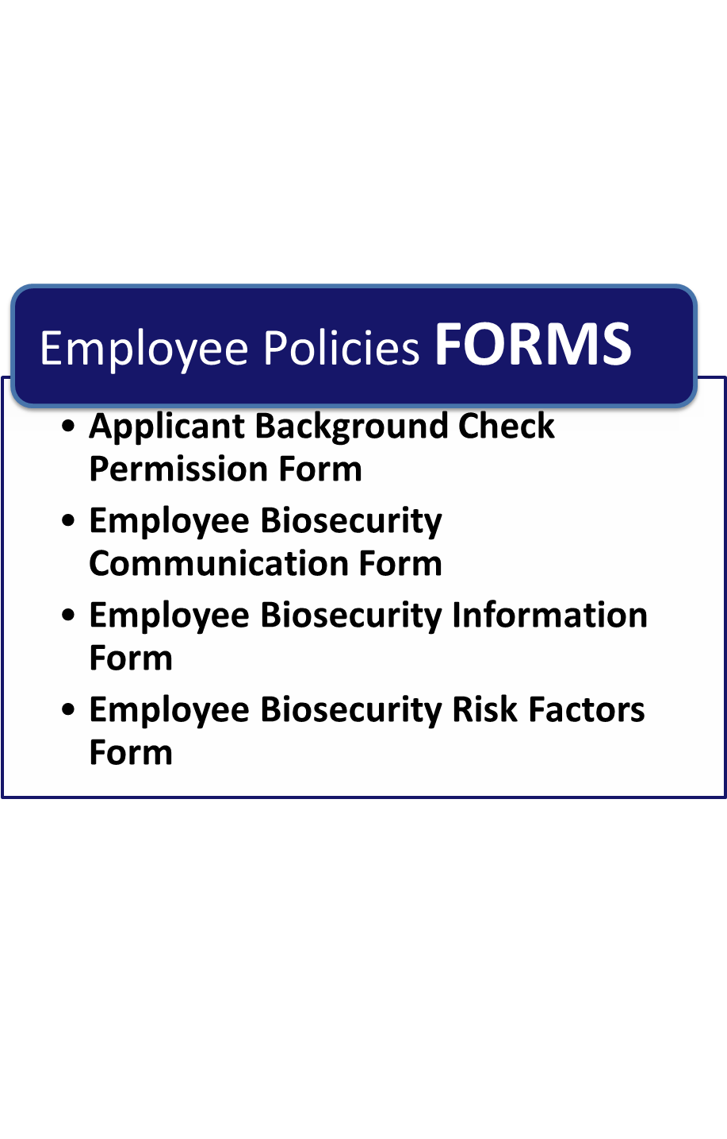

**Page Intentionally Left Blank**

##### Applicant Background Check Permission Form

(Please read and sign this form in the space provided below. Your written authorization is necessary for completion of the application process.)

I, ______________________hereby authorize_______________________ to investigate my background and qualifications for purposes of evaluating whether I am qualified for the position for which I am applying. I understand that _______________________ will utilize an outside firm or firms to assist it in checking such information, and I specifically authorize such an investigation by information services and outside entities of the company's choice. I also understand that I may withhold my permission and that in such a case, no investigation will be done, and my application for employment will not be processed further.

|  |  |  |
| --- | --- | --- |
|  |  |  |
| Signature of Employee |  | Date |
|  |  | |
| Employee Name Printed |  | |

**Page Intentionally Left Blank**

##### Employee Biosecurity Communication Form

Communicate information with employees during a heightened event by completing and distributing the form below:

| **Employee Biosecurity Communication for _________________________** |
| --- |
| **Situation Update** |
| *Provide latest update on the situation* |
| **Work Roster** |
| *Communicate who is required to report to work (i.e., essential and non-essential personnel)* |
| **Work Assignment Information** |
| *Tell employees the following: when and where to report to work, expected duration of shift, and roles and responsibilities during heightened event* |
| **Updates to Facility Operational Plan** |
| *Provide information on changes to the facility operations.* |
| **Next Situation Update** |
| *Inform employees of next planned update meeting* |

##### Employee Biosecurity Information Form

|  |  |  |  |  |  |
| --- | --- | --- | --- | --- | --- |
| **Employee Information** | | | | | |
|  | | |  | | |
| Department Assigned | | | Date | | |
|  |  | | | |  |
| Last Name | First Name | | | | MI |
|  |  | |  |  | |
| Home Address | City | | State | Zip | |
|  |  |  | | |  |
| Home Phone |  | Cell Phone | | | |
|  |  |  | | |  |
| Email: |  | Best way to reach you | | | |
|  |  |  | | | |
| Personal Vehicle Make |  | Personal Vehicle Model | | | |
|  |  |  | | | |
| Personal Vehicle Year |  | Personal Vehicle Plate | | | |

| **Emergency Contact Information** | | | | |
| --- | --- | --- | --- | --- |
|  | | |  | |
| Primary Contact Name | | | Relationship | |
|  | |  |  |  |
| Home Phone | | Cell Phone | | |
|  | |  |  |  |
| Alternate Contact Name | |  | Relationship | |
|  | |  |  |  |
| Home Phone |  | Cell Phone | | |

##### Employee Biosecurity Risk Factors Form

To be updated annually. For use in a heightened biosecurity event.

1. Do you have regular contact with other livestock premises, feedyards, dairies, swine operations, sheep and/or goat operations, livestock markets, processing plants, or livestock slaughtering facilities?

Yes No If yes, what premises? ______________________________

If yes, do you clean and disinfect your vehicle? Yes No

If yes, do you change outer clothes? Yes No

If yes, do you disinfect footwear or change into footwear assigned to the premises upon return? Yes No

1. Do you have livestock at your home?

Yes No If yes, what kind?

**Please report all illness in animals to management.**

1. Do you live with someone who works at another livestock premise, feedyard, dairy, swine/sheep/goat operation, livestock market. processing plant, slaughter facility, or rendering plant?

Yes No

If yes, what premises? ______________________________

If yes, who? ______________________________________

1. Do you work at any other livestock premises?

Yes No

If yes, where? __________________________________________

What is your job description? ______________________________

1. Have you recently been outside the United States?

Yes No

If yes, where? ____________________________________and also complete Notification of Foreign Travel form in Chapter 7: Foreign Travel.

.

**Page Intentionally Left Blank**

Chapter 1: Biosecurity Overview

Chapter 2: Biosecurity Assessment

Chapter 3: Employee Policies

**Chapter 4: Crisis and Risk Communications**

Chapter 5: Coordination with Animal Health Agencies and Local Government

Chapter 6: Visitor Control

Chapter 7: Foreign Travel

Chapter 8: Movement On and Off the Property

Chapter 9: Zoonotic Diseases

Chapter 10: Record Keeping

Chapter 11: Animal Handling and Contact

Chapter 12: Disease Detection and Surveillance

Chapter 13: Feral Animal and Wildlife Management

Chapter 14: Physical Security

Chapter 15: Vector Control

Chapter 16: Cleaning and Disinfection

**Page Intentionally Left Blank**

# Chapter 4: Crisis and Risk Communication

**Routine Biosecurity Considerations for Crisis and Risk Communication**

Risk communication is vital to any crisis response. Ideally, a risk communication plan involves all relevant stakeholders, develops key messages, and monitors the effectiveness of communication. Stakeholder interests’ and responsibilities may be significantly affected by regulatory risk management decisions throughout all phases of the response.

**Feedyard stakeholders** include employees, cattle owners, packers, and commodity and livestock haulers among others. All disasters and emergencies require immediate response; as a result, different agencies and groups may become involved. Anticipate the involvement of law enforcement, emergency management officials and state and federal officials, and industry group such as the Kansas Livestock Association and the National Cattleman’s Beef Association (NCBA), by incorporating communication and coordination with outside agencies in any risk communication plan. See Chapter 5: Animal Health Agency and Local Government Coordination.

In 2012, the Centers for Disease Control and Prevention (CDC) published the *Crisis and Emergency Risk Communication Manual (CERC)*, which describes five distinct phases that occur in Crisis and Emergency Risk Communications. The routine biosecurity section addresses the first phase, or the pre-crisis phase. The heightened biosecurity section discusses the remaining four phases: initial, maintenance, resolution, and evaluation. The phases are illustrated in Figure 4.1.

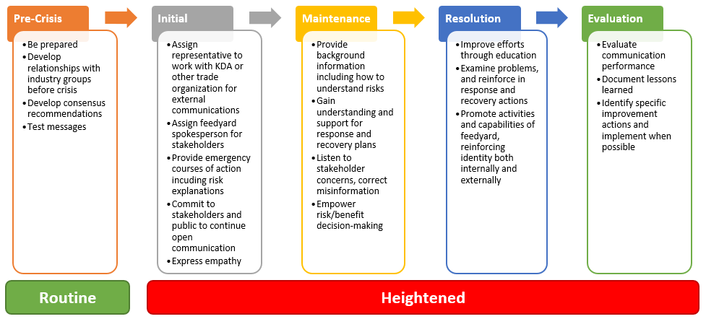

#### Figure 4.1 – Crisis and Emergency Risk Communication Lifecycle

**Pre-crisis** phase recommendations include: 1) fostering alliances with stakeholders and 2) developing, training, and testing communication messages. Develop initial communication strategies and messages in advance. [The Center for Food Security and Public Health](http://www.cfsph.iastate.edu/Infection_Control/index.php) is great source of readily available biosecurity communication materials:

Pre-crisis activities include:

* **Designating a person or team** responsible for risk and crisis communication. The designated employee or team must be able to respond to the needs of, and communicate with, very different audiences. These include various branches of government, the public, media, industry, and employees. The goal of crisis communications is to promote and encourage openness, transparency, flexibility, and consistency in communication messages and activities.
* **Establishing and maintaining relationships** with local law enforcement and emergency management officials. See Chapter 5: Animal Health Agency and Local Government Coordination for more information.
* **Educating employees** about biosecurity risks and how to protect the feedyard from a foreign animal disease outbreak. To be effective, risk communication plans must be understood, supported, and adopted by every employee. This may require translating materials into additional languages most familiar to employees (e.g., Spanish). Training and familiarizing personnel with crisis communications plans prior to an incident will ensure employees are prepared to react appropriately during a heightened biosecurity situation. For more information about training, see Chapter 3: Employee Policies.

**Routine Biosecurity Plan for Crisis and Risk Communication**

**The Pre-Crisis Phase**

|  |  |
| --- | --- |
| **General Practices:** | |
|  | Monitor and recognize emerging risks on the feedyard |
|  | Create pre-scripted communication messages by completing the Disease Assessment Report See Chapter 12: Disease Detection and Surveillance for use in the heightened biosecurity event |
|  | Anticipate and develop likely preliminary answers to stakeholder questions |

|  |  |
| --- | --- |
| **Designate a Person or Team:** | |
|  | Identify spokespersons, resources, and resource mechanisms well ahead of time |
|  | Ensure messages are coordinated with the industry, KDA-DAH, KLA and KCA so that they share “one voice” |
|  | Ensure employees know not to talk to the media unless authorized to do so |

|  |  |
| --- | --- |
| **Establish and Maintain Relationships:** | |
|  | Establish relationships with key industry groups such as KLA, KCA and NCBA |
|  | Work with experts to develop consensus recommendations |

|  |  |
| --- | --- |
| **Educate Employees:** | |
|  | Educate employees about biosecurity risks and how to protect the feedyard from a FAD outbreak |
|  | Train personnel on crisis communications plans prior to an incident |
|  | Practice following the measures in the biosecurity plan, using the messages already created, and refining the plan and messages as needed |
|  | If necessary, translate education material |

**Heightened Biosecurity Considerations for Crisis and Risk Communications**

Some of the procedures and recommended measures may not be applicable to every situation or specific feedyard. Choose objectives to implement based on the situational need. The recommended measures for a heightened biosecurity incident are scalable and customizable.

The remaining phases of crisis and risk communication, as outlined in *CERC*, are **initial**, **maintenance**, **resolution**, and **evaluation**. These four phases may occur during a heightened biosecurity incident. Highlights of these phases are outlined in Figure 4.1.

**The initial phase** of a crisis can be characterized by confusion, uncertainty, and intense media interest. Information is usually incomplete and the facts scattered. Recognize that information from the public, the media, other organizations, and from within the feedyard may not be accurate. Situational awareness is key. During this phase, 1) collect information about what happened, 2) interpret and separate the factual information from rumors, 3) determine the communication response, 4) coordinate with other response groups and agencies and 5) verify the magnitude of the event as quickly as possible. Use the Risk and Crisis Communication Talking Points to prepare the message.

**The maintainance phase** begins when most or all of the direct harm from the disease outbreak is contained, and the intensity of the crisis begins to subside. As one crisis communicator commented, “You know you have reached the maintenance phase when you get to go home and take a shower.” Communication objectives during this phase include the following:

* + - 1. Provide background and encompassing information to those who need it
      2. Work to answer questions such as the following:
* “How did this happen?”
* “Has this happened before?”
* “How can we keep this from happening again?”
* “Will we be all right in the long term—will we recover?”
  + - 1. Generate understanding and support for response and recovery plans
      2. Listen to feedback and correct misinformation
      3. Explain emergency recommendations
      4. Empower decision-making ability involving risk and benefit analysis

**The resolution phase** and the maintenance phase often blend into one another as the crisis subsides. Acknowledge the resolution phase may take considerable time as details of the event and especially responsibility and blame are addressed. Objectives for this phase include:

* 1. Examine problems and mishaps, and then reinforce what worked and address what did not work during the recovery and response efforts
  2. Promote the activities and capabilities of the feedyard
  3. Help reinforce the reputation of the feedyard as capable and responsive

As the crisis resolves, there is a return to some form of normalcy. Often this is a new normal, which includes an increased understanding of risks and new ways to avoid them. While in some cases complete recovery takes years, most of the recovery systems are put in place in the resolution phase. This phase is also characterized by a reduction in public and media interest.

**The evaluation phase** occurs when the crisis is over. During this phase the effectiveness of the communciation plan is evaluated. This phase will likely be led by KLA, KCA, KDA-DAH and USDA with input from the feedyard community and those involved in the crisis and recovery effort. A crisis is a very important learning opportunity. Failure to learn the lessons from it increases the chance of a failed response in the future. Responders typically focus on tactics and implementation, not on the overall communication strategy. When the crisis is over:

1. Evaluate responses, including communication effectiveness
2. Document and communicate lessons learned—what worked and where were the challenges
3. Determine specific actions to improve crisis communication and thus the overall crisis response capability

When in an heightened risk communication situation, there are some risk perceptions that must be considered. See Annex C: *Seven Cardinal Rules of Risk Communication**.*

Understanding the nuances of Crisis and Risk Communications is critical to effective message development and delivery. This chapter only touched on the high points of the art of communication. Please see the 2012 [Crisis and Emergency Risk Communication Manual](http://emergency.cdc.gov/cerc/) published by the CDC for complete detail and explanation of this topic.

Maintain heightened crisis and risk communication protocols throughout the duration of the animal health emergency until animal health officials have eradicated or otherwise controlled the disease.

**Heightened Biosecurity Plan for Crisis and Risk Communication**

*Please review any recommended measures not implemented routinely and consider implementing them during heightened biosecurity operations*

|  |  |
| --- | --- |
| **Initial Phase**: | |
|  | Present information that is simple, credible, accurate, consistent, and delivered in a timely manner. Use the Risk and Crisis Communication Talking Points to prepare the message for stakeholders. |
|  | Ensure messages convey empathy and reassurance to reduce emotional turmoil |
|  | Use spokespersons identified in the pre-crisis phase, and identify methods of communication |
|  | Establish general and broad-based understanding of the crisis circumstances, consequences, and anticipated outcomes based on available information |

| **Maintenance Phase**: | |
| --- | --- |
|  | Provide background and supportive information to those who need it (including employees) |
|  | Encourage support and cooperation with response and recovery efforts |
|  | Gather feedback from the affected public and employees—listen, learn, and assess |
|  | Correct misunderstandings, rumors, or unclear facts |

| **Resolution Phase**: | |
| --- | --- |
|  | Explain ongoing remediation, recovery, and rebuilding efforts to stakeholders |
|  | Facilitate honest and open discussion about causes, blame, responsibility, resolutions, and adequacy of the response |
|  | Improve individual understanding of new risks |
|  | Promote behaviors that avoid risks |
|  | Promote personal preparedness |
|  | Promote activities and capabilities of the feedyard by reinforcing positive messages and images |

| **Evaluation Phase:** | |
| --- | --- |
|  | Discuss, document, and share lessons learned with stakeholders |
|  | Determine specific actions to improve crisis communication and crisis response capability in the feedyard |
|  | Evaluate the effectiveness of the biosecurity plan and make adjustments as needed |

**Page Intentionally Left Blank**

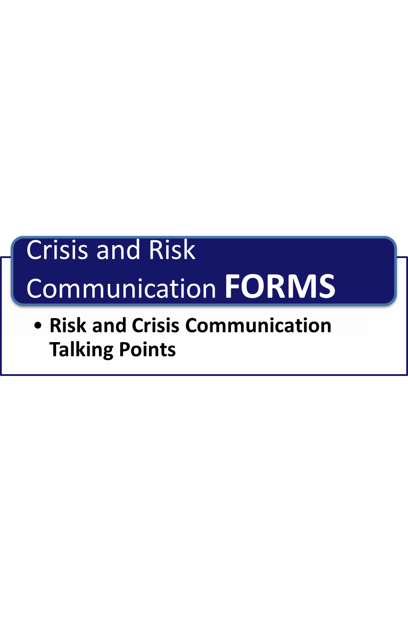

**Page Intentionally Left Blank**

##### Risk and Crisis Communication Talking Points

*Use this form to construct a message to convey situation to stakeholders.*

|  |
| --- |
| **Express Empathy** |
| *Describe how you are concerned for anyone impacted by this situation* |
| **Share Facts** |
| *Share what you know about the situation*  *Who*  *What*  *Where*  *Why*  *When*  *How* |
| **Share Unknowns** |
| *Share what facts are unknown about the situation* |
| **Share Actions Taken and are Taking** |
| *Explain the steps you are taking to get answers to the unknown* |
| **Share Statement of Commitment** |
| *Explain how you are committed to getting answers and solving the problem* |
| **Referrals** |
| *Provide name, number, or website to obtain situation updates and information* |
| **Next Update** |
| *Indicate when next update will be given* |

*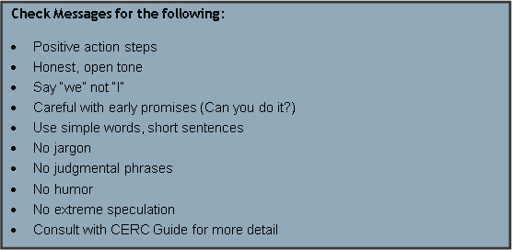Source: Adapted from CERC 2012 Manual*

Chapter 1: Biosecurity Overview

Chapter 2: Biosecurity Assessment

Chapter 3: Employee Policies

Chapter 4: Crisis and Risk Communications

**Chapter 5: Coordination with Animal Health Agencies and Local Government**

Chapter 6: Visitor Control

Chapter 7: Foreign Travel

Chapter 8: Movement On and Off the Property

Chapter 9: Zoonotic Diseases

Chapter 10: Record Keeping

Chapter 11: Animal Handling and Contact

Chapter 12: Disease Detection and Surveillance

Chapter 13: Feral Animal and Wildlife Management

Chapter 14: Physical Security

Chapter 15: Vector Control

Chapter 16: Cleaning and Disinfection

**Page Intentionally Left Blank**

# Chapter 5: Coordination with Animal Health Agencies and Local Government

**Routine Biosecurity Considerations for Coordination with Animal Health Agencies and Local Government**

Disease outbreaks can occur naturally or through acts of terrorism. Both scenarios require feedyard management to communicate and coordinate with a multitude of government agencies (state and local), and organizations including, but not limited to, industry partners, animal health agencies, emergency management and law enforcement. Most of these organizations have the same ultimate goal in a disease emergency: to protect public health and the health and well-being of animals and the beef industry. However, their perspectives and roles differ.

**An intentional introduction** of a FAD occurs when the disease is purposely introduced into the animal population. FAD outbreaks are rare and devastating so when an outbreak occurs, experts suspect it was intentional. When an outbreak is not accidental or naturally occurring, governmental agencies are involved.

Safety considerations during an outbreak are important to all responders, but approaches are different. In the animal health community for example, the first course of action is to stop the spread of disease, clean and disinfect the affected area, and exit as soon as possible. Law enforcement, however, has a different focus. Law enforcement collects evidence and seeks to determine who caused the incident. It is important to work closely with all response agencies, most importantly law enforcement, in the event of an intentional introduction of disease on the feedyard.

**Natural or accidental outbreaks** occur when the FAD is native to or is introduced into the country accidentally or unknowingly. However, there may still be an investigation if there is proof of extreme negligence or accidental breaking of a law (e.g., importing prohibited agricultural goods into the country). During a natural or accidental outbreak, animal health officials with, support from state of local government officials, will play a critical role in controlling and eradicating disease.

Regular communication with local animal health officials and local government agencies is important. The first time to contact these officials is not when a feedyard is in crisis. Relationships should be established and on-scene actions should be coordinated between response organizations prior to a biosecurity incident to minimize conflicts or confusion between first responders in the event of an actual emergency. Take steps to understand agency concerns and roles and responsibilities. Direct and effective cooperation with local officials is crucial. Invite the Emergency Management Coordinator for your community to review and refine the *Cattle Feedyard Biosecurity Plan*. Familiarity with feedyard functions will be important if local officials are ever needed to respond to a situation at the facility. Establishing and maintaining an active working relationship with local officials and familiarizing representatives with the facility before an incident will expedite response during a heightened incident.

Training workers in safety, security, and recognizing outbreaks is an important component of biosecurity and emergency preparedness. See Chapter 3: Employee Policies and *Cattle Feedyard Business Continuity Plan* for information on training.

**Routine Biosecurity Plan for Coordination with Animal Health Agencies and Local Government**

|  |  |
| --- | --- |
| **Overall:** | |
|  | Discuss feedyard specific risks with local and state animal health officials |
|  | Arrange for local law enforcement or insurance agent to perform a security survey of the facility |
|  | Request local law enforcement routinely conduct patrols along facility’s perimeter |
|  | Immediately report any unusual or suspicious persons, vehicles, or activity to local law enforcement |

| **Create and Post Feedyard Facility Map:** | |
| --- | --- |
|  | Create a facility map so that it can be provided to law enforcement, animal health and emergency management professionals in the event of a biosecurity event. The map should include the following information:  The name and address of the feedyard owner/proprietor/manager and physical relationship of the feedyard to adjacent feedyards, fields, or structures  Buildings/structures, including offices, houses, barns, outbuildings, silos, grain bins, chemical and fertilizer storage, manure storage/pits (indicate sizes and locations of entrances), including appropriate access points  Transportation routes, including access roads, highways, crossroads, etc.  Locations of storage areas for machinery or other equipment  Fences and gates (indicate dimensions)  Well and/or municipal water supply, hydrants, and ponds  Electric, gas, and phone lines and shutoff  Location of chemicals including Material Safety Data Sheets (MSDS)  Septic tanks, wastewater systems, and cisterns  Drainage ditches, culverts, and surface drains  Fields/pastures including areas where animals are located  Fuel storage tanks |

|  |  |
| --- | --- |
| **Develop Emergency Contact List:** | |
|  | Create an Emergency Contacts List that has numbers for animal health agencies, local law enforcement, and public health |
|  | Post list around facility near telephones and on bulletin boards. Have employees program these numbers in cell phones |

**Heightened Biosecurity Considerations for Coordination with Animal Health Agencies and Local Government**

Relationships with animal health officials and local government agencies are critical during a heightened biosecurity event. These relationships are crucial to the timely response to a disease outbreak (regardless of cause) on a feedyard. Be prepared to accommodate requests for information and access by animal health officials and other government agencies.

Report suspected FAD outbreaks to Kansas Department of Agriculture – Division of Animal Health (KDA-DAH) and, or the Veterinary Service unit of U.S. Department of Agriculture’s Animal and Plant Health Inspection Service (USDA-AHPHIS).

Coordinationbetween feedyard management and local/State officials is essential during a FAD outbreak occurring anywhere in the country. Federal and state health officials and regional and local emergency managers will have access to important information on quarantines and movement control restrictions for example, and can advise feedyards on how to ensure the safe movement of livestock around controlled areas. Emergency managers can coordinate with state and federal responses and are an invaluable line of communication during any type of crisis.

Response to an FAD will be managed from the top down meaning initial control will be under the Kansas Department of Agriculture. Authorities will determine if and when to activate local, regional, state, and federal emergency management plans. For more information on the Kansas response plan see: The [Kansas Food and Agriculture Incident Annex](http://agriculture.uat.ks.gov/docs/default-source/em-handouts/kansas-food-and-agriculture-incident-annex.pdf?sfvrsn=2) Appendix C (Livestock Emergency).

In most situations, a foreign animal disease diagnostician (FADD) will be assigned to investigate the health status of animals. The FADD will be responsible for: 1) obtaining samples and submitting them for analysis, 2) establishing movement restrictions and increasing biosecurity, and 3) activating the First Assessment and Sampling Team (FAST), if needed through the state veterinarian or USDA-APHIS and 4) maintaining heightened animal health official and local government coordination protocols throughout the duration of the animal health emergency until the disease has been eradicated or otherwise controlled.

**Heightened Biosecurity Plan for Coordination with Animal Health Agencies and Local Government**

*Please review any recommended measures not implemented routinely and consider implementing them during heightened biosecurity operations*

|  |  |
| --- | --- |
| **Recommended Measures** | |
|  | Accommodate requests for information and access by local law enforcement, animal health and emergency management officials |
|  | Contact veterinarian with any concern or suspicion of a FAD. For example, diseases causing abnormal rates of morbidity or mortality, diseases occurring in an abnormal group of animals (pneumonia in late day cattle), or suspicious lesions (blisters around mouth or feet). |
|  | Report any suspicious diseases to a veterinarian and ensure that all cases of reportable diseases (see Annex A: Disease Table) are reported to:  Kansas Department of Agriculture – Division of Animal Health (Manhattan) 785-564-6601  USDA-APHIS Area Director (AD) (785) 228-6577 |
|  | Maintain open communications as requested by local emergency management, animal health and law enforcement officials |

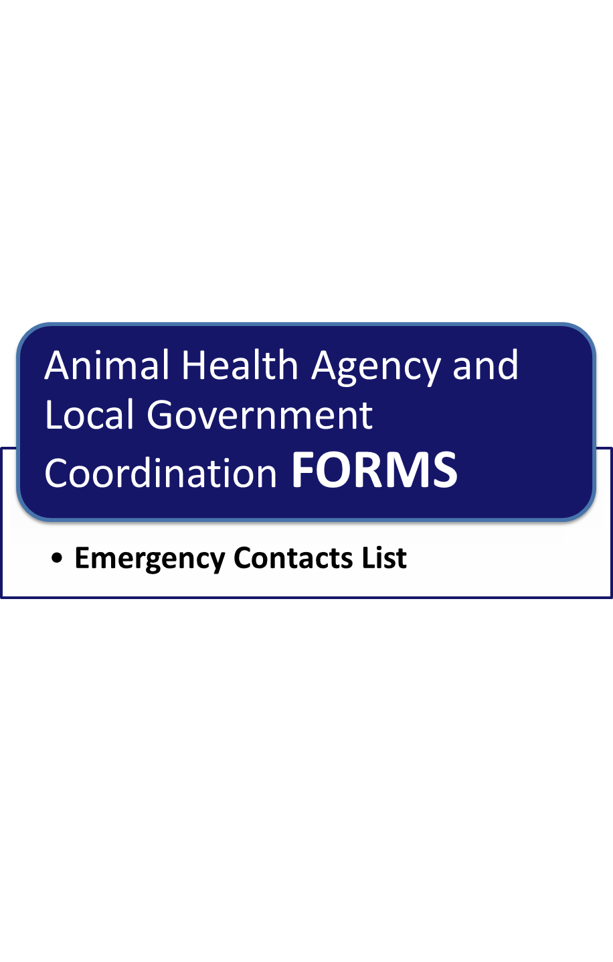

**Page Intentionally Left Blank**

##### Emergency Contacts List

| Emergency Contacts | Phone Number |
| --- | --- |
| Hospital | ____________________ |
| Police Department | ____________________ |
| County Sheriff | ____________________ |
| County Emergency Management Office | ____________________ |
| Kansas Dept of Ag – Div of Animal Health | ____785-564-6601____ |
| USDA APHIS Veterinary Services - Topeka | ____785-228-6577____ |
| Poison Control Center | ____________________ |
| Veterinarian | ____________________ |
| Gas Company | ____________________ |
| Electric Company | ____________________ |
| Chemical Suppliers | ____________________ |
| Feed Suppliers | ____________________ |
| Vehicle / Equipment Dealers | ____________________ |
| Ambulance | ____________________ |
| Fire Department | ____________________ |
| Neighbors | ____________________ |
| County Public Health Department | ____________________ |

**Page Intentionally Left Blank**

Chapter 1: Biosecurity Overview

Chapter 2: Biosecurity Assessment

Chapter 3: Employee Policies

Chapter 4: Crisis and Risk Communications

Chapter 5: Coordination with Animal Health Agencies and Local Government

**Chapter 6: Visitor Control**

Chapter 7: Foreign Travel

Chapter 8: Movement On and Off the Property

Chapter 9: Zoonotic Diseases

Chapter 10: Record Keeping

Chapter 11: Animal Handling and Contact

Chapter 12: Disease Detection and Surveillance

Chapter 13: Feral Animal and Wildlife Management

Chapter 14: Physical Security

Chapter 15: Vector Control

Chapter 16: Cleaning and Disinfection

**Page Intentionally Left Blank**

# Chapter 6: Visitor Control

**Routine Biosecurity Considerations for Visitor Control**

Visitors to a feedyard can pose a significant disease risk to cattle and operations. Visitors can be grouped into low-, medium-, and high-risk visitors (see Figure 6.1) based on their prior exposure to animals and how closely they come in contact with cattle on the feedyard.

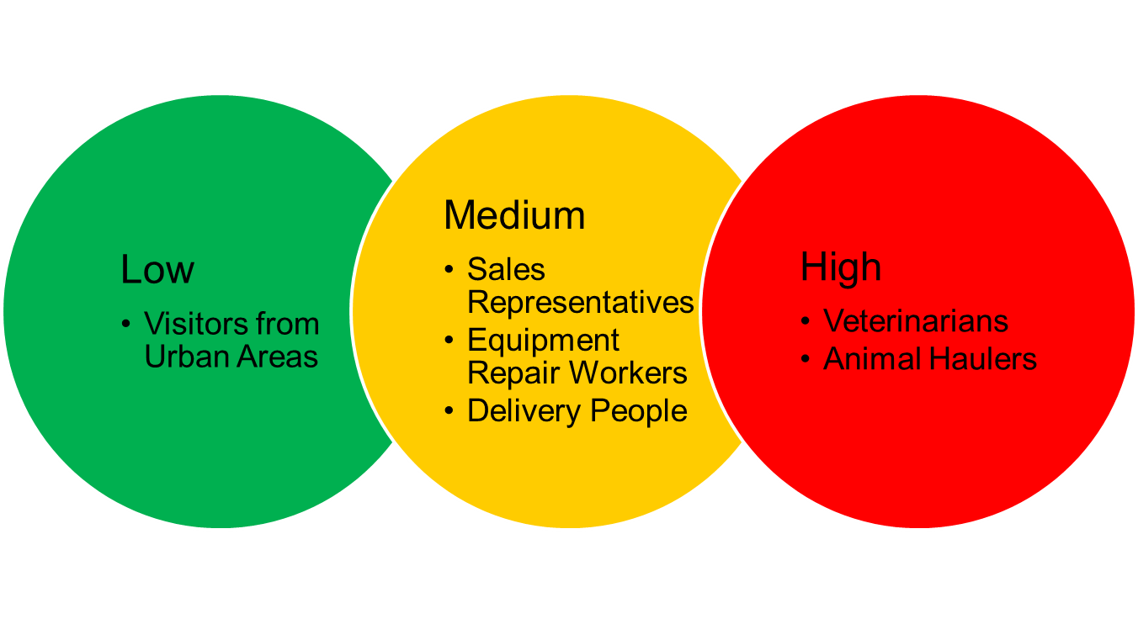

#### Figure 6.1 – Visitor Risk

**Low-risk** visitors are individuals with no recent livestock or poultry contacts prior to the visit. An example of this type of visitor is someone who lives in an urban area with no livestock or poultry contacts prior to visit.

**Medium-risk** visitors are individuals who have limited animal contact due to the location of worksites on premises. Examples of this type of visitor include sales representatives, equipment repairpersons, and delivery people.

**High-risk** visitors are individuals who have regular close contact with animals, their excretions, and secretions. Examples of this type of visitor include veterinarians, animal haulers, and custom processors. Additionally, visitors who recently traveled to foreign countries should be evaluated as a potential high-risk visitor. For more information on the risk associated with foreign travel see Chapter 7: Foreign Travel.

Visit requests from medium- and high-risk visitors should be evaluated on a case-by-case basis. Feedyard management can make discretionary decisions as to whether these visit requests are granted, and may decide that these visitors should follow some or all of the heightened biosecurity visitor control recommended measures.

Visitors who work with livestock pose a risk due to the likelihood of coming into contact with other herds and diseases those herds may carry. Even if management knows these individuals and works with them regularly, it is important that the feedyard manages the actions and interactions of these visitors on the feedyard. People and equipment that interact with other herds regularly pose a significant threat of foreign animal disease transmission to an operation.

Anyone who has recently interacted with livestock or traveled outside of the country should be asked to take extra precautions such as showering and changing clothing, and cleaning and disinfecting equipment and vehicles before coming onto the feedyard. If the visitor was on a farm in a region known to have a FAD, the visit should be postponed until his or her risk can be reduced.

All visitors allowed on-site should be escorted at all times and be informed as to what is and is not allowed.

**Visitor logs** (see Routine Biosecurity Visitor Sign-in Form) are an easy way to track who is coming onto the yard. The simple act of requiring individuals such as delivery, sales, and service representatives, to sign-in ensures the feedyard staff knows that a visitor is onsite. For more information regarding questioning visitors about foreign travel see Chapter 7: Foreign Travel.

**Visitor policies and procedures agreement forms** (see Visitor Agreement Form) outline basic rules for all feedyard visitors. The visitor agreement form can be expanded to include general operational security outside of biosecurity procedures. For example, the feedyard can include a statement alerting visitors “not to take photographs without feedyard management permission.” Instructions requiring visitors to “wear hard-hats while in the mill**”** is another example.

**Routine Biosecurity Plan for Visitor Control**

|  |  |
| --- | --- |
| **Signage:** | |
|  | Post a sign marked “Visitor entrance. All visitors must sign-in.” at the yard entrance(s) |
|  | Post signs directing visitors to the front office and sign-in desk |
|  | Post signs to designate a parking area for visitors and ensure the parking area is located away from livestock and feed |

|  |  |
| --- | --- |
| **Visitor Check-in:** | |
|  | Require all visitors (including delivery, sales and service representatives) to sign in and out each time they visit the feedyard. The Routine Biosecurity Visitor Sign-in Form provided in the form section of this chapter will be printed and kept in a log at the _________________________________. |
|  | Require all visitors review and sign a visitor policies and procedures agreement when visiting the yard. The Routine Biosecurity Visitor Policy and Procedure Agreement Form provided in the form section of this chapter will be printed and kept at the _________________________________. |
|  | Require visitors going anywhere other than the main office or entrance be accompanied by a feedyard employee |
|  | Ask visitors if they have interacted with other livestock within 24 hours. If they answer yes, treat them as high-risk visitors |
|  | Ask visitors if they have recently traveled to a foreign country (if yes, see Chapter 7: Foreign Travel) |

|  |  |
| --- | --- |
| **Visitor Personal Vehicle Control:** | |
|  | Require all visitors park their personal vehicles in designated visitor parking areas |
|  | If necessary for the visitor(s) to enter the feedyard, ensure visitors ride with feedyard personnel in feedyard vehicles |
|  | If visitors must drive a personal vehicle further into the feedyard, ensure they follow the path designated by a feedyard employee  ***Note****:* Visitors who have business vehicles that need to enter the feedyard beyond the visitor parking area (e.g., feed haulers) should follow the biosecurity measures described in Chapter 8: Movement on and off the Property |

|  |  |
| --- | --- |
| **Visitor Control:** | |
|  | Do not allow visitors to proceed to cattle areas with food or drink |
|  | Require visitors bringing equipment onto the feedyard to clean and disinfect equipment before and after each use |
|  | Require visitors wear clean footwear and walk through a bootbath or otherwise clean/disinfect them or wear footwear supplied by the feedyard prior to proceeding past visitor area |
|  | Require visitors wear clean disposable or reusable protective clothing e.g., coveralls, hats, gloves, and clean disposable or reusable boots |
|  | Clean and disinfect all visitor equipment/tools that come in contact with animals or feedstuffs prior to entering, and before leaving, the yard  For more specific guidance see Chapter 16: Cleaning and Disinfection |
|  | Require visitors to wash their hands with soap and water before entering and after proceeding past the office |

**Heightened Biosecurity Considerations for Visitor Control**

During an animal disease outbreak, visitors to a feedyard pose a significant disease risk to cattle and operations. **As such, all visitors should be treated as high-risk.** Visits can be divided into essential or non-essential.

**Essential visitors** are individuals who need to come onto the yard in order to perform a function necessary to maintain feedyard operation and animal health. Examples of essential visitors include vendors, contractors, repairmen and veterinarians.

**Non-essential visitors** are individuals who wish to visit the feedyard, but whose visit is not required for the operation of the feedyard. Examples of non-essential visitors include someone requesting a tour or sales representatives.

During an animal disease outbreak emergency, all non-essential visit requests should be denied or postponed until the health emergency is over. All essential visit requests should be reviewed to ensure they are essential. All granted visit requests should be strictly monitored and heightened biosecurity measures practiced.

In an outbreak situation, the risk of a visitor bringing disease onto the feedyard increases, especially if the premises are within or near the outbreak area. If a disease outbreak occurs within the United States, but the feedyard is located outside the outbreak area, feedyard management is responsible for ensuring visitors observe biosecurity and Cleaning and Disinfection (C&D) measures appropriate to the level of perceived risk (see Chapter 16: Cleaning and Disinfection for more information).

**Feedyards near outbreak area** may be at a greater risk than those located further from the outbreak area. This is because there is a greater chance that feedyard visitors may live or work in the outbreak area. Therefore, premises nearer to the outbreak area should institute stricter visitor control measures than operations hundreds or thousands of miles away.

**Feedyards outside outbreak area** may choose to enforce some or all of the heightened biosecurity practices. Feedyard management should use this guidance and the attached forms to aid in determining if a visit request should be granted. Additionally, many veterinary practitioners are more comfortable making multiple farm visits outside the quarantined area as long as they diligently observe heightened biosecurity measures.

**Feedyards inside outbreak area** should require visitors to follow heightened biosecurity recommended measures. Only essential visitors should be allowed to enter the premises. Outside consultants (for example, veterinarians and nutritionists) should limit their visits to no more than one feedyard per day and only make on site visits to non-infected locations. (***Note***: some diseases, such as FMD, can be persistent for days. As such, the length of time between visits to multiple feedyards may need to be longer.) For specific biosecurity measures, refer to the *FAD PReP SOP: Biosecurity.*

**Zoonotic diseases** can be transmitted between animals and humans. With a zoonotic disease, there is risk that visitors who have the disease could infect the cattle, or that infected cattle on the operation could give the disease to visitors. When there is heightened risk of a zoonotic disease, the Visitor Control section of the biosecurity plan should be coordinated with Chapter 4: Crisis and Risk Communication. For more information see Chapter 9: Zoonotic Diseases.

Maintain heightened visitor control protocols throughout the duration of the animal health emergency until animal health officials have eradicated or otherwise controlled the disease.

**Heightened Biosecurity Plan for Visitor Control**

*Please review any recommended measures not implemented routinely and consider implementing them during heightened biosecurity operations*

|  |  |
| --- | --- |
| **Signage:** | |
|  | Post a sign marked “Controlled Area. Do not enter without permission” at the yard entrance  See Heightened Biosecurity Signs for an example |
| **Visitor Check-in:** | |
|  | Require all visitors (including delivery, sales and service representatives) to sign in and out each time they visit the feedyard. The Heightened Biosecurity Visitor Sign-in Form provided in the form section of this chapter will be printed and kept in a log at _________________________________. |
|  | Require all visitors to fill out the visitor questionnaire form before visiting the yard. The Heightened Biosecurity Visitor Questionnaire Form provided in the form section of this chapter will be printed and kept in a log at _________________________________. |
|  | Review all visit requests and invitations; and only permit essential visitors |
|  | Delay non-essential visits or relocate off-site until the threat level is no longer heightened |
|  | Require visitors to make appointments or provide advance notice of arrival |
|  | Question visitors about any recent travel, highlighting visits to the outbreak location |
|  | Delay the visit of anyone who has traveled to the outbreak area or find a replacement for the service provided by anyone who has traveled to the outbreak area |
|  | Direct visitors to a location where they can put on and take off boots and coveralls and clean up before and after animal contact |

|  |  |
| --- | --- |
| **Visitor Personal Vehicle Control:** | |
|  | Do not allow visitor personal vehicles access to the feedyard; direct visitors to park at the entrance/designated parking areas away from the animal pens and feed storage areas |
|  | Use feedyard vehicles to every extent possible. If possible, direct essential visitors to park remotely and transport them onto the yard using feedyard vehicles. |
|  | Provide facilities for cleaning and disinfecting vehicles and equipment before entry into the feedyard; see Chapter 16: Cleaning and Disinfection for more information |
|  | Spray disinfectant on vehicles wheel wells and undercarriage prior to entry and again upon leaving |

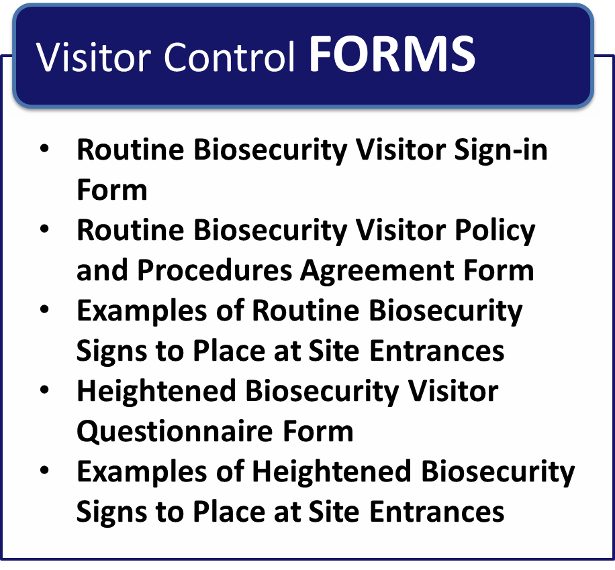

**Page Intentionally Left Blank**

##### Routine Biosecurity Visitor Sign-in Form

| **Date** | **Time In** | **Time Out** | **Visitor’s Name** | **Cell Phone Number** | **Company Name** | **Vehicle Make/Model** | **State and License Plate #** | **Reason for visit** | **Have you had contact with other livestock recently?** | **Have you recently visited a foreign country?** |
| --- | --- | --- | --- | --- | --- | --- | --- | --- | --- | --- |
|  |  |  |  |  |  |  |  |  |  |  |
|  |  |  |  |  |  |  |  |  |  |  |
|  |  |  |  |  |  |  |  |  |  |  |
|  |  |  |  |  |  |  |  |  |  |  |
|  |  |  |  |  |  |  |  |  |  |  |
|  |  |  |  |  |  |  |  |  |  |  |
|  |  |  |  |  |  |  |  |  |  |  |
|  |  |  |  |  |  |  |  |  |  |  |
|  |  |  |  |  |  |  |  |  |  |  |
|  |  |  |  |  |  |  |  |  |  |  |
|  |  |  |  |  |  |  |  |  |  |  |
|  |  |  |  |  |  |  |  |  |  |  |
|  |  |  |  |  |  |  |  |  |  |  |
|  |  |  |  |  |  |  |  |  |  |  |
|  |  |  |  |  |  |  |  |  |  |  |

**Page Intentionally Left Blank**

##### Routine Biosecurity Visitor Policy and Procedures Agreement Form

As a visitor to___________________________________, I agree to the following listed practices:

1. I agree not to drive my vehicle anywhere beyond the entryway and visitor parking area without permission of feedyard management.
2. I agree that I will not attempt to come into direct contact with animals or feed without permission from feedyard management.
3. If I do have permission to come into contact with animals or feed, I will wash my hands thoroughly before and after doing so.
4. I will inform feedyard management if I have had contact with livestock or poultry prior to my visit. This includes:
   * regular close contact with animals, their excretions, and secretions, and
   * limited contact with animals due to the location of worksites on other premises.
5. I will inform management if I own or care for livestock or poultry.
6. I will inform management if I have recently traveled outside of the United States.
7. I will not proceed into the cattle areas with food, drink, gum or tobacco.

Visitor Name: _______________________________________

Visitor Signature: ____________________________________

Date: _________________

**Page Intentionally Left Blank**

##### Examples of Routine Biosecurity Signs to Place at Site Entrances

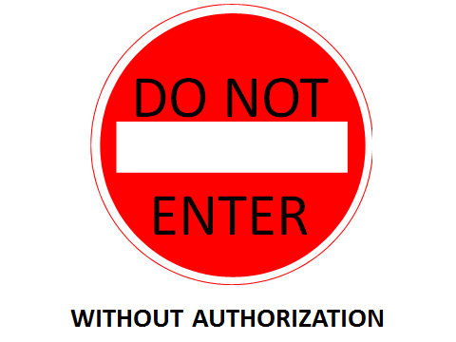

**Page Intentionally Left Blank**

##### Heightened Biosecurity Visitor Sign-in Form

| **Date** | **Time in** | **Time out** | **Visitor’s Name** | **Cell Phone Number** | **Company Name** | **Vehicle Make/Model** | **State and License Plate #** | **Reason for visit** | **Have you had contact with other livestock recently?** | **Have you recently visited a foreign country?** | **Have you visited *area of concern recently*?** |
| --- | --- | --- | --- | --- | --- | --- | --- | --- | --- | --- | --- |
|  |  |  |  |  |  |  |  |  |  |  |  |
|  |  |  |  |  |  |  |  |  |  |  |  |
|  |  |  |  |  |  |  |  |  |  |  |  |
|  |  |  |  |  |  |  |  |  |  |  |  |
|  |  |  |  |  |  |  |  |  |  |  |  |
|  |  |  |  |  |  |  |  |  |  |  |  |
|  |  |  |  |  |  |  |  |  |  |  |  |
|  |  |  |  |  |  |  |  |  |  |  |  |
|  |  |  |  |  |  |  |  |  |  |  |  |
|  |  |  |  |  |  |  |  |  |  |  |  |
|  |  |  |  |  |  |  |  |  |  |  |  |
|  |  |  |  |  |  |  |  |  |  |  |  |
|  |  |  |  |  |  |  |  |  |  |  |  |
|  |  |  |  |  |  |  |  |  |  |  |  |
|  |  |  |  |  |  |  |  |  |  |  |  |

**Page Intentionally Left Blank**

##### Heightened Biosecurity Visitor Questionnaire Form

Name: _______________________________________________________________

Address: _____________________________________________________________

Phone Number: _______________________________________________________

Date of Visit: _________________________________________________________

Reason for Visit: ______________________________________________________

(Circle one)

|  |  |
| --- | --- |
| 1. Can your visit be postponed? | Yes or No |
| 2. Can your business be conducted off-site or via telephone? | Yes or No |
| 3. Does your visit require viewing or handling the animals at this facility? | Yes or No |
| 4. Have you traveled to the “outbreak area” recently?   * If yes, did you visit a farm or feedyard or have animal contact while there? | Yes or No  Yes or No |
| 5. Have you had contact with livestock recently?   * If yes, what species and when? ______________________   **_________________________________________________________** | Yes or No |
| 6. Will you use the protective clothing (for example, rubber boots) provided? | Yes or No |

Visitor Signature Date

Approval Signature Date

If you answered yes to question #1 or #2, your visit may not be allowed.

If **yes** to question #3 or #4, contact with animals may not be allowed.

If you answered **yes** to question #4 and/or #5, and your visit is deemed necessary, protective clothing must be worn.

**Page Intentionally Left Blank**

##### Examples of Heightened Biosecurity Signs to Place at Site Entrances

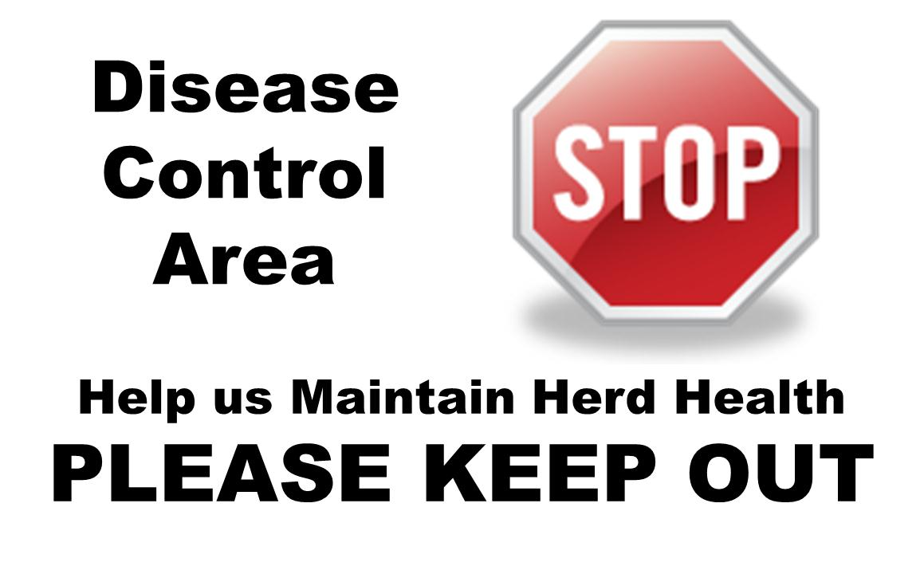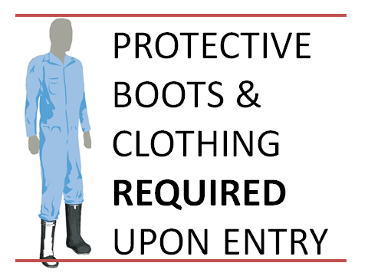

**Page Intentionally Left Blank**

Chapter 1: Biosecurity Overview

Chapter 2: Biosecurity Assessment

Chapter 3: Employee Policies

Chapter 4: Crisis and Risk Communications

Chapter 5: Coordination with Animal Health Agencies and Local Government

Chapter 6: Visitor Control

**Chapter 7: Foreign Travel**

Chapter 8: Movement On and Off the Property

Chapter 9: Zoonotic Diseases

Chapter 10: Record Keeping

Chapter 11: Animal Handling and Contact

Chapter 12: Disease Detection and Surveillance

Chapter 13: Feral Animal and Wildlife Management

Chapter 14: Physical Security

Chapter 15: Vector Control

Chapter 16: Cleaning and Disinfection

**Page Intentionally Left Blank**

# Chapter 7: Foreign Travel

**Routine Biosecurity Considerations for Foreign Travel**

Foreign and emerging animal diseases constitute the primary threat to the health of livestock herds. Increases in free market economies and relaxation of restrictions on foreign imports and exports have resulted in animals and animal products moving around the world in unprecedented numbers and at record rates. People are also traveling around the world to increasingly exotic locations.

This increase in world travel and animal traffic elevates the risk of introduction of disease causing organisms to feedyards. Such agents are not limited to agricultural areas and can also be encountered at zoos, rural areas, fairs, animal exhibitions, and meat markets. Animals used for transportation and feral animals are also a source of risk.

**Employee notification of foreign travel** requirements exist to make feedyard management aware of employee travel prior to departure. Notification provides the opportunity for management to discuss risks and advise employees on biosecurity before departure and to determine when the employee will be allowed to return to work. Require all employees to give notification of employee intent to travel to foreign countries prior to departure. This includes both personal and professional travel as well as travel to Canada and Mexico. Have employees fill out the provided Notification of Foreign Travel form.

U.S. Customs and Border Protection (CBP) enforces a ban on bringing food and other agricultural items into the country in baggage or on person as these items may carry animal and plant pests and diseases. Remind employees visiting foreign countries of these restrictions before their departure.

**Visitors to foreign countries** may transport many diseases back to the United States that can cause major health and economic problems to feedyards. Disease organisms may live in soil, manure, animal carcasses or buildings. Some organisms can survive for long periods in moist, shaded locations. Animals that have had a disease may shed the organism for weeks or months after recovery. In many parts of the world, farm animals are found in cities and urban areas, not just in farming areas. Additionally, Animals may be used for transportation, may be pets, or may be driven to market (i.e., to a feedyard or processing facility).

FADs are endemic in many parts of the world. For example, FMD is endemic to parts of South America. Visitors to South America could bring the FMD virus onto the feedyard thus compromising the United States’ coveted World Organization for Animal Health (OIE) “FMD free” status. An FMD outbreak could devastate the entire feedyard industry and the United States economy.

**Shoes** are particularly hard to clean and disinfect. Disease organisms can be brought into the country even if there are no visible signs of debris (e.g., feces) on footwear. Advise employees who plan on visiting agricultural sites to take footwear that can easily be disinfected (e.g., rubber boots). Any footwear worn during foreign travel should be cleaned and disinfected before wearing them on the feedyard. See Chapter 16: Cleaning and Disinfection for more information.

**Clothing** can also be a source of animal disease. For example, there have been documented cases of travelers bringing screw worm larvae into the United States on clothing. Contact with foreign livestock or farms can potentially contaminate footwear, clothing and equipment with infectious disease agents; thus providing a venue to infect domestic animals.

**Routine Biosecurity Plan for Foreign Travel**

|  |  |
| --- | --- |
| **Signage:** | |
|  | Post a sign marked “If you have traveled outside the United States in the past fourteen (14) days, you may inadvertently transmit a Foreign or Emerging Animal Disease to our feedyard. Please call (____) _____-_______ before entering the premises.” |

|  |  |
| --- | --- |
| **Visitors to Foreign Countries:** | |
|  | Avoid visiting farms, sale barns, fairs, stockyards, zoos and any other animal facility |
|  | Before foreign travel, fill out Notification of Foreign Travel form |
|  | Check the following websites for surveillance information:  <http://www.oie.int/en/alerts-disease-information/>  <http://www.glews.net/disease-events/> |

**Heightened Biosecurity Considerations for Foreign Travel**

Be aware of the disease status (disease alerts, or countries where disease is endemic) of countries where employees and visitors may travel. Disease reporting and investigative systems in some countries may be inadequate, and information is often not up to date. Assume anyone who travels to a foreign country may come into contact with disease organisms.

Ask all visitors and employees to report foreign travel. Check the disease status of the country. Consult your veterinarian and/or state health authority for information about the disease status of a country. Additional resources for learning about active disease outbreaks worldwide are available on the following websites:

* <http://www.oie.int/en/alerts-disease-information/>
* <http://www.glews.net/disease-events/>

Any employees traveling to a high risk FAD country should be treated with extra caution. Consult with your veterinarian and/or state health authority to determine when an employee who has traveled to a high risk area should be allowed to return to work, and what cleaning and disinfection measures they should undertake.

Maintain heightened foreign travel protocols throughout the duration of the animal health emergency until animal health officials have eradicated or otherwise controlled the disease.

**Heightened Biosecurity Plan for Foreign Travel**

*Please review any recommended measures not implemented routinely and consider implementing them during heightened biosecurity operations*

|  |  |
| --- | --- |
| **At Risk Countries:** | |
|  | Ensure employees are aware of what countries pose a high risk for bringing FAD into the feedyard |
|  | If visiting an areas where FMD may be endemic, do not return to the feedyard for at least two weeks after returning to the United States |
|  | Consult your veterinarian and/or state health authority to determine when an employee who has traveled to an at risk area should be allowed to return to work |

**Page Intentionally Left Blank**



**Page Intentionally Left Blank**

##### Notification of Foreign Travel

1. **Background:** 
   1. Travel outside of the United States is a matter of biosecurity interest to ___________________ Feedyard. Such travel includes points in Canada, the Caribbean, and Mexico as well as more distant places.
2. **Foreign Travel Briefing Information:**

As you prepare to travel outside the United States, you may find yourself visiting sites such as fairs and zoos, agriculture production areas including family farms, and other areas which might bring you into contact with Foreign and Emerging Animal Diseases (FAD). The following tips and rules are provided to prevent you from placing the cattle at ____________________ Feedyard at risk.

* 1. Be aware that there are many diseases in addition to FMD that can cause major health and economic problems to feedyards. In many parts of the world, farm animals are often found in cities and urban areas, not just in farming areas. They may be used for transportation, they may be pets, or they may be in the process of being driven to market.
  2. Many animal diseases can also cause disease in humans (zoonosis). Avoid touching or handling wild animals and be sure to wash hands thoroughly if you do come into contact with an animal. Be sure to only eat food that has been thoroughly cooked.
  3. Just because no major disease is in the news in the area to be visited, does not mean that the disease is not present. Disease organisms may live in the soil, manure, animal carcasses or buildings. They may survive for very long periods in moist, shaded locations. Animals that have had a disease may shed the organism for weeks or months after they recover themselves.
  4. Avoid visiting farms sale barns, fairs, stockyards, zoos and any other animal facility.
  5. Educate yourself of any animal disease outbreaks in the area you plan on traveling to. The following websites contain surveillance information:
* <http://www.oie.int/en/alerts-disease-information/>
* <http://www.glews.net/disease-events/>
* <http://www.cfsph.iastate.edu/DiseaseInfo/index.php> (click on a disease to find distribution maps and news reports)
  1. If visiting a high risk for FAD country, work with feedyard management, a veterinarian, and/or state health authority to determine when it is safe to return to work.
  2. Before traveling to a high risk for FAD country:
     + Take footwear that can easily be disinfected (e.g., rubber boots)
     + Take inexpensive, easily washed clothes
     + Use boots and coveralls while in animal area, and change clothes immediately upon leaving animal area
     + Disinfect equipment and boots often
     + Remove any organic matter (dirt, manure) from luggage, cameras, cell phones and other personal items before returning to the United States
     + Place all clothing and shoes in plastic bags before packing in your luggage
     + Any footwear worn during foreign travel should be cleaned and disinfected before wearing on the feedyard
  3. When you return from foreign travel:
     + Wash all clothing (including boots and hats) before returning to the feedyard
     + Do not bring plant or animal products into the United States. This includes all types of food items, including canned foods
     + Do not bring back equipment used around foreign livestock or poultry

|  |  |  |  |  |  |
| --- | --- | --- | --- | --- | --- |
|  | | |  | | |
| Name of Traveler (Printed) | | |  | | |
|  | | | |  |  |
| Signature of Traveler | | | |  | Date |
|  |  |  | |  |  |
| Name of Feedyard Manager |  | Signature of Feedyard Manager | |  | Date |

Chapter 1: Biosecurity Overview

Chapter 2: Biosecurity Assessment

Chapter 3: Employee Policies

Chapter 4: Crisis and Risk Communications

Chapter 5: Coordination with Animal Health Agencies and Local Government

Chapter 6: Visitor Control

Chapter 7: Foreign Travel

**Chapter 8: Movement On and Off the Property**

Chapter 9: Zoonotic Diseases

Chapter 10: Record Keeping

Chapter 11: Animal Handling and Contact

Chapter 12: Disease Detection and Surveillance

Chapter 13: Feral Animal and Wildlife Management

Chapter 14: Physical Security

Chapter 15: Vector Control

Chapter 16: Cleaning and Disinfection

**Page Intentionally Left Blank**

# Chapter 8: Movement On and Off the Property

**Routine Biosecurity Considerations for Movement On and Off the Property**

Feedyards are busy places with many employees and vehicles entering and leaving on a daily basis. Employees and contractors (e.g., processing crews, electricians, manure haulers etc.) routinely travel through all areas of the feedyard and have access to many cattle. Chapter 6: Visitor Control of this guide addresses visitor control and documentation, but most feedyards do not include employees, contract crews and truck drivers in record keeping. Documenting the movement of every worker on a daily basis may not be practical but it is a recommended biosecurity practice. Keep track of all products, vehicles, and people entering the operation, and require processing crews, truck drivers, and all vendors to sign-in at the front office or check-in with the night watchman. At a minimum, keep the records outlined in Chapter 10: Record Keeping for product inventory, vendor sign-in sheets, and employee contact forms. Records of all people and product movement are essential to have in the event of an outbreak.

**Vehicles** present a tremendous opportunity for transporting pathogens and efficiently delivering them to susceptible animals. Require employees and all personnel (veterinarians, delivery and service representatives) with vehicles to sign-in at the front office (See Chapter 6: Visitor Control for more information). If vendors drive onto the facility, ensure their drive path is as far from animals as possible. Additionally, request that trucks to be periodically cleaned at a commercial truck washing facility. Soiled vehicles should be restricted from driving in the pen areas. For information on available truck washes on a state-by-state basis, visit the [National Biosecurity Resource Center for Animal Health Emergencies](http://www.biosecuritycenter.org/truckwash.php) website.

**Designate parking areas** located onthe perimeter of the feedyard to prevent potential pathogen spread. Post signs directing visitors to a designated parking area. If visitors drive personal vehicles on the feedyard, ensure their drive path is away from feed storage areas and animal pens.

**Designate a limited access staging area** on the perimeter of the property, where equipment can be left for servicing and deadstock can be taken for pick-up (preferably out of sight from main roadways and neighboring properties).

**Animal delivery/loadout facilities** are usually located along the perimeter of feedyards. This aids in limiting the potential for trucks to spread contamination to cattle pens. Maintain parking and load-out areas with gravel, asphalt or concrete surfaces. Adequate drainage away from the pens ensures that run-off, potentially containing contamination, is kept away from animal areas. Additional precautions can also be taken, such as providing a wash-down facility and/or a tire washing area with a disinfectant.

**Rendering** of carcasses is a common disposal method for many feedyards. Rendering is frequently managed by a business independent of the feedyard and often includes a “pickup” service. Because renderers pick up deadstock from multiple locations, there is a much higher biosecurity threat associated with these vehicles. Direct renderer’s trucks to a predetermined location; preferably at the edge of the facility away from main traffic areas and feed or live animal areas.

**Human foot traffic** also poses a disease risk. Chapter 6: Visitor Control of this guide contains specific information about visitor control. Consider requiring all visitors to wear clean coveralls and overboots to protect livestock from potential pathogens that may survive on visitor’s clothing or shoes. Alternatively, a boot bath may be installed at the main entrance with a requirement that all visitors disinfect their footwear. For more information on boot baths see Chapter 16: Cleaning and Disinfection.

To the extent possible, have employees work from the feed alleys without entering the pens. Employees that are required to enter pens should do so through gates and avoid climbing through or over feed bunks. Prevent visitors from walking through feces, and urine. Soiled footwear can contaminate the feed and other areas.

**Manure** is an inevitable by-product of feedyards. Regular removal will reduce health issues (decreasing the infectious burden of animal disease pathogens), odor, and fly breeding grounds. However, manure removal can also contribute to the spread of disease as pathogens can survive in the ideal environmental conditions and temperatures manure provides. Clean pens after the removal of each group of cattle, before introducing new animals. This strategy can aid in breaking disease cycles from pathogens spread via fecal-oral transmission.

Many orally transmitted diseases originate from manure that is harboring the pathogen. Follow a waste management program to control animal access to the pathogens in manure. Remove waste on a frequent basis. Preferably use designated equipment for manure handling. If manure handling is contracted to an outside source, ensure equipment is cleaned before being brought onto feedyard property. If equipment is used for other purposes, such as feed delivery, ensure it is cleaned and disinfected to prevent cross contamination (see Chapter 16: Cleaning and Disinfection) for more information on cleaning and disinfection).

**Feed products** are potential sources for the introduction and/or transmission of disease. Products include harvested feeds (hay and grain), mineral mixes, and other supplements. Evaluate the biosecurity of feed products regularly. Purchase feed from a reputable vendor with an acceptable quality assurance program and appropriate documentation. This verifies reasonable measures are taken to protect the feed from contamination with potential disease-causing material, including ruminant derived protein.

The best feed can become a threat if not handled and stored correctly. Attempt to exclude wildlife from outdoor pens and prevent access of wild or feral animals to stored feed and feeding areas. Birds and vermin are effective at transmitting disease and are common in feed storage areas. Recognize that even domestic animals pose risks as dogs, cats, goats, sheep and horses can introduce disease to cattle by contaminating feed with urine, feces or other body fluids (See Chapter 13:Feral Animals and Wildlife Management).

For certain feedstuffs, like silage and grain, proper handling means protection from weather to prevent spoilage and mycotoxin development. Ensile and process feed in appropriate conditions (e.g., freedom from oxygen, ideal pH conditions, etc.) to protect the feed. Clean up and dispose of spilled feeds promptly, particularly when adjacent to storage or feeding areas. Spilled feed attracts wildlife, fosters spoilage, and serves as breeding ground for pests. Use stored feeds in a first-in-first-out manner. If more than one storage bin exists for a commodity (e.g., corn), empty each bin completely before refilling. Avoid adding new commodities on top of existing stores.

Feeding in troughs, rather than on the ground, may reduce exposure to pathogens. However, troughs can spread pathogens as animals eat from the same surface repeatedly. If this surface is soiled with feces, urine, nasal discharge or even saliva, it can serve as a fomite. Clean troughs frequently and remove all visible debris.

**Water sources** are another risk factor for oral transmission. Examine and clean troughs regularly. Remove all organic debris (manure, feed and other material) frequently, as this provides a source and sustenance for many pathogens.

Regularly inspect and protect the water quality. Deep wells and municipal sources afford greater protection from potential contamination. The U.S. Environmental Protection Agency (EPA) and Kansas Department of Health and Environment recommend annual testing for coliform bacteria to assess the quality of the water source.

**Routine Biosecurity Plan for Movement On and Off the Property**

|  |  |
| --- | --- |
| **Vehicles and Equipment:** | |
|  | Ensure staff is aware of the potential for introduction and transmission of disease by visiting vehicles, machinery and equipment |
|  | Do not share equipment or vehicles between feedyards  If equipment must be shared, remove all manure, wash equipment with warm water and soap, rinse, and disinfect. Rinse again before using equipment with animals from feedyard |
|  | Ensure vehicles, machinery and equipment entering the feedyard area are directed to specified locations and delivery areas within the feedyard |
|  | Limit movement of non-feedyard vehicles, machinery and equipment to areas of the feedyard beyond the specified delivery areas |

|  |  |
| --- | --- |
| **Designated Parking Area:** | |
|  | Designate parking areas located onthe perimeter of the feedyard |
|  | Ensure the parking area has adequate drainage that flows away from the pens to prevent contamination |

|  |  |
| --- | --- |
| **Animal Delivery/Loadout Facilities:** | |
|  | Place animal delivery/load out facilities on the perimeter of the feedyard |
|  | Clean all transport trucks and trailers regularly |

|  |  |
| --- | --- |
| **Animal Movement:** | |
|  | Keep records of all animal movement  See Chapter 10: Record Keeping for more information and forms |

|  |  |
| --- | --- |
| **Rendering:** | |
|  | Establish a dead animal pickup point away from pen areas and not in yard vehicle traffic patterns so rendering trucks do not contaminate the operation  Chose a location that:  Allows for pick-up without vehicle movement through feed or cattle lanes  Is clearly marked  Is located along the perimeter of the feedyard  Is out of sight from main roadways and neighboring properties |
|  | Communicate location of deadstock to drivers ahead of scheduled pick-up |

| **Human Foot Traffic:** | |
| --- | --- |
|  | Inform employees of the potential for introduction and transmission of disease by visitors |
|  | Ensure all visitors entering the feedyard are directed to a designated meeting place away from the main feedyard area, preferably the office, before access is allowed to the main feedyard area |
|  | Control the access of visitors to the cattle pens |
|  | Maintain a register of visitors and vehicles to the feedyard  See Chapter 6: Visitor Control, for an example of a visitor sign-in form |

| **Manure:** | |
| --- | --- |
|  | Be aware manure and effluent pose a potential biosecurity risk |
|  | Use dedicated equipment (e.g., shovels, loaders, trucks) for manure management |
|  | Clean and disinfect manure handling equipment with a solution designed to destroy or eliminate infectious microorganisms prior to using the equipment to handle feed or other commodities |
|  | Keep records of manure movement on the feedyard  See Chapter 10: Record Keeping for more information and forms |
|  | Ensure manure doesn’t contaminate feed |
|  | Enforce manure management procedures to control and prevent overflow |
|  | Record movements of manure and/or compost removed from the feedyard site |

| **Feed Products:** | |
| --- | --- |
|  | Do not allow workers to step in feed bunks |
|  | Prevent feed delivery equipment from crossing routes contaminated by manure |
|  | Use dedicated equipment (e.g., shovels, skid steer, dump buckets) for feed management |
|  | Keep feed and manure handling traffic separated from each other as much as possible |
|  | Purchase feed commodities from preferred suppliers who maintain a quality assurance program that includes a biosecurity component whenever possible  Ensure documentation of quality assurance procedures is provided with purchased feed  Verify reasonable measures are taken to protect the feed from contamination with potential disease-causing material, including ruminant derived protein |
|  | Comply with FDA ban on feeding of prohibited proteins to cattle |
|  | Enforce wildlife and feral animal control measures to prevent contamination of feed |
|  | Protect feed from adverse weather to prevent spoilage and mycotoxin development |
|  | Frequently clean up and dispose of spilled feeds |
|  | Keep feed troughs clean (remove visible debris) and well maintained |

| **Water Sources**: | |
| --- | --- |
|  | Examine and clean water troughs regularly to remove all organic debris (manure and spoiled or waste feed) |
|  | Examine water source regularly  Use deep wells and municipal sources whenever possible  Protect water sources as much as possible and monitor for problems  Perform annual culture tests for coliform bacteria to assess the quality of the water source |

**Heightened Biosecurity Considerations for Movement On and Off the Property**

If there is a confirmed FAD outbreak in the United States, state and federal regulations restricting movement, increasing surveillance, testing, and reporting requirements may go into effect. Within 48 hours of the identification of the Index Case, the USDA will implement a surveillance plan which helps: 1) define the extent of the FAD outbreak, 2) identify Infected Premises, 3) identify new cases quickly through a combination of observation and laboratory testing, and 4) identify Disease-Free Zones. Once a feedyard, region, state, or country is established as a Disease-Free Zone, movement restrictions and disease monitoring requirements lessen, easing the response effort in that area.

**Quarantine and movement control measures** may be put in place to stop the spread of disease if a FAD outbreak occurs within the United States. These quarantine and movement controls will define Infected Zone(s*)*, Buffer Zone(s), Control Area(s), and biosecurity procedures to protect non-infected animals. Figure 8.1 from the Foreign Animal Disease Preparedness and Response Plan (FAD PReP) Foot and Mouth Disease Response Plan, illustrates an example of the zones and premises.



#### Figure 8.1 Example Illustrations of Zones and Premises

Do not move susceptible animals from outside an Infected Zone into or through an Infected Zone unless they are going to slaughter and the nearest facility is inside the Infected Zone. To ensure any product from an infected or exposed animal is properly disposed of, and any suspect product is detained, quarantine and movement controls will be imposed on such products. Permits may be required to move livestock into, within and out of a Control Area. Reroute livestock conveyances prior to reaching the Infected Zone.

Even if movement restrictions do not directly impact operations (i.e., if feedyard is located outside of the Control Area), restrictions may make the purchase, sale, and shipment of livestock and feed difficult. Practice proper biosecurity measures by developing a vehicle routing plan with commodity transporters to ensure Control Areas are avoided.

**Vehicles** **and equipment** pose a serious threat during heightened biosecurity operations. Clean all transport trucks and trailers regularly, preferably after each use. Clean the outside and undercarriage, as well as the interior of the trailer. If cattle are still being transported onto the feedyard, clean livestock trailer between every load of cattle. If possible, provide a wheel wash facility for any vehicle coming onto the feedyard. Wheel washing will help prevent contamination from feed delivery vehicles to feedyard equipment (see Chapter 16: Cleaning and Disinfection for more information).

Park non-essential vehicles off-site. Document the movement of people and vehicles at the facility during a disease outbreak. Refer to Chapter 6: Visitor Control for an example of a sign-in form that can be used to track the movement vehicles.

**Live animals** present the greatest risk for introducing or spreading disease during an outbreak. Movement of uninfected finished cattle off feedyard may be halted during a FAD outbreak depending on the feedyard’s proximity to the processing facility and whether travel through or within a Control Area is required to get animals to the facility. In order for permits to be issued for movement, visual inspections and diagnostic testing may be required. Additionally, finished cattle may be required to be sent to the closest processing facility to minimize movement. If contracts exist between the feedyard and a processing facility, and the transportation required to reach the destination crosses Control Areas, route modifications may be required.

**Animals in transit** present a difficult issue in the event of a FAD outbreak. When a highly contagious FAD is first discovered in the United States, state or federal animal health officials may issue an immediate restricted or stop movement order. Establish driving routes that minimize potential disease exposure, while accounting for the welfare of the animals, to lower risk and improve safety. Federal and state mandates will be issued and must be followed for cattle owners to receive compensation for cattle losses.

**Unfinished cattle** on uninfected feedyards in a Control Area during a highly contagious FAD outbreak may be allowed to remain on feed and be finished to normal market weight. Alternatively, depending on their proximity to Infected Premises and risk of exposure, regulatory officials and feedyard management may decide to send cattle to harvest early to control disease spread. Consider withdrawal times for all products used on the animals. Depending on the FAD, animals may be vaccinated against the disease, finished, and then sent to a processing plant. Follow vaccination withdrawal times if animals are to be slaughtered for human consumption.

**Mortalities** may be much higher than normal during a FAD outbreak. This can be directly from disease, or from culling animals as a means to control the outbreak. Plans for heightened biosecurity operations should address the possibility that the feedyard may have to dispose of large numbers of carcasses in the event of a disease outbreak. Many feedyards rely on renderers to handle their routine mortalities. In heightened biosecurity operations renderers may be reluctant to process any animals due to concerns of potential contamination. Conversely, renderers may be called in to help with the processing of diseased carcasses as part of the ongoing response to an outbreak. In either case, it may be necessary to develop an alternative carcass management plan to handle routine mortalities during heighten biosecurity operations. Depending on the number of mortalities, and the amount and type of land available on the feedyard, it may be possible to dispose of some animals on-site via composting or burial. Feedyard managers should work with KDHE to determine how much of their land is suitable for on-site disposal and roughly how many carcasses can be managed on-site.

Transportation of large numbers of infected carcasses to an off-site location for disposal may be required. If so, specialized transport vehicles will be needed to transport items (carcasses, other materials) to the disposal site whether it is on or off the premises. If waste must travel on public roads, transport it in closed, leak-proof trucks or dumpsters. Secondary containment may be needed, depending on the type of waste being transported. Consult a qualified waste management professional to determine what disposal options and capacities are available locally. Follow local, state and federal guidance on the transportation of infected carcasses.

Consult the KDA-DAH and see the following for more information:

FAD PReP, Foot-and-Mouth Disease Standard Operating Procedures: 14. Disposal, DRAFT 2012.

U.S. Department of Transportation Hazardous Materials Program Definitions and General Procedures at 49 CFR 105.5(b)

USEPA [guidance on hazardous waste](http://www.epa.gov/osw/hazard/wastetypes/wasteid/index.htm)

Kansas Department of Health and Environment – Disposal

**Manure** management is important in controlling pathogens as a large number of diseases are spread via feces. Most pathogens in fecal matter are susceptible to heat, desiccation and sunlight if exposed. Organisms, however, may be protected by fecal matter and may live for an extended period of time, especially in cold weather. Drag pens to break up the manure and remove manure promptly to curb disease spread.

During and after a disease outbreak, make decisions on how to disinfect and dispose of pathogen contaminated manure. Untreated manure can spread disease to other livestock (e.g., grazing cattle) and possibly wildlife. In many operations the manure management plan involves the application of manure to crop land and possible contamination with pathogens of concern will need to be considered before application. Clean and disinfect manure handling equipment between operations. For additional details, see *FAD PReP/NAHEMS Guidelines: Disposal (2011), Cleaning and Disinfection (2011)*.

**Feed troughs** can be a means of spreading disease as they are a gathering point for cattle and can become contaminated with feces, urine, nasal discharge and saliva. Troughs should be cleaned routinely under normal operations; during heightened biosecurity operations troughs should be disinfected if used for multiple groups of cattle. Further, concrete bunks can deteriorate over time; cracks and holes serve as reservoir of organisms when packed with feed and moisture. Plastic bunk liners, polyethylene, polyurethane or epoxy coating can be used to keep the surface smooth if needed.

Maintain heightened movement protocols throughout the duration of the animal health emergency until animal health officials have eradicated or otherwise controlled the disease.

**Heightened Biosecurity Plan for Movement On and Off the Property**

*Please review any recommended measures not implemented routinely and consider implementing them during heightened biosecurity operations*

|  |  |
| --- | --- |
| **Quarantine and Movement Control Measures:** | |
|  | Ensure Risk Communication Strategy (see Chapter 4: Crisis and Risk Communications) contains a plan for communicating movement restrictions |
|  | Ensure vehicles, equipment, and animals coming onto the feedyard have not recently been to a FAD control area |
|  | Ensure movement of vehicles, equipment, and animals onto the feedyard has a route plan that avoids control areas |

|  |  |
| --- | --- |
| **Vehicles** **and Equipment:** | |
|  | Clean all transport trucks and trailers regularly, preferably after each use  Ensure cleaning includes the outside and undercarriage as well as the interior of the trailer  Provide a wash-down facility and/or a tire washing area with disinfectant |

|  |  |
| --- | --- |
| **Animals in Transit:** | |
|  | Work with transport company to establish driving routes that minimize potential disease exposure and are not affected by stop movement orders |
|  | Keep records of the routes followed in order to be able to trace the movement of all animals at the feedyard |
|  | Consider delivering animals to an alternative location until their disease status can be determined |

|  |  |
| --- | --- |
| **Mortalities:** | |
|  | Evaluate mortality management plan for the possibility of higher than normal mortalities  Determine what, if any, land is available on-site for composting or burial  Consult a qualified waste management professional to determine what off-site carcass disposal options are available |
|  | If rendering is used to manage routine mortalities:  Consult with rendering company to determine if there may be a disruption to this service  Determine if modifications to the pick-up location need to be made in order to limit the entry/movement of high risk rendering trucks on the feedyard |
|  | Determine if temporary alternative carcass management plans need to be implemented due to lack of availability or disruption of routine systems |

|  |  |
| --- | --- |
| **Manure:** | |
|  | Review manure management plan with veterinarian and environmental manager to determine if manure will be a source of pathogens  Determine if disinfection of manure is required  Determine if pH neutralization of disinfected manure is required |
|  | Remove manure promptly to curb disease spread |

| **Feed Troughs:** | |
| --- | --- |
|  | Disinfect feed troughs before they are to be used for a different group of cattle |
|  | Use plastic bunk liners, polyethylene, polyurethane or epoxy coating to keep the surface smooth if needed |

**Page Intentionally Left Blank**

Chapter 1: Biosecurity Overview

Chapter 2: Biosecurity Assessment

Chapter 3: Employee Policies

Chapter 4: Crisis and Risk Communications

Chapter 5: Coordination with Animal Health Agencies and Local Government

Chapter 6: Visitor Control

Chapter 7: Foreign Travel

Chapter 8: Movement On and Off the Property

**Chapter 9: Zoonotic Diseases**

Chapter 10: Record Keeping

Chapter 11: Animal Handling and Contact

Chapter 12: Disease Detection and Surveillance

Chapter 13: Feral Animal and Wildlife Management

Chapter 14: Physical Security

Chapter 15: Vector Control

Chapter 16: Cleaning and Disinfection

**Page Intentionally Left Blank**

# Chapter 9: Zoonotic Diseases

**Routine Biosecurity Considerations for Zoonotic Diseases**

Zoonotic diseases are diseases transmitted from animals to humans and vice versa. As shown in Figure 9.1, cattle can transmit disease to other cattle or humans. Once infected, humans can transmit disease to other humans or other cattle. Zoonotic diseases have the ability to spread quickly through a feedyard if good biosecurity measures are not in place.

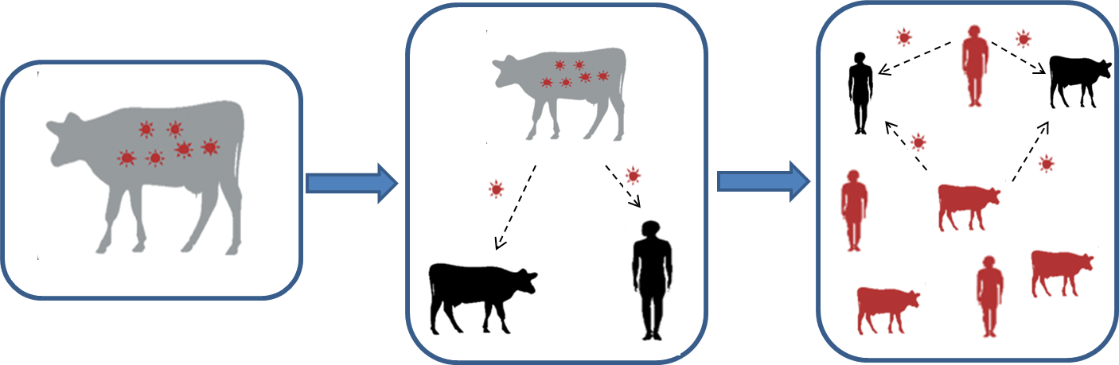

#### Figure 9.1 – Zoonotic Disease Model

Cattle may be a source of several zoonotic diseases that can cause severe disease in humans. It is important that people working with cattle have a basic understanding and awareness of the clinical signs of the disease as well as appropriate precautions and actions needed to prevent each disease. Some of these diseases also have the potential to be used in bioterrorist activities. Good biosecurity and personal hygiene practices reduce the risk of human illness. More information on specific diseases can be found in Annex A.

**Immunocompromised individuals** have an increased risk for contracting disease. For example, these individuals include pregnant women, chemotherapy patients, organ transplant recipients, persons with HIV/AIDS, and people with chronic diseases such as diabetes, among others. Individuals with compromised immune systems may not disclose medical conditions to employers. Educating workers on how to prevent transmission of zoonotic diseases will help reduce the risk of infection among those with compromised immune systems.

**Age** increases the risk of contracting a zoonotic disease. Children under the age of five, and the elderly are at particular risk. The 2007 Census of Agriculture reported the average age of today’s farmer is 57.1 and in Kansas, 35% of feedyard principal operators are 65 years or older. While there is no physiological definition of when a person is “older” or “elderly,” it is known that the immune system does not function as efficiently in older adults as it does in younger people. Illness may be more difficult to fight in this population, making prevention even more important.

**Immigrant workers** often come from countries with a higher prevalence of diseases resulting in compromised immune systems causing greater susceptibility to infection. Language barriers may cause miscommunication about risk of exposure. Work with knowledgeable translators to communicate the transmission methods and risk of exposure to zoonotic diseases. Keeping workers informed about zoonotic diseases will reduce the risk of infection.

**Veterinarians** possess the most knowledge and are a feedyard’s primary source of information on zoonotic diseases. Work with veterinarians to educate workers on the risk factors and methods of transmission of zoonotic diseases. Veterinarians and employers must share in the responsibility of education about zoonotic disease.

While the possibility of exposure and transmission of zoonotic diseases from animals to people cannot be totally eliminated, it can be minimized.

**Routine Biosecurity Plan for Zoonotic Disease**

|  |  |
| --- | --- |
| **Awareness Education:** | |
|  | Work with veterinarian or livestock extension specialists to get accurate and up-to-date information about zoonotic diseases |
|  | Educate anyone who works with animals about zoonotic disease risks |
|  | Provide information in both English and other primary languages (e.g., Spanish) as appropriate |
|  | Provide zoonotic disease educational materials in employee hiring packet |
|  | Post information for employees and visitors:  Define immunocompromised and list diseases or medical conditions that compromise immune systems  Speak proactively with employees regarding animal handling guidelines and recommendations  Provide handouts/brochures on zoonoses with resources for further information |

| **Personal Hygiene:** | |
| --- | --- |
|  | Provide hand washing facilities with warm running water, soap, clean towels and locate them next to animal contact areas |
|  | Post signs reminding staff to wash hands after handling animals |
|  | Check soap and towels, and replenish as necessary |
|  | Remind staff to wear gloves when possible |
|  | Keep employee eating and break areas separate from potentially contaminated environments |
|  | Ask workers to designate clothing for work and change after handling animals |

|  |  |
| --- | --- |
| **Personal Protective Equipment:** | |
|  | Provide employees with PPE:  Gloves, coveralls, boots  Mask, goggles |

**Heightened Biosecurity Considerations for Zoonotic Diseases**

Enact heightened biosecurity measures when there is a threat of a specific zoonotic disease. Not all diseases are zoonotic, and if the disease is not a risk to human health, (for example FMD), there is no reason to implement the recommended measures in this section. Identify actions needed to protect employees, visitors, and families in the event there is increased risk for a zoonotic disease outbreak. For more information, please see the *FAD PReP/NAHEMS Guidelines: Health and Safety (2011)* and *PPE (2011)*.

**Zoonotic risk** is not the same as biosecurity risk. Some diseases can pose a significant health risk to humans, but are not a significant risk to cattle health or are not highly contagious. *E. coli* 0157:H7 is an example of a high zoonotic risk, but low biosecurity risk. Conversely, some diseases like FMD are a high biosecurity risk, but are not a zoonotic risk.

Table 9.2 below lists some cattle diseases that are zoonotic. Annex A contains information about how these diseases are transmitted and Annex B lists additional information on selected diseases. The route of transmission is important in determining what protective measures to implement to protect humans from contracting disease. The recommended measures in the heightened biosecurity plan are separated by route of transmission. In a heightened zoonotic disease situation, implement plan measures warranted by the nature of the disease of concern.

For more details see the [Center for Food Security and Public Health](http://www.cfsph.iastate.edu/DiseaseInfo/index.php?lang=en) disease information website.

#### Table 9.2 – Zoonotic Cattle Diseases

|  |  |  |
| --- | --- | --- |
| Diseases Present in U.S. Cattle | | FADs |
| Anthrax  Brucellosis  *E. coli*  Giardia  Leptospirosis  Listeriosis | Pseudocowpox  Rabies  Ringworm  *Salmonella*  Tuberculosis  Q fever | Crimean Congo Hemorrhagic Fever  Japanese Encephalitis  Melioidosis  Rift Valley Fever  Screwworm |

**PPE** such as coveralls and gloves must be worn by personnel handling animals, tissues, and fluids. If a FAD is zoonotic, enhanced PPE may include goggles and an appropriate respirator (N-95 or N-99) or a full face shield if aerosolization is not a route of human exposure. See the *FAD PReP/NAHEMS Guidelines: Personal Protective Equipment (2011)* and associated SOP for more information.

Maintain heightened zoonotic disease protocols throughout the duration of the animal health emergency until animal health officials have eradicated or otherwise controlled the disease.

**Heightened Biosecurity Plan for Zoonotic Disease**

*Please review any recommended measures not implemented routinely and consider implementing them during heightened biosecurity operations*

|  |  |
| --- | --- |
| **Surveillance:** | |
|  | Inform all employees of the risk of contracting disease and the signs and symptoms of disease in humans |
|  | Instruct employees to report all signs and symptoms of disease in themselves and their family members and close contacts |

**Implement the following measures as necessary based upon the transmission route of the disease of concern.**

|  |  |
| --- | --- |
| **Aerosol Transmission:** | |
|  | Implement a dust control plan |
|  | Inform employees that contaminated soil can be a source of zoonotic disease |
|  | Require employees to wear an N-95 or N-99 mask when handling infectious animals or their tissues |
|  | Require employees to wear a respirator when power washing |

|  |  |
| --- | --- |
| **Vector Transmission:** | |
|  | See Chapter 15: Vector Control for recommended measures for vector control |

| **Direct Contact/Fomite Transmission:** | |
| --- | --- |
|  | Implement the following policies regarding gloves:  Wear gloves when working with animals with sick or unknown health status,  Wash hands after removing gloves |
|  | Implement the following policies regarding clothing:  Require clean coveralls be worn in animal areas  Restrict feedyard work clothing from being worn outside facility  Provide laundry/uniform service or laundry facilities on feedyard |
|  | Implement the following policies regarding boots  Require clean boots in animal areas  Provide a boot bath or wash bucket and brush at the entrance/exit for ease of cleaning or replace with a trashcan and utilize plastic boot covers.  Wash hands after removing boots |
|  | Regularly clean equipment |
|  | Wash and disinfect grooming equipment regularly and immediately if used on horses with skin lesions |
| For more information, see Chapter 16: Cleaning and Disinfection | |

|  |  |
| --- | --- |
| **Oral Transmission:** | |
|  | Employ a manure management plan |
|  | Properly handle and store manure |
|  | Prevent manure from contaminating drinking water |
|  | Remind staff to maintain good personal hygiene |
|  | Remind staff to wash hands after animal contact, before eating, and drinking |

Chapter 1: Biosecurity Overview

Chapter 2: Biosecurity Assessment

Chapter 3: Employee Policies

Chapter 4: Crisis and Risk Communications

Chapter 5: Coordination with Animal Health Agencies and Local Government

Chapter 6: Visitor Control

Chapter 7: Foreign Travel

Chapter 8: Movement On and Off the Property

Chapter 9: Zoonotic Diseases

**Chapter 10: Record Keeping**

Chapter 11: Animal Handling and Contact

Chapter 12: Disease Detection and Surveillance

Chapter 13: Feral Animal and Wildlife Management

Chapter 14: Physical Security

Chapter 15: Vector Control

Chapter 16: Cleaning and Disinfection

**Page Intentionally Left Blank**

# Chapter 10: Record Keeping

**Routine Biosecurity Considerations for Record Keeping**

Record keeping is a key component in maintaining routine biosecurity on a cattle feedyard. There are several software programs designed specifically for maintaining records at commercial cattle operations; however, pen and paper can be an effective record keeping system as well. Feedyards need to keep records of the business operations that pertain to biosecurity, including: 1) products and inventory, 2) animal identification, 3) treatment records, 4) animal purchase, sale or transfer and 5) personnel contact and vehicle information and 6) visitor sign-in forms. Keep records in a uniform manner and update as needed, or anytime animals are treated.

**Product and inventory** records are essential for biosecurity purposes. Maintain a record of product lot or serial numbers in case of a manufacturer’s recall. This will help identify both the tainted products and the animals that were administered the product. Keep records of product inventory and use products before expiration date. Maintain an inventory of keys for doors and locks to keep track of personnel who have access to pharmaceuticals, additives, and hazardous materials. Limit the potential for sabotage by only allowing authorized personnel access to storage areas and use the Animal Health Products Inventory Form, Pharmaceuticals and Hazardous Materials Storage Area Access Log, and the Door or Lock Key Inventory Form.

**Animal identification** is essential for disease tracking and helps reduce the number of animals that need to be investigated, the time needed to respond, and decreases the cost to producers and the government. Individual tagging of cattle is the best means of facilitating disease tracing; however, tagging animals by home pen is also acceptable. When cattle are received; record the animal identification number, breed, sex, source, and the trucking company used for transport on the Cattle Receiving Log. Keep these records for at least five years.

**Animal treatment records** help identify the origin and extent of a disease outbreak. It is important to routinely record all illness and treatment of cattle because outbreaks may not be recognized in the earliest stages. Maintain thorough animal health records to assist the veterinarian in making recommendations or adjusting treatment protocols. Use the Animal Health Record Form when dispensing veterinary pharmaceuticals or administering treatment.

**Purchase, sale, or transfer of cattle** **records** are also necessary for disease traceability. Many cattle diseases, such as bovine tuberculosis (bTB), are not identified until after slaughter. Maintain purchase, sale and transfer records for at least five years, so the animal’s origin and dates of possession can be determined. Record the transfer of cattle within feedyards and animal movement history on the Cattle Movement Record to aid in disease outbreak investigations.

**Vehicle and contact information** of all visitors and employees that access the feedyard will facilitate timely determination of exposure to an outbreak. In an outbreak of a highly contagious zoonotic disease outbreak, public health officials may recommend performing diagnostic testing on personnel and visitors. Maintaining current contact information for employees and feedyard visitors are essential for surveillance measures. Record the contact and vehicle information for all visitors, delivery, sales, and service representatives on the Visitor Sign-In Form in Chapter 6: Visitor Control. See Chapter 3: Employee Policies for the Employee Biosecurity Information Form.

**Employee training** on topics such as how to recognize signs and symptoms of disease, and required roles and responsibilities during a heightened biosecurity event is important. Distribute an Employee Training Log to employees to record training attendance. Maintain records to ensure personnel are educated on matters pertinent to facility biosecurity. For more information about training, see Chapter 3: Employee Policies.

**Routine Biosecurity Plan for Record Keeping**

|  |  |
| --- | --- |
| **Animal Identification:** | |
|  | Upon receipt of cattle, record the:   * Animal ID (back tag/ear tag information) * Age * Breed * Sex * Source/Origin * Trucking company used for transport   See Cattle Receiving Log for an example |
|  | Maintain records for a minimum of 5 years |

|  |  |
| --- | --- |
| **Inventory Security:** | |
|  | Inventory pharmaceuticals, hazardous materials, chemicals, and feed additives. When shipments are received, record the:   * Date * Quantity * Supplier/Distributer * Product name * Lot/Serial number * Expiration date   See Animal Health Products Inventory Form for an example |
|  | Maintain an access log for product and ingredient storage areas and require employees to sign-in when accessing the storage facility or area where hazardous materials, feed ingredients, pharmaceuticals and pesticides are stored  See Pharmaceuticals and Hazardous Materials Storage Area Access Log for an example |

| **Animal Treatment Records:** | |
| --- | --- |
|  | Keep records of animal treatment for at least 5 years from the date of transfer or sale of cattle |
|  | Store paper records in a fire-proof safe or electronically off-site |
|  | Treatment records will contain the following information:   * Animal or group identification * Treatment date * Diagnosis and associated treatment * Product administered (include manufacturer) * Product lot/serial number * Dose given * Route of administration (Intramuscular, Subcutaneous, etc.) * Location of injections * Earliest date the animal could clear withdrawal time * Name or initials of person who administered the drug |
| See Animal Health Record Form for example | |

|  |  |
| --- | --- |
| **Purchase, Transfer or Sale of Cattle:** | |
|  | Keep records and store at the _________________________________. for at least 5 years from the date of transfer of cattle |
| See Cattle Movement Record for example | |

| **Vehicle and Contact Information:** | |
| --- | --- |
|  | Keep contact information of all feedyard personnel and associated personal vehicles |
|  | Keep personnel records up-to-date and retain for at least 12 months |
|  | Keep a log of all visitors to the feedyard by requiring visitors to sign-in at the office |
|  | Keep a log of delivery vehicles and service or sales representative visits by requiring drivers and representatives to sign-in at the office |
| See Visitor Sign-in Form in Chapter 6: Visitor Control and Employee Biosecurity Information Form in Chapter 3: Employee Policies for examples | |

|  |  |
| --- | --- |
| **Personnel Training:** | |
|  | Require employees to sign-in when receiving training or education, store copies of training log at the _________________________________. |
| See Employee Training Log as an example | |

**Heightened Biosecurity Considerations for Record Keeping**

If there is a suspected or confirmed FAD outbreak in the United States, state and federal regulations can result in increased reporting requirements. Keeping accurate and comprehensive records as part of routine record keeping is essential during an outbreak to facilitate tracing of animals and possible exposure to disease. Routine records can assist management in identifying visitors, personnel, feed, products, equipment and vehicles in the event of a heightened biosecurity situation. Movement records of animals, visitors and personnel may be required to verify or exclude exposure to disease.

**Animal identification and traceability** play a key role in disease surveillance, control, eradication, and continuity of business. Maintaining records of animal origin as part of routine record keeping will help expedite disease investigations. See Routine Biosecurity Considerations for Record Keeping for additional information.

**Animal treatment records** are especially important during disease outbreaks. Keep accurate treatment and vaccination records during an outbreak situation because proof of negative disease status or vaccination may be required.

**Animal purchase, sale or transfer records** are important to help eliminate or confirm exposure to a disease outbreak. Keep routine records of cattle purchase, sale, transfer and movement, including origin and the trucking company used for transport.

**Vehicle and contact information** for all feedyard visitors and employees can be used to trace exposure to disease. Recording vehicles that access feedyard property can help exclude or confirm exposure to disease. In the event of an outbreak, require visitors to disclose recent travel by completing the Heightened Biosecurity Visitor Sign-In Form found in Chapter 6: Visitor Control. Public health officials may recommend performing diagnostic testing on personnel and visitors in the event of a zoonotic disease. Maintaining current contact information for employees and retaining visitor logs is essential for surveillance measures. See Chapter 3: Employee Policies for employee forms.

Maintain heightened record keeping protocols throughout the duration of the animal health emergency until animal health officials have eradicated or otherwise controlled the disease.

**Heightened Biosecurity Plan for Record Keeping**

*Please review any recommended measures not implemented routinely and consider implementing them during heightened biosecurity operations*

|  |  |
| --- | --- |
| **Animal Identification:** | |
|  | In the event of a heightened biosecurity animal health event, reevaluate the use of individual tagging to track the movement and treatment of animals |
|  | Use livestock marking chalk, hang tags with individual number, or radio-frequency identification (RFID) ear tags to visually distinguish processed or treated cattle and return to home pen, or isolate from non-treated cattle in hospital pens |
|  | Keep thorough cattle identification records including date of introduction, cattle origin and the trucking company used to transport |
| See Animal Health Record Form and Cattle Receiving Log as an example | |

|  |  |
| --- | --- |
| **Animal Treatment Records:** | |
|  | Ensure all non-routine treatments or vaccines administered are recorded on a treatment form or in a computerized cattle health management system, to ensure appropriate withdrawal times are observed |
| See Animal Health Record Form as an example | |

| **Purchase, Sale or Transfer of Cattle:** | |
| --- | --- |
|  | Maintain thorough and accurate records of animal transfer and movement as part of routine record keeping |
|  | Document all animal movements, including the dates of introduction, where the animal was moved from, reason for move and the trucking company transporting the animals |
|  | Treat each feedyard location as a separate premises for record keeping purposes |
| See Cattle Movement Record as an example | |

|  |  |
| --- | --- |
| **Vehicle and Contact Information:** | |
|  | Maintain a sign-in sheet of all visitors, vehicles and equipment that access the premises (including state and federal emergency response officials, vehicles and equipment), record keeping will assist with disease surveillance and tracking  See Heightened Biosecurity Visitor Sign-in Form in Chapter 6: Visitor Control |
|  | Maintain a sign-in sheet of all employees and their vehicles that access the premises, record keeping will assist with disease surveillance and tracking  See Employee Biosecurity Information Form in Chapter 3: Employee Policies as an example |

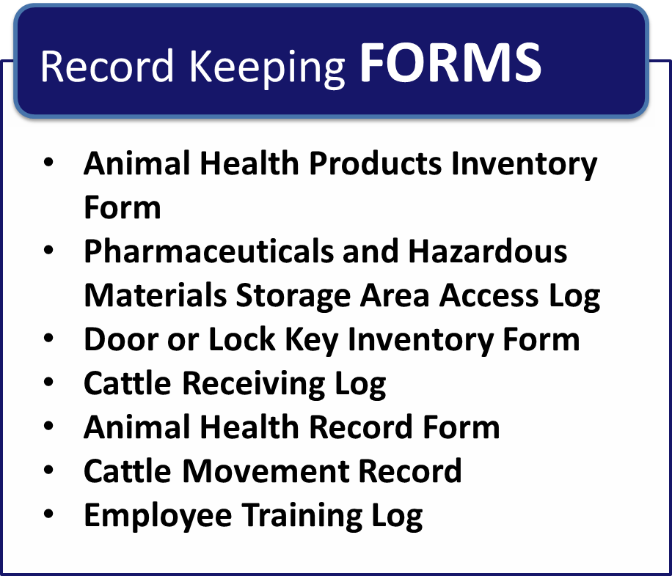

**Page Intentionally Left Blank**

##### Animal Health Products Inventory Form

| **Date Received** | **Supplier/ Distributor** | **Product Name** | **Quantity**  **Received** | **Lot #/**  **Serial #** | **Expiration Date** |
| --- | --- | --- | --- | --- | --- |
|  |  |  |  |  |  |
|  |  |  |  |  |  |
|  |  |  |  |  |  |
|  |  |  |  |  |  |
|  |  |  |  |  |  |
|  |  |  |  |  |  |
|  |  |  |  |  |  |
|  |  |  |  |  |  |
|  |  |  |  |  |  |
|  |  |  |  |  |  |
|  |  |  |  |  |  |
|  |  |  |  |  |  |
|  |  |  |  |  |  |
|  |  |  |  |  |  |
|  |  |  |  |  |  |
|  |  |  |  |  |  |
|  |  |  |  |  |  |
|  |  |  |  |  |  |
|  |  |  |  |  |  |

**Page Intentionally Left Blank**

##### Pharmaceuticals and Hazardous Materials Storage Area Access Log

| **Date** | **Name** | **Product Name** | **Quantity Removed** | **Initials** |
| --- | --- | --- | --- | --- |
|  |  |  |  |  |
|  |  |  |  |  |
|  |  |  |  |  |
|  |  |  |  |  |
|  |  |  |  |  |
|  |  |  |  |  |
|  |  |  |  |  |
|  |  |  |  |  |
|  |  |  |  |  |
|  |  |  |  |  |
|  |  |  |  |  |
|  |  |  |  |  |
|  |  |  |  |  |
|  |  |  |  |  |
|  |  |  |  |  |
|  |  |  |  |  |
|  |  |  |  |  |
|  |  |  |  |  |
|  |  |  |  |  |

**Page Intentionally Left Blank**

##### Door or Lock Key Inventory Form

| **Date Key Issued** | **Name of Employee** | **Key Issued for Access to:** | **Number on Key** | **Employee Initials** | **Date Key Returned** | **Employee Initials** |
| --- | --- | --- | --- | --- | --- | --- |
|  |  |  |  |  |  |  |
|  |  |  |  |  |  |  |
|  |  |  |  |  |  |  |
|  |  |  |  |  |  |  |
|  |  |  |  |  |  |  |
|  |  |  |  |  |  |  |
|  |  |  |  |  |  |  |
|  |  |  |  |  |  |  |
|  |  |  |  |  |  |  |
|  |  |  |  |  |  |  |
|  |  |  |  |  |  |  |
|  |  |  |  |  |  |  |
|  |  |  |  |  |  |  |

**Page Intentionally Left Blank**

##### Cattle Receiving Log

**Pen #: __________________ Lot #: ________________________**

| **Date** | **Animal ID** | **Age** | **Breed** | **Sex** | **Source** | **Transport Company** | **Other** |
| --- | --- | --- | --- | --- | --- | --- | --- |
|  |  |  |  |  |  |  |  |
|  |  |  |  |  |  |  |  |
|  |  |  |  |  |  |  |  |
|  |  |  |  |  |  |  |  |
|  |  |  |  |  |  |  |  |
|  |  |  |  |  |  |  |  |
|  |  |  |  |  |  |  |  |
|  |  |  |  |  |  |  |  |
|  |  |  |  |  |  |  |  |
|  |  |  |  |  |  |  |  |
|  |  |  |  |  |  |  |  |
|  |  |  |  |  |  |  |  |
|  |  |  |  |  |  |  |  |
|  |  |  |  |  |  |  |  |
|  |  |  |  |  |  |  |  |
|  |  |  |  |  |  |  |  |
|  |  |  |  |  |  |  |  |
|  |  |  |  |  |  |  |  |
|  |  |  |  |  |  |  |  |

**Page Intentionally Left Blank**

##### Animal Health Record Form

**Animal #:_________________________________________**

**Cattle Lot #:_______________________________________ Pen #:_____________________ Number of Head: ___________**

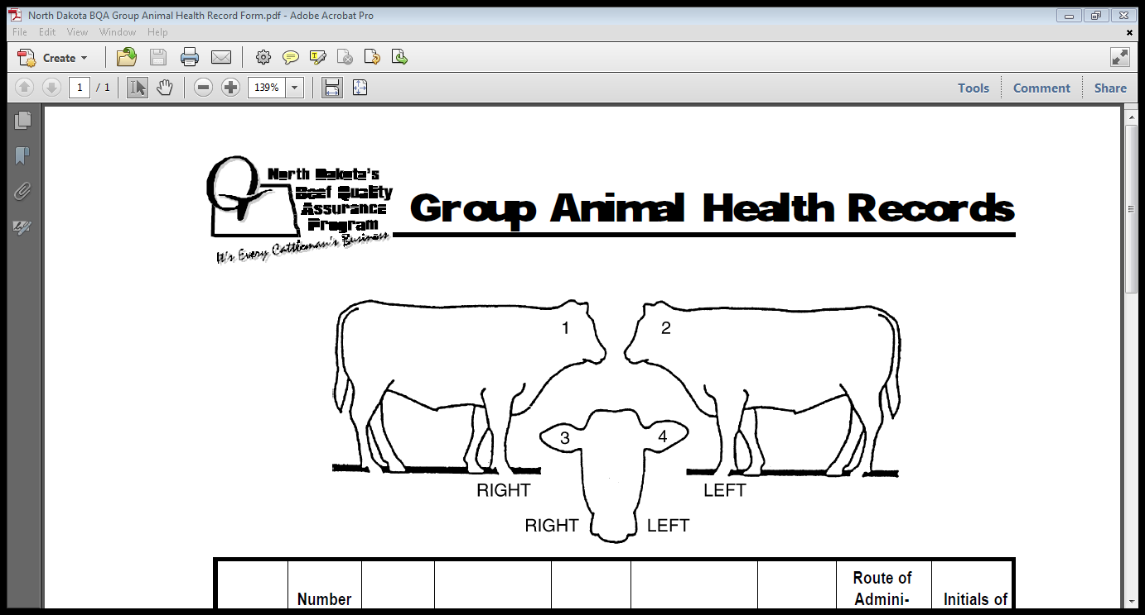

| **Date** | **Animal or Group ID #** | **Diagnosis/Treatment** | **Product & Manufacturer** | **Lot #/Serial #** | **Dose** | **Route of Administration** | **Injection Location** | **Earliest WD Date** | **Initials of Treatment Administrator** |
| --- | --- | --- | --- | --- | --- | --- | --- | --- | --- |
|  |  |  |  |  |  |  |  |  |  |
|  |  |  |  |  |  |  |  |  |  |
|  |  |  |  |  |  |  |  |  |  |
|  |  |  |  |  |  |  |  |  |  |
|  |  |  |  |  |  |  |  |  |  |
|  |  |  |  |  |  |  |  |  |  |

**Page Intentionally Left Blank**

##### Cattle Movement Record

**Cattle Lot #:_____________ Pen #:___________ Number of Head: ___________**

| **Date** | **Moved From** | **Moved To** | **Reason for Move** | **Transport Company** | **Employee Initials** |
| --- | --- | --- | --- | --- | --- |
|  |  |  |  |  |  |
|  |  |  |  |  |  |
|  |  |  |  |  |  |
|  |  |  |  |  |  |
|  |  |  |  |  |  |
|  |  |  |  |  |  |
|  |  |  |  |  |  |
|  |  |  |  |  |  |
|  |  |  |  |  |  |
|  |  |  |  |  |  |
|  |  |  |  |  |  |
|  |  |  |  |  |  |
|  |  |  |  |  |  |
|  |  |  |  |  |  |
|  |  |  |  |  |  |
|  |  |  |  |  |  |
|  |  |  |  |  |  |
|  |  |  |  |  |  |
|  |  |  |  |  |  |
|  |  |  |  |  |  |
|  |  |  |  |  |  |

**Page Intentionally Left Blank**

##### Employee Training Log

| **Employee Name (Printed)** | **Employee Signature** | **Area(s) of Responsibility** | **Type of Training** | **Training Description** |
| --- | --- | --- | --- | --- |
|  |  |  |  |  |
|  |  |  |  |  |
|  |  |  |  |  |
|  |  |  |  |  |
|  |  |  |  |  |
|  |  |  |  |  |
|  |  |  |  |  |
|  |  |  |  |  |
|  |  |  |  |  |
|  |  |  |  |  |
|  |  |  |  |  |
|  |  |  |  |  |
|  |  |  |  |  |
|  |  |  |  |  |
|  |  |  |  |  |
| **Trainer Name (printed): ______________________ Title: __________________________**  **Trainer Signature: __________________________ Date: __________________________** | | | | |

**Page Intentionally Left Blank**

Chapter 1: Biosecurity Overview

Chapter 2: Biosecurity Assessment

Chapter 3: Employee Policies

Chapter 4: Crisis and Risk Communications

Chapter 5: Coordination with Animal Health Agencies and Local Government

Chapter 6: Visitor Control

Chapter 7: Foreign Travel

Chapter 8: Movement On and Off the Property

Chapter 9: Zoonotic Diseases

Chapter 10: Record Keeping

**Chapter 11: Animal Handling and Contact**

Chapter 12: Disease Detection and Surveillance

Chapter 13: Feral Animal and Wildlife Management

Chapter 14: Physical Security

Chapter 15: Vector Control

Chapter 16: Cleaning and Disinfection

**Page Intentionally Left Blank**

# Chapter 11: Animal Handling and Contact

**Routine Biosecurity Considerations for Animal Handling and Contact**

A fundamental practice for controlling disease exposure is limiting animal contact through segregation of various groups of animals. Sick animals and new arrivals pose the greatest risk; however, disease transmission can result from contact between seemingly healthy animals from different sources, of different ages, or at different production stages. The properties of various diseases and the health status of the herd are crucial considerations in biosecurity planning. The extent and effectiveness of biosecurity measures will depend on how these significant variables are addressed.

**New animals** are the primary source of disease on a feedyard. New cattle can be infected with a disease without showing signs right away. For example, animals exposed to the FMD virus can take as long as 14 days before signs of illness are exhibited. The most certain way to prevent introducing a new disease would be to maintain a “closed herd.” Knowing that this is not an option in a feedyard, limit the number of consignments that make up a home pen. Keep newly-arrived animals in a specific section of the yard. Continual introductions to an established group of animals result in social stress (which increases susceptibility to disease) and repeated exposure to new pathogens.

Limit purchases to the minimal number of sources possible, preferably those with a known and trusted herd health program. Producers can use risk categorization to determine the level of acceptable biosecurity risk compared to cost. Figure 11.1 below depicts an example of risk categorization.

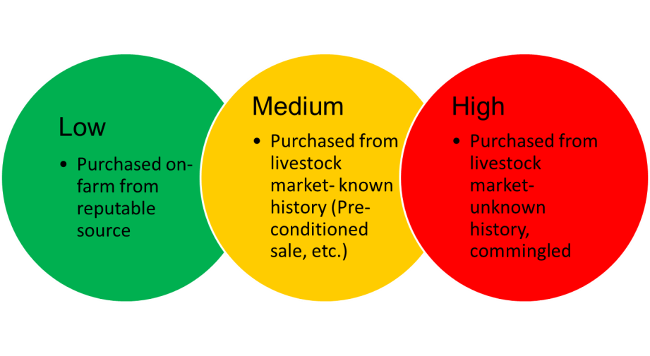

#### Figure 11.1 – New Animal Biosecurity Risk Groups

**Sick animals** need to be identified quickly and promptly separated from healthy animals**.** Prevent further stress on sick animals by providing clean, well-maintained and isolated locations. Strive to maintain a separate isolation facility for each production group (e.g., cattle on feed for 1-30 days and 31 days – finished) and disease. Frequently observe animals for symptoms to detect a disease early and prevent its spread.

Do not use the same treatment areas for healthy animals as sick animals. If this is not possible, thoroughly clean and disinfect facility and equipment after treatment of ill animals. See Chapter 16: Cleaning and Disinfection for more information.

Humanely euthanize animals that are not going to recover in a timely manner, as these animals can serve as a reservoir for many disease organisms.

**Deadstock** can be a reservoir for many disease organisms. Dead animals need to be disposed of promptly and properly so predators, wild birds, etc. do not spread disease. Have a veterinarian or trained personnel necropsy animals that died of unknown causes to help identify a potentially infectious disease.

Develop protocols for handling and removing deadstock. Carcass disposal options vary, and typically there is no one-preferred way. Consider using rendering services, where available, as it is an easy, safe, and cost effective method. However, because rendering trucks can introduce disease to the yard, pre-identify carcass staging areas as far away as possible from healthy livestock, preferably at the perimeter of the feedyard. Review applicable federal, state and local regulations for disposal options.

**Working horses** are critical to the workforce of feedyards. The best biosecurity practice is to have horses live permanently at the facility. However, some operations allow horses to return home with owners, to transport and ride in events (e.g., cattle roping competitions, rodeos, etc.). These activities allow physical contact with other animals of unknown health status, which presents risk to the feedyard. Documenting horse movement on and off the feedyard is necessary in a disease outbreak for possible disease traceability. Take a proactive approach to monitor the movement and health status of horses to ensure livestock are not subject to unnecessary health risks.

**Animal contact** creates a potential for spreading disease from affected to susceptible animals. Treat, feed, or handle the most susceptible animals first and sick animals last; while taking appropriate disinfection precautions between groups. When diagnosis is uncertain or a disease of severe consequence is suspected (i.e., FAD), stop animal movement and require a veterinarian examine affected animals, perform necropsies, and collect and submit proper diagnostic samples.

Implement measures to minimize contact between cattle and other animals by preventing fence line contact between feedyard cattle and neighboring livestock. A physical security, and wildlife and feral animal contact prevention plan should also be in place. For more information, see Chapter 14: Physical Security and Chapter 13: Feral Animals and Wildlife Management.

**Routine Biosecurity Plan for Animal Handling and Contact**

|  |  |
| --- | --- |
| **Stock Purchases:** | |
|  | Purchase feeder calves from preferred suppliers with a quality assurance program including a biosecurity component |
|  | Ensure vendor provides a record detailing origin of purchased cattle |
|  | Prior to purchase, check best practice guidelines for specific diseases and request appropriate declarations regarding the health status, herd health program, or preconditioning of purchased cattle |

|  |  |
| --- | --- |
| **New Animals:** | |
|  | Inspect cattle on arrival to assess animal health status |
|  | Individually identify all cattle as soon as possible after arrival, ensuring identification can be cross-referenced to origin and movement for trace back purposes |
|  | Minimize the mixing of newly arrived cattle with other stock during the introductory period |

| **Sick Animals:** | |
| --- | --- |
|  | Isolate all animals with the following symptoms immediately to prevent contact with other susceptible animals:  Reluctance to come to the bunk to eat  Standing at the bunk but not eating  Separating themselves from the group  Appearing lethargic  Increased respiratory rate  Nasal discharge  Sunken eyes  Lameness  Other abnormal symptoms such as excessive drooling, neurologic disorders, and/or abnormally high sickness/death rates |
|  | Do not allow any animal to come into contact with urine, saliva, or fecal discharge of suspect animals |
|  | Maintain separate treatment areas for sick animals and processing areas for healthy/new cattle |
|  | Do not use the same treatment areas for healthy animals as sick animals |
|  | Thoroughly clean and disinfect facility and equipment after treatment of ill animals. See Chapter 16: Cleaning & Disinfection for more information on cleaning and disinfection. |

|  |  |
| --- | --- |
| **Deadstock:** | |
|  | Dispose of deadstock in accordance with documented procedures taking into account environmental and public considerations |
|  | Maintain dead stock in an enclosed area to prevent predators, wild birds, etc. from coming into contact with the carcass |
|  | Identify/assign pre-staged carcass pickup location near facility perimeter |
|  | Have a veterinarian, or other trained person, perform a necropsy on any animals that die from suspicious causes. Trained personnel that conduct a necropsy should immediately contact a vet, if the cause of death is not known |

| **Working Horses:** | |
| --- | --- |
|  | Maintain vaccination and health records for all working animals on the feedyard |
|  | Require all owners/responsible parties to inform management before transporting horses on or off the feedyard |
|  | Have employees inform management if horses will be taken to a location where horses may come into contact with non-feedyard horses or cattle |

| **Animal Contact:** | |
| --- | --- |
|  | Do not allow contact between feedlot animals and outside animals |
|  | Provide as much distance between cattle and neighboring animals as possible |
|  | Consider double fencing the perimeters to minimize nose-to-nose contact |
|  | Ensure perimeter fences are maintained to minimize exposure of cattle at the feedyard to stock in adjoining areas |
|  | Ensure feedyard internal fences are maintained to minimize accidental mixing of cattle within the feedyard |
|  | Prohibit all non-essential visitor contact with animals |
|  | Ensure essential visitors (e.g., veterinarians, nutritionists, animal health officials) follow biosecurity guidelines |
|  | Prevent contact between animals of differing status (newly arrived cattle versus long day cattle) |
|  | Minimize switching animals between pens |
|  | Limit sharing of water sources to prevent orally spreading diseases between pens of cattle |
|  | Clean water troughs on a regular basis to remove algae and organic matter |
|  | Ensure adequate space for the number of animals that utilize feed, water, and shade sources |
|  | Minimize stacking of stressful events (e.g., handling cattle multiple times on the same day) |

**Heightened Biosecurity Considerations for Animal Handling and Contact**

Limit contact between the animals on feed and new animals during a heightened event. There is a serious, but lesser, transmission risk posed by people, material, conveyances, and other animals such as horses that may have been in contact with the disease and serve as mechanical vectors. Prevent contact with susceptible animals and minimize transmission risk through heightened biosecurity and cleaning and disinfection measures.

**Sick animal isolation** periods are determined by the disease of concern, the operation, and the animals at risk. In some cases, cattle with different diseases may be combined, (e.g., pneumonia cases may be comingled with foot rot cases). Limit this practice to the greatest extent possible. Sick animals, or those recovering from a disease, are more susceptible to infection with another disease and thus require extra care during a heightened disease situation. See Chapter 12: Disease Detection and Surveillance for more information.

**Deadstock management** is a key component of a successful heightened biosecurity plan. Mortalities may be much higher than normal during a FAD outbreak. This can be directly from disease or the culling of animals. Selection of a disposal method depends on the disease, local conditions and regulations, and the number of animals. Disposal challenges included: concerns over time needed to depopulate and finding enough land mass to bury carcasses.

Develop contingency carcass management plans for both routine deadstock and mass depopulation. For example, in situations involving mass depopulation, rendering services can be quickly overwhelmed or transportation of carcasses may be prohibited due to movement restrictions. Have backup plans, preferably on-site disposal plans, in place to manage routine deadstock in case normal disposal options are not available.

**Working horses** should be quarantined in the event of a disease outbreak affecting both cattle and horses (e.g., vesicular stomatitis). In the case of vector-borne diseases like vesicular stomatitis, direct contact is not a main route of transmission, so interactions between horses and cattle could still occur. If disease can be spread via direct contact, monitor horses for signs of disease and limit contact with cattle. For diseases spread via fomite (e.g., foot-and-mouth disease), a horse’s tack (bridle, saddle, blanket) or hooves could become contaminated with manure or saliva from infected cattle and may carry disease pathogens between groups of animals in different pens and other areas of the operation. Follow the advice of regulatory officials and veterinarians regarding contact between working animals and cattle. Consider the use of alternative means for monitoring cattle, such as all-terrain vehicles (ATVs) that can be cleaned between pens.

Maintain heightened animal handling protocols throughout the duration of the animal health emergency until animal health officials have eradicated or otherwise controlled the disease.

**Heightened Biosecurity Plan for Animal Handling and Contact**

*Please review any recommended measures not implemented routinely and consider implementing them during heightened biosecurity operations*

|  |  |
| --- | --- |
| **New Animals:** | |
|  | Quarantine animals recently purchased for a minimum of two incubation periods for disease of concern |
|  | Restrict all new animal arrivals to one area of the feedyard; do not place new cattle in pens throughout the feedyard |
|  | Do not allow new additions to share water, feed or facilities with established animals |
|  | Temporarily stop receiving animals. Consult with veterinarian to determine appropriate duration. |

| **Sick Animals:** | |
| --- | --- |
|  | Implement disease surveillance measures and risk communication strategies to educate employees to identify signs and symptoms of disease |
|  | Monitor animals closely and frequently for any developing or continuing illness or signs of disease |
|  | Isolate sick animals from the pen to minimize disease spread |
|  | Isolate sick animals for a minimum two incubation periods of the disease |
|  | Contact your veterinarian immediately to examine sick animals |
|  | Where possible, separate home pens to prevent direct contact between high risk animals (for example, alleys or empty pens between pens newly arrived cattle) |
|  | Use separate facilities, equipment and staff to handle isolated livestock |
|  | Handle the isolated animals LAST |
|  | Clean and disinfect all equipment, clothing, boots, etc. that come into contact with ill animals |

| **Deadstock:** | |
| --- | --- |
|  | Develop a management plan for mass disposal of deadstock |
|  | Develop contingency disposal plans in case normal disposal measures are unavailable |
|  | Ensure that all federal, state and local disposal regulations are met  Kansas Department of Agriculture – Division of Animal Health (KDA-DAH) rules require that animals that die from a disease recognized as communicable by the veterinary profession must be disposed of within 24 hours by burial or burning. Animals dying from anthrax must be burned on-site within 24 hours of death.  Some diseases are reportable, and require contact of the KDA-DAH at 785-564-6601 prior to disposal. See Annex A for list of KDA-DAH reportable animal diseases. |

**Page Intentionally Left Blank**

Chapter 1: Biosecurity Overview

Chapter 2: Biosecurity Assessment

Chapter 3: Employee Policies

Chapter 4: Crisis and Risk Communications

Chapter 5: Coordination with Animal Health Agencies and Local Government

Chapter 6: Visitor Control

Chapter 7: Foreign Travel

Chapter 8: Movement On and Off the Property

Chapter 9: Zoonotic Diseases

Chapter 10: Record Keeping

Chapter 11: Animal Handling and Contact

**Chapter 12: Disease Detection and Surveillance**

Chapter 13: Feral Animal and Wildlife Management

Chapter 14: Physical Security

Chapter 15: Vector Control

Chapter 16: Cleaning and Disinfection

**Page Intentionally Left Blank**

# Chapter 12: Disease Detection and Surveillance

**Routine Biosecurity Considerations for Disease Detection and Surveillance**

Many diseases are already present in North American cattle but do not cause a high degree of illness and/or deaths. For some diseases, the monetary consequences may be severe even if sickness and mortality are not. This can be the result of a loss of consumer confidence, the cost of diagnosis, treatment and intervention (vaccination etc.), and potential carcass management costs. Additional losses may include human health costs such as medical care, lost productivity, and loss of employees (who may quit or be unable to return to work).

Medical treatments are administered to protect herds from disease; these measures are part of a *Feedyard Health Management Plan*. Biosecurity plans address physical, sanitary and other aspects of herd health and should be aligned with heard health management plans.

**Diagnostic sample collection and testing** is performed when a FAD is suspected. Veterinarians, animal health technicians, and other trained personnel should follow Standard Operating Procedures (SOPs) for sample collection, preservation, packaging, and shipment. More information on sample collection can be found in the heightened biosecurity section of this chapter.

**Sick animals** may exhibitthefollowing characteristics

1. Reluctance to come to the bunk to eat
2. Standing at the bunk but not eating
3. Separating themselves from the group
4. Appearing lethargic
5. Increased respiratory rate
6. Nasal discharge
7. Sunken eyes
8. Lameness
9. Other abnormal symptoms such as excessive drooling, neurologic disorders, and/or abnormally high sickness/death rates

Educate employees on the signs and symptoms of any diseases that are a concern to the operation. Check new cattle closely for signs of illness.

**Disease traceability** is fundamental to health management plans (medical treatments and vaccinations), and marketability in feedyards. Implement disease traceability measures such as individual tagging of all animals during routine biosecurity operations to prepare for a potential disease incident. Check the KDA-DAH website for current regulations regarding identification and tagging.

During an animal disease emergency event, it may be necessary to: locate the source of the animal(s) in question, identify premises on which the animal(s) previously resided, and source of other exposed or potentially exposed animals. Retain records of animal origin and movement to expedite disease investigations.

**Routine vaccinations** vary depending on prevalence of disease both in the feedyard area and in the origin of the cattle. Considerations for vaccine selection are safety, efficacy, necessity, and economics. Tailor protocols to needs based upon geographic location, feedyard industry sector, facility, and husbandry practices. Most cattle in feedyards receive vaccinations for common respiratory pathogens and for clostridial diseases.

**Routine Biosecurity Plan for Disease Detection and Surveillance**

|  |  |
| --- | --- |
| **Health Management Plan:** | |
|  | Ensure that the goals of this *Biosecurity Plan* are aligned with the *Feedyard Health Management Plan* |

|  |  |
| --- | --- |
| **Surveillance:** | |
|  | Train feedyard personnel to report sick animals  Ensure that all staff involved in the daily monitoring and handling of stock are aware of the importance of early detection of emerging diseases and know what to do if they suspect an animal may be exhibiting symptoms of such a disease  Inspect animals daily  Monitor daily feed intake for early identification of illness in the cattle  Contact the feedyard veterinarian immediately if unusual illness or signs are noticed |
|  | Perform necropsy on animals that died from unknown causes |
|  | Collect information on the health status and the source of any animal(s) brought onto the yard |
|  | Undertake routine monitoring of cattle in the feedyard for signs of sickness |

| **Sick Animals:** | |
| --- | --- |
|  | Isolate sick animals from the herd to minimize disease spread. Isolation should be, at a minimum, two incubation periods for the disease (consult your veterinarian) |
|  | Use separate facilities, equipment, and staff to handle isolated livestock  OR  If this is not possible, at a minimum, handle or visit the isolated animals last |
|  | Clean and disinfect all equipment, clothing, boots, etc. that come into contact with ill animals |
|  | Report cases of unusual sickness or death in the feedyard to your veterinarian or the local government veterinary officer |
|  | Comply with the requirements for initial investigation of unusual sickness and/or deaths as directed by the federal and state animal health agencies |
|  | Work with a veterinarian to develop treatment protocols and monitor response rates on routine visits to the yard |
|  | Train work crews to monitor treatment response rates and stay aware of treatment success even when a veterinarian is not on the yard |

|  |  |
| --- | --- |
| **Disease Traceability:** | |
|  | Individually tag all animals |
|  | Place a secondary identification on all animals that were treated for illness so they can be rapidly identified and more closely monitored once they have returned to their home pen |
|  | Keep records of all medical and vaccination treatments. (See Chapter 10: Record Keeping for forms) |

| **Routine Vaccination:** | |
| --- | --- |
|  | Implement protocols for routine vaccinations |

**Heightened Biosecurity Considerations for Disease Detection and Surveillance**

If there is a confirmed FAD outbreak in the United States, state and federal regulations may restrict movement and direct increased surveillance, testing, and reporting requirements. Within 48 hours of identification of the first animal and premises with disease (also known as the Index Case) a National Surveillance Plan will be implemented to define the extent of the FAD outbreak. The plan determines how to identify infected premises, how to confirm new cases quickly through a combination of observation and laboratory testing, and how to identify disease-free zones. If an area is determined to be a disease-free zone, movement restrictions and disease monitoring requirements lessen, easing the response effort in that area.

**Disease surveillance** is the process of monitoring susceptible animals for clinical signs of the identified FAD. Educate and require feedyard workers to report clinical signs of disease. Work with veterinarians and state officials to develop a feedyard specific disease surveillance plan (see the Disease Surveillance Plan Form). Also refer to the *FAD PReP/NAHEMS Guidelines and SOP: Surveillance, Epidemiology, and Tracing (2011)* for in depth information.

**Disease assessment reports** can be used to collect information about the outbreak, the signs and symptoms of disease, and disease countermeasures. Use the report to communicate to staff and other officials about the disease and to create targeted heightened biosecurity plans based upon the disease transmission route. See Annex A: Disease Table for more information on routes of transmission. To develop a disease assessment report, see Annex A: Disease Table, and the Disease Assessment Report Form. Annex B contains examples of completed disease assessment reports. Use the “Foot and Mouth Disease (FMD) Fact Sheet” as a handout to educate employees as necessary, see Annex D.

**Sick animals** are often first identified through changes in daily feed intakes. For example, due to lesions on the feet and in the mouth from the FMD virus, feed intake could decrease, triggering an alert and the need for closer investigation. Monitor cattle feed intakes and behavior closely during a heightened biosecurity period to identify and isolate sick animals as quickly as possible.

**Disease traceability** is critical to associate individual animals or herds of animals with accurate information on origin and contact history. Uniquely identifying individuals, pens, or herds of animals helps track movement and properly assign test results or other information for the emergency response. Packers may require proper vaccine and medication withdrawal information, and confirmation that cattle are not from a control area.

Be sure to account for potential routes of transmission information and consider possible contact with wildlife. Work with animal health officials to collect trace-back information. Typically, it will be necessary to collect trace-back information for a minimum of twice the length of the maximum incubation periods before onset of clinical signs of infected animals.

Collect trace-forward information up to time the quarantine ends. It is highly likely the index case will not be the first animal or premises that had infection or disease within the country or the area. Maximize efforts to determine the true index premises.

**Emergency vaccination strategies** may be considered in an FAD outbreak. If emergency vaccination crews are brought onto the feedyard, they are a potential source of spreading of disease. If using a service for routine vaccinations during a disease outbreak, follow biosecurity precautions and maintain strict records including: company name (if contract crews), crew member names, contact information, exposure to other livestock in the previous five days (the maximum time humans can carry foot-and-mouth disease virus in their nasal passages in a high exposure, research setting [[FAD PReP Beef Feedyard Industry Manual]).](https://www.aphis.usda.gov/animal_health/emergency_management/downloads/documents_manuals/beef_feedlot.pdf) Also record the name(s) of products, date(s) administered, and tag numbers of cattle vaccinated. This information may be needed to trace where a highly contagious FAD infection came from (trace back) or where it may have been spread to (trace forward).

**Diagnostic sample collection and testing** allows for the correct diagnosis and treatment to be implemented. These measures will be performed under the direction of the animal health authority. Inform employees about sampling procedures and teams that may be coming onto the feedyard. This information can be added as a part of the Disease Surveillance Plan. Like vaccination crews, sample collection crews are also a potential source for spreading disease.

In any FAD outbreak, require strict adherence to biosecurity and infection control procedures. Personnel handling animals, tissues, and fluids need to wear PPE such as coveralls and gloves. Utilize appropriate PPE for zoonotic diseases (see Chapter 9: Zoonotic Diseases for more information). Clean and disinfect equipment in the designated area prior to leaving the feedyard (see Chapter 16: Cleaning and Disinfection for more information).

Maintain heightened disease detection protocols throughout the duration of the animal health emergency until animal health officials have eradicated or otherwise controlled the disease.

**Heightened Biosecurity Plan for Disease Detection and Surveillance**

*Please review any recommended measures not implemented routinely and consider implementing them during heightened biosecurity operations*

|  |  |
| --- | --- |
| **Disease Surveillance:** | |
|  | Write a disease surveillance plan  See the Forms section for instructions on how to write a Disease Surveillance Plan |
|  | Do not bring animals onto the yard unless there is proof they are from disease-free areas |

|  |  |
| --- | --- |
| **Disease Assessment:** | |
|  | Write a disease assessment report  See the Forms section for instructions on how to write a Disease Assessment Report. Annex B contains examples of completed reports. |

| **Disease Traceability:** | |
| --- | --- |
|  | Identify animals that receive emergency vaccine |
|  | Keep a record of all animals’ entry and exit from the feedyard so potential contact with an infected animal can be traced back |
|  | Keep records of truck delivery routes (from animal purchase point to the feedyard) used by all cattle haulers to identify any animals which may have come from or driven through areas where disease is present (control areas) |
| See Chapter 10: Record Keeping for examples of forms which can be used to record these actions. | |

**Page Intentionally Left Blank**

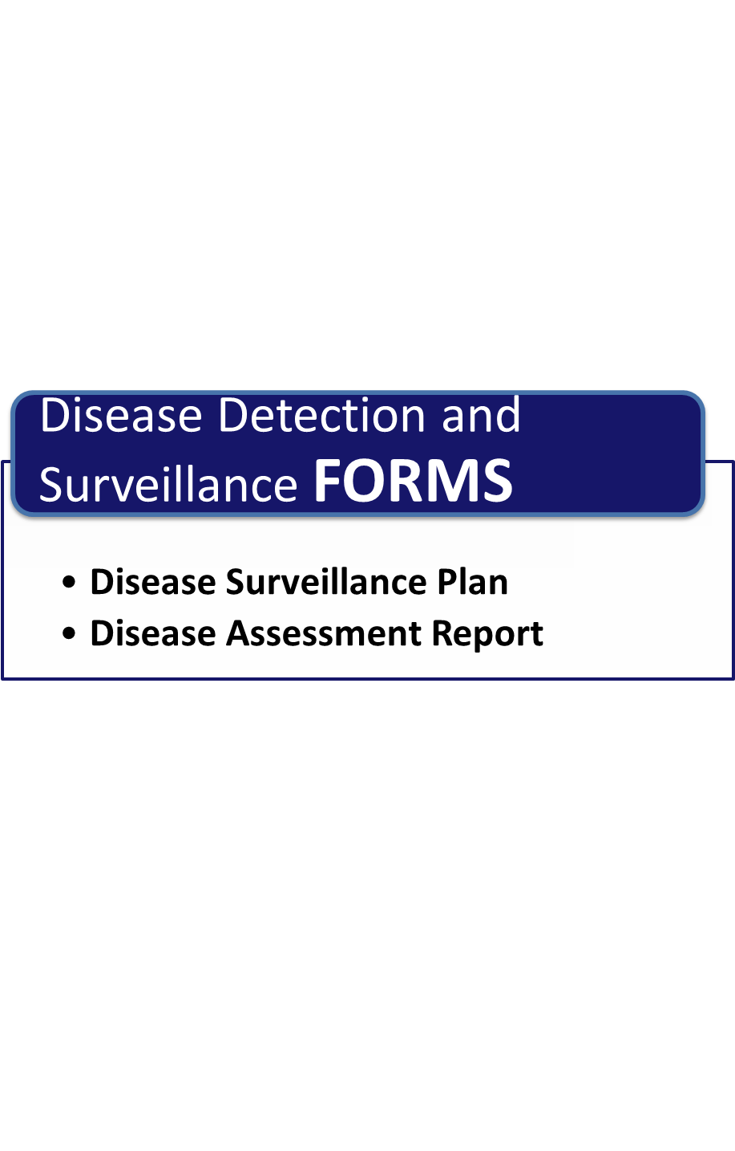

**Page Intentionally Left Blank**

##### Disease Surveillance Plan

*Give the form below to your veterinarian to help with the creation of a Disease Surveillance Plan. This plan explains how to identify and treat animals that are suspected of having an FAED and should be explained and given to employees working directly with animals.*

| **Disease Surveillance Plan for _________________________** |
| --- |
| **Case Definition** |
| *(Insert a case definition for “suspect” animals providing clinical signs that private practitioners and people in daily contact with livestock might use. The case definition will be provided by a veterinarian, the KDA or USDA. A “suspect” animal is one that shows signs of disease, but has no confirmed lab result.)* |
| **Reporting** |
| *(Provide information where employees should report concerns.)* |
| **Treatment of “Presumptive Positive” Animals** |
| *(Provide an explanation of how to treat and care for “presumptive positive” animals while awaiting diagnosis. A “presumptive positive” animal has clinical signs and a positive lab result)* |
| **Disease Tracing** |
| *(Provide a list of what disease tracing (epidemiological) information indicating the presence of the disease of concern.)* |
| **Actions to be Performed When there is a “Confirmed Positive” Animals** |
| *(Insert a list of actions, including notifications, which must be taken once an animal is “confirmed positive”. A “confirmed positive” animal is one from which the disease agent has been isolated and identified. This information will be provided by the Kansas Department of Agriculture or U.S. Department of Agriculture (USDA.)* |

##### Disease Assessment Report

*Work with veterinarian to fill in the boxes below to create a Disease Assessment Report. Examples of complete reports are available in* *Annex B**. The complete report should provide general background on a disease, and should be provided to employees and their families.*

|  |
| --- |
| **Disease Assessment Report for _________________________** |
| **Outbreak History** |
| *(Provide details of the outbreak history, specifically, information about when the outbreak began and where the outbreak is occurring. This information can come from a variety of reliable sources.)* |
| **Signs and Symptoms of Disease in Cattle** |
|  |
| **Signs and Symptoms of Disease in Humans** |
| *(Provide details of the signs and symptoms of the disease in humans if applicable. If the disease is not zoonotic, that information should be included as well.)* |

| **Disease Assessment Report for _________________________** |
| --- |
| **Mechanism for Spread of Disease** |
| *(Provide details of the route of transmission of the disease by choosing from the list below. More than one route may apply. Details on the route on transmission of many cattle disease can be found in* *Annex A**.)*  Aerosol  This disease can be spread through aerosol transmission. Aerosol transmission occurs when disease agents contained in droplets are passed through the air from one animal to another or from an animal to a human, or vice versa. Most pathogenic agents do not survive for extended periods of time within the aerosol droplets, and as a result, close proximity of infected and susceptible animals is required for disease transmission.  Direct Contact  This disease can be spread through direct contact. Transmission by direct contact requires the presence of an agent or organism in the environment or within an infected animal. A susceptible animal becomes exposed when the agent directly touches open wounds, mucous membranes, or the skin through blood, saliva, nose to nose contact, rubbing or biting.  Fomite  This disease can be spread through fomites. A fomite is an object that can carry disease agents from one susceptible animal to another. Examples of fomites include brushes, clippers, needles, balling guns clothing, feed or water buckets, and shovels. Traffic transmission is another special type of fomite transmission in which a vehicle, trailer, or human spreads organic material to another location.  Oral  This disease can be spread through oral means. Pathogenic agents can be transmitted to animals orally through consumption of contaminated feed, water, or licking/chewing on contaminated environmental objects. Feed and water contaminated with feces, urine or saliva are frequently the cause of oral transmission of disease agents. However, feed and water can be contaminated with other infectious agents as well such as ruminant protein in ruminant feed.  Vector-Borne Transmission  This disease can be spread through a vector. Vector-borne transmission occurs when an insect acquires a pathogen from one animal and transmits it to another. Fleas, ticks, mosquitoes, flies, and cockroaches are common vectors.  Environmental Transmission  This disease can be spread through the environment. This disease agent can survive for extended periods of time in soil or other organic material like bedding, old feed, etc. Animals can then acquire the disease agent from the environment through inhalation of aerosolized microbes, via oral consumption, or from direct contact with an animal or with fomites. The routes the disease agent uses to get into the animal can be controlled if the animal's environment is controlled.  Zoonotic  Zoonotic diseases are transmissible between animals and humans. Human exposure to zoonotic diseases may occur through any of the six routes of transmission discussed previously. Because of public health concerns, the zoonotic risk of a particular pathogenic agent should be considered in a biosecurity risk assessment. |
| **Medical Countermeasures** |
| *(Provide details of available medical countermeasures.)* |
| **Sanitary Countermeasures** |
| *(Provide details of available sanitary countermeasures.)* |

**Page Intentionally Left Blank**

Chapter 1: Biosecurity Overview

Chapter 2: Biosecurity Assessment

Chapter 3: Employee Policies

Chapter 4: Crisis and Risk Communications

Chapter 5: Coordination with Animal Health Agencies and Local Government

Chapter 6: Visitor Control

Chapter 7: Foreign Travel

Chapter 8: Movement On and Off the Property

Chapter 9: Zoonotic Diseases

Chapter 10: Record Keeping

Chapter 11: Animal Handling and Contact

Chapter 12: Disease Detection and Surveillance

**Chapter 13: Feral Animal and Wildlife Management**

Chapter 14: Physical Security

Chapter 15: Vector Control

Chapter 16: Cleaning and Disinfection

**Page Intentionally Left Blank**

# Chapter 13: Feral Animals and Wildlife Management

**Routine Biosecurity Considerations for Feral Animals and Wildlife Management**

Rodents, feral animals, and wildlife can be a significant source of disease on a feedyard. Mobility allows them to spread disease both on and off premises. The threat posed by animals may be overlooked due to their small size and nocturnal activity. Controlling rodents and wildlife is difficult because of the open design of feedyards where food, water, and waste are easily accessible. Preventing feral animals and wildlife from entering the premises is the best strategy to mitigate the threat to livestock.

Feral animals and wildlife can acts as fomites by carrying disease causing organisms on their fur, feathers or feet. Birds and rodents can spread diseases for a short time and distance and can also contaminate feed and water sources with their urine and/or feces. Additionally, some diseases can be spread from feral animals and wildlife through insect vectors. For more information on how biosecurity measures can prevent the transmission of disease by targeting vectors see Chapter 15: Vector Control.

**Rodents and vermin** (e.g., rats, mice, and rabbits) spread diseases from contaminated areas to uncontaminated areas by walking through infected manure and bodily excretions. This can subsequently contaminate the food or water supply on the feedyard or neighboring facility. Prevent rabbits (which are a major source of tularemia, a.k.a. Rabbit Fever) from interacting with cattle and feed. One way this can be accomplished is by removing potential hiding and nesting sites, keeping grounds free of trash and debris, and using baits and traps. Due to the open nature of many feed storage areas, it may be difficult to prevent rodents and vermin from gaining access to feed. Use pest control practices to control rodent infestation as necessary while ensuring that any baits and poisons used do not mix with cattle feed.

**Feral cats and dogs** may carry parasites and diseases and travel easily between farms and feedyards. Feral animals infected with leptospirosis or rabies can cause outbreaks in both people and cattle. Feral cats and dogs can also transmit parasites and diseases to domesticated dogs and cats on the premises. Ensure pets residing at or visiting the facility are up to date with vaccinations.

**Feral swine or hogs** can break fencing, and consume feed and water intended for livestock. Feral swine can also transmit many diseases to cattle including: swine fever, vesicular stomatitis, brucellosis, bovine tuberculosis, and FMD. Swine (domestic and feral) are considered “amplifiers” of the FMD virus and can shed large amounts of virus over great distances. Although swine typically prey upon young and small animals, they can kill or injure weak adult cattle. Prevent feral swine from entering property by installing and partially burying chain-link fencing. Kansas law permits landowners and their designated agents to control feral hogs causing property damage by any legal means without benefit of a hunting license. The designees shall have a permit issued by the animal health commissioner in their possession at the time of the killing of the feral swine.

**Wildlife,** such as birds (both endemic species and migrating flocks), are attracted to feedyards because grain and water are stored in the open. Birds can contaminate food and water sources and pass diseases like coccidiosis and salmonella to cattle and personnel who clean water troughs. Due to the open nature of feeders and feed bunks, work with animal damage control officials to manage bird populations.

**Wildlife,** such as white-tailed deer, carry ticks and diseases such as Lyme disease, bovine Tuberculosis (bTB), Chronic Wasting Disease (CWD) and FMD that can impact livestock, pets and humans. Deer can jump great heights; consider constructing perimeter fences that are at least 8 feet high to prevent deer from entering the feedyard.

**Wildlife,** such as coyotes are opportunistic hunters and scavengers. Coyotes harbor numerous parasites and often carry rabies and tularemia, which is easily transmittable to other animals and humans. Consider measures to prevent coyotes from entering premises.

For more information on diseases and how they can be transmitted to cattle see Chapter 12: Disease Detection and Surveillance and Annex A: Disease Table.

**Routine Biosecurity Plan for Feral Animals and Wildlife Management**

|  |  |
| --- | --- |
| **Rodents and Vermin:** | |
|  | Keep feedyard parking lots, premises and storage areas clean to discourage rodents |
|  | Raise stationary equipment and ensure it is easily movable to facilitate cleaning behind and underneath it |
|  | Stack bagged feed on pallets to allow room for traps or bait placement |
|  | Tightly seal building and container openings greater than ¼ to ½ inch |
|  | Ensure distance between the bottom of doors and thresholds does not exceed ¼ inch |
|  | Install floor drains with metal grates to prevent rodents from entering buildings using drainage pipes or sewage systems |
|  | Keep grass and weeds short around buildings and structures |
|  | Install a 3 foot wide gravel rodent barrier around buildings and structures to discourage burrowing |
|  | Set traps along walls and in areas where rodent activity is suspected |
|  | Use bait and/or traps according to instructions; check baits and/or traps regularly |

| **Feral Cats and Dogs:** | |
| --- | --- |
|  | Ensure pets are vaccinated and included in any vector control program  See Chapter 15: Vector Control |
|  | Keep pet food and water indoors so as not to attract feral animals |
|  | Keep fences and gates in good repair to prevent feral animals from accessing the property |

| **Feral Swine:** | | |
| --- | --- | --- |
|  | Bury at least 10 inches of fencing underground to prevent feral swine from digging under fences |
|  | Inspect and check fencing for damage and repair in a timely manner |
|  | Shoot feral swine that have gained access to and/or caused damage to private property |

|  |  |  |
| --- | --- | --- |
| **Birds:** | | |
|  | Keep feedyard parking lots, premises and storage areas clean to discourage bird activity |
|  | Work with animal damage control experts to manage bird populations |
|  | Clean up spilled feed around feed mill and periodically clean up spilled feed in front of feed bunks |
|  | Maintain water level in cattle water troughs so it is deep enough that birds cannot stand in it |
|  | Install plastic “strip doors” in doorways of buildings to prevent bird entry |
|  | Place netting on the undersides of rafters to discourage bird nesting |
|  | Keep grass, weeds, and brush short around the perimeter of the feedyard to discourage bird nesting |

| **Deer:** | |
| --- | --- |
|  | Ensure perimeter fencing is at least 8 feet high to prevent deer from jumping the fence |
|  | Keep high fenced gates closed when not in use to prevent deer from entering the premises |

**Heightened Biosecurity Considerations for Feral Animals and Wildlife Management**

In the event of an animal disease outbreak, wildlife poses a significant disease threat to cattle and personnel. Wildlife and feral animals can be carriers of highly contagious and zoonotic diseases and can complicate disease eradication and control efforts. Take aggressive precautions during periods of heightened biosecurity to limit contact between cattle and wildlife. Ensure the recommended measures for routine feral animal and wildlife management are enforced to keep problematic animals from entering the premises and potentially infecting cattle.

Fencing is the most effective barrier against wildlife spreading disease through direct contact, fomite, oral and vector-borne routes of transmission (See Chapter 14: Physical Security). However, FMD can aerosolize, spread through the air and infect cattle through respiratory tracts. Feral swine are a serious threat for the spread of FMD. Swine shed large quantities of the FMD virus into the air via respiration. Work closely with animal health and emergency management officials to prevent potentially infected feral swine from entering the premises.

Maintain heightened feral animal and wildlife management protocols throughout the duration of the animal health emergency until animal health officials have eradicated or otherwise controlled the disease.

**Heightened Biosecurity Plan for Feral Animals and Wildlife Management**

*Please review any recommended measures not implemented routinely and consider implementing them during heightened biosecurity operations*

|  |  |  |
| --- | --- | --- |
| **Fencing:** | | |
|  | Conduct a fencing inspection upon implementation of heightened biosecurity measures |
|  | Review routine measures and aggressively implement for heightened biosecurity as necessary |

|  |  |
| --- | --- |
| **Rodents:** | |
|  | If a rodent infestation is suspected, contact a local pest control service and/or animal damage control experts to eradicate the population |

|  |  |
| --- | --- |
| **Feral Cats and Dogs:** | |
|  | Set traps for feral dogs and cats to prevent them from entering the premises |

| **Pets:** | |
| --- | --- |
|  | Keep pets indoors, in a kennel, or tied securely to avoid contact with livestock and feed areas |
|  | Do not allow pets to enter the premises |

| **Feral Swine:** | |
| --- | --- |
|  | Set traps several hundred feet outside of the perimeter fencing to prevent feral swine from reaching the fence line |
|  | Work with local emergency management and animal health officials on the control and eradication of feral swine near the facility |

|  |  |
| --- | --- |
| **Birds:** | |
|  | Contact a local pest control service and/or animal damage control officials to control the bird population using repellants, traps and toxicants |

**Page Intentionally Left Blank**

Chapter 1: Biosecurity Overview

Chapter 2: Biosecurity Assessment

Chapter 3: Employee Policies

Chapter 4: Crisis and Risk Communications

Chapter 5: Coordination with Animal Health Agencies and Local Government

Chapter 6: Visitor Control

Chapter 7: Foreign Travel

Chapter 8: Movement On and Off the Property

Chapter 9: Zoonotic Diseases

Chapter 10: Record Keeping

Chapter 11: Animal Handling and Contact

Chapter 12: Disease Detection and Surveillance

Chapter 13: Feral Animal and Wildlife Management

**Chapter 14: Physical Security**

Chapter 15: Vector Control

Chapter 16: Cleaning and Disinfection

**Page Intentionally Left Blank**

# Chapter 14: Physical Security

**Routine Biosecurity Considerations for Physical Security**

The goal of biosecurity is to prevent the introduction of diseases on a feedyard. Physical security is the first line of defense against the accidental or intentional introduction of disease by wildlife, vector, or people. Routine physical security also prevents and deters theft and damage.

**External security** is an important part of a biosecurity plan due to the open nature of most feedyards. Fencing around pens or the perimeter of the facility is the most effective security measure against the most significant threats to the facility. Wild animals, such as deer and feral pigs, can transmit diseases to both cattle and humans See Chapter 13: Feral Animals and Wildlife Management. If a disease of concern is present in wildlife in the area, then consider adding fencing to prevent wildlife from interacting with animals. For example, to prevent deer from getting into pens, fences should be at least 8 feet high. Bury fencing 10 inches deep to prevent feral pigs and other animals from digging under them. While fences are expensive to install, they are inexpensive to maintain and could prevent larger future loss.

Activists, terrorists and disgruntled employees could intentionally introduce diseases to a feedyard. Surveillance systems, fencing, security guards, lighting and signage will discourage unauthorized persons from accessing the facility. A surveillance system, night watchman, and/or patrols ensure the facility remains secure after business hours. Well-placed signs clearly communicate property boundaries, the presence of alarm systems and security patrols. Post signage along the perimeter of the facility and prominently display at entrances, parking lots, and on buildings and gates. A well-lit facility and perimeter discourages trespassing. Install motion detection lights in areas where people could attempt to access the facility after hours, such as site entrances, external gates and parking lots.

**Internal security** will ensure the safety of feed, records (computer and paper), and equipment and supplies. Safeguard the inside of buildings, computers and other systems to prevent tampering or sabotage. Evaluate the security of water and feed systems with respect to ease of intentional introduction of pathogens or other forms of contamination. Protect sensitive or restricted areas (such as water and feed systems) with locks or other access control measures, and maintain a door or lock key inventory to keep track of personnel who have access to those areas. Consider using combination locks or key cards for restricted areas, change combinations and re-program cards as part of routine security or in the event of employee termination.

Hazardous materials, pharmaceuticals and feed additives must be securely stored to prevent unauthorized access. For additional information on inventory, see Chapter 10: Record Keeping.

**Employees** are a critical component in enforcing physical security; train personnel to be aware of and immediately report suspicious behavior. See Chapter 3: Employee Policies for more information.

**Routine Biosecurity Plan for Physical Security**

| **External Security:** | |
| --- | --- |
|  | Install fencing around pens or the perimeter of the facility, check for damage and make repairs in a timely manner |
|  | Employ a guard or security patrol to monitor the facility after business hours |
|  | Use an off-site monitored security system with electronic alarms on doors and windows |
|  | Install video cameras at the following locations:  Site entrances  Parking lots  Restricted areas  Storage areas (hazardous materials, pharmaceuticals and feed additives)  Feed mill  Front office  Other _____________ |
|  | Use ladder guards to prevent unauthorized use of ladders |
|  | Install locks on the entry and discharge points of:  Water tanks  Feed tanks  Fuel tanks |
|  | Lock and secure all vehicles, machinery and equipment stored outside after business hours |
|  | Ensure door hardware and locks are intended for industrial use |
|  | Install locks on all doors, windows, and vents on buildings that contain equipment, hazardous materials, pharmaceuticals and feed additives |
|  | Install self-locking doors and/or alarms on emergency exits and auxiliary doors |
|  | Conduct security inspections of storage facilities, including temporary storage vehicles on a ___________ basis |
|  | Ensure roof and vent openings are locked to prevent unauthorized entry |

| **Signage:** | |
| --- | --- |
|  | Prominently display alarm and security service signs |
|  | Post “Warning: This Property Monitored by a 24 Hour Security Patrol” signs along perimeter and in parking areas  See Signs for Routine Physical Security for an example |
|  | Post “Private Property No Trespassing” signs along the perimeter of the facility  See Signs for Routine Physical Security for an example |
|  | Post “Do Not Enter Authorized Personnel Only” signs on the outside of all emergency exits  See Signs for Routine Physical Security for an example |
|  | Post signs directing visitors to the main office and sign-in desk  See Chapter 6: Visitor Control for sign examples |
|  | Post signs designating a visitor parking area. Ensure the parking area is located away from livestock, feed, and other restricted areas.  See Chapter 6: Visitor Control for sign examples |

| **Lighting:** | |
| --- | --- |
|  | Ensure areas surrounding structures and buildings are well-lit after dark |
|  | Install back-up lighting for emergencies |
|  | Install motion detection lights and electronic sensors at site entrances, perimeter gates and parking lots |

| **Internal Security:** | |
| --- | --- |
|  | Have keys labeled “Do Not Duplicate” to prevent unauthorized duplication |
|  | Frequently change combination locks or re-program key cards, ensure codes and combinations are changed after employee resignation or termination |
|  | Maintain a key inventory for all personnel with keys for doors or locks; ensure keys are collected after employee resignation or termination  See Chapter 10: Record Keeping for an example of a Key Inventory Form |
|  | Restrict access to keys and controls to the following:  Front office  Computer systems  Heating, Ventilation, Air Conditioning (HVAC systems)  Propane, natural gas  Fuel supplies  Feed supplements/micro-ingredients  Feed mill  Pharmaceuticals  Hazardous Materials (chemicals, pesticides, etc.)  Water  Electricity/generators |
| Follow the Information Technology (IT) Disaster Recovery Plan in the *Cattle Feedyard Business Continuity Guide* for securing computer systems | |
|  | Require delivery drivers to check-in at the front desk and maintain a log recording all deliveries to the facility  For more information see Chapter 6: Visitor Control |
|  | Ensure that the packing manifest for incoming deliveries matches the purchase order |
|  | Inspect packages for tampering, if packages show signs of tampering, contact local law enforcement and supplier |
|  | Keep receiving areas locked after-hours |

|  |  |
| --- | --- |
| **Awareness and Training:** | |
|  | Train employees to challenge visitors who do not have visitor identification or who are not accompanied by yard personnel |
|  | Train employees to recognize and report all suspicious behavior |
| See Chapter 3: Employee Policies for more information about training | |

**Heightened Biosecurity Considerations for Physical Security**

In the event of a heightened biosecurity incident, a facility will need increased physical security measures to prevent a known threat (such as disease agents or an activist group that intends harm) from entering the premises. Physical security will be the primary line of defense in preventing or minimizing the risk of disease introduction to a facility.

If FAD is suspected in the area, take necessary steps to prevent non-essential access to the feedyard:

* Establish one access point to minimize the introduction, and mitigate the spread of disease
* Designate an entrance/exit that is on or near a level surface with access to a water source for cleaning and disinfection (See Chapter 16: Cleaning and Disinfection)
* Lock all gates and secure/block access points to prevent people, vehicles, and equipment from unauthorized entry into or departure from the feedyard

Maintain heightened physical security protocols throughout the duration of the animal health emergency until animal health officials have eradicated or otherwise controlled the disease.

**Heightened Biosecurity Plan for Physical Security**

*Please review any recommended measures not implemented routinely and consider implementing them during heightened biosecurity operations*

|  |  |
| --- | --- |
| **External Security:** | |
|  | Install or make alterations to pen and perimeter fencing as necessary to prevent access to the facility |
|  | Establish one entrance and one exit point from the facility, block and/or lock all other entrances and exits |
|  | Use temporary fencing and concrete barriers to block all but one point of entry and exit |
|  | Place barriers as necessary to prevent people, vehicles or equipment from entering or exiting the facility |
|  | Lock all gates and fencing not designated as the primary facility entrance/exit |
|  | Assign security personnel to regularly monitor blocked points of access/exit for unauthorized access |

|  |  |
| --- | --- |
| **Signage:** | |
|  | Post “Access Restricted to all Visitors and Non-Essential Personnel” signs along the perimeter fencing, blocked points of access/exit, visitor office, and parking areas  See Signs for Heightened Physical Security for an example |
|  | Post “Restricted Area, Keep Out, Authorized Personnel Only” signs on all buildings and structures  See Signs for Heightened Physical Security for an example |

| **Shipping and Receiving:** | |
| --- | --- |
|  | Contact vendors and cancel/postpone deliveries for non-essential items |
|  | Require deliveries for essential items to be by appointment only |
|  | Arrange for small items to be delivered off-site and picked-up by feedyard personnel |

**Page Intentionally Left Blank**

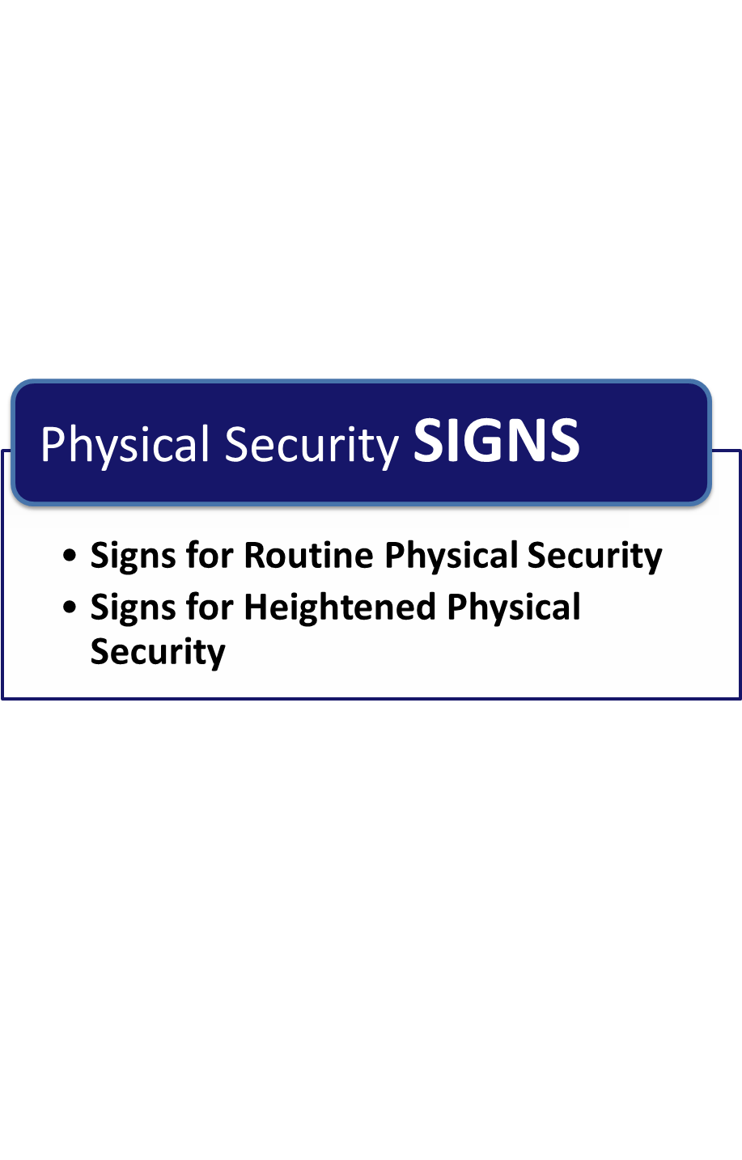

**Page Intentionally Left Blank**

##### Signs for Routine Physical Security



**Page Intentionally Left Blank**

##### Signs for Heightened Physical Security

**Page Intentionally Left Blank**

Chapter 1: Biosecurity Overview

Chapter 2: Biosecurity Assessment

Chapter 3: Employee Policies

Chapter 4: Crisis and Risk Communications

Chapter 5: Coordination with Animal Health Agencies and Local Government

Chapter 6: Visitor Control

Chapter 7: Foreign Travel

Chapter 8: Movement On and Off the Property

Chapter 9: Zoonotic Diseases

Chapter 10: Record Keeping

Chapter 11: Animal Handling and Contact

Chapter 12: Disease Detection and Surveillance

Chapter 13: Feral Animal and Wildlife Management

Chapter 14: Physical Security

**Chapter 15: Vector Control**

Chapter 16: Cleaning and Disinfection

**Page Intentionally Left Blank**

# Chapter 15: Vector Control

**Routine Biosecurity Considerations for Vector Control**

Vectors such as mosquitoes, ticks, and flies can pose a significant disease risk to cattle. These parasites can amplify the spread of zoonotic and bovine diseases and increase stress on cattle. Prevention practices are the most effective strategy of routine vector control.

Vectors can transmit diseases to cattle either mechanically or biologically. Mechanical transmission occurs when the vector obtains the disease from one animal directly from an animal’s eyes, nose or from the environment in contaminated manure or feed and transmits it to another animal. Biological transmission takes place when the vector ingests the pathogen from the blood of an infected animal and then transfers the pathogen into or onto another animal.

The most effective way to prevent mechanical or biological transmission is to reduce vector breeding areas, minimize vector exposure to the cattle, and eliminate the vector(s) using a combination of environmental, biological and chemical control methods. Follow an Integrated Pest Management (IPM) plan under the direction of a qualified pest control specialist. Examine and augment Integrated Pest Management Plans as necessary to align with the goals of this *Biosecurity Plan*.

**Environmental control** is the most important prevention strategy for vector control. Focus effort on controlling insect breeding areas. Elimination of locations for breeding and laying eggs reduces the number of disease spreading insects on the feedyard. Remove sources of standing water or treat them with larvicide, regularly remove organic debris and keep vegetation short to discourage mosquito, fly and tick breeding.

**Biological controls** include parasitic wasps, predatory mites, biocides and beetles that feed on pupae/larvae living in manure and vegetation and are effective methods to control insect populations. However, only use insects in approved areas because they may feed on other beneficial insects. Check with an IPM specialist for recommendations.

The use of certain chemical and biological pesticides is restricted by state laws in most states and may only be used by licensed pest control specialists. State law requires keeping records of pesticide application for two years. Follow the [Kansas Department of Agriculture](http://www.texasagriculture.gov/Portals/0/forms/PEST/Applicator/pesticide_applicator_record_requirements.pdf) pesticide applicator requirements. Use the Pesticide Use Record form to record application of restricted-use and state-limited-use pesticides. When using chemical control methods applied directly to the animal, use the Animal Health Record Form in Chapter 10: Record Keeping.

**Chemical controls** include pesticides, insecticides, antiparasitics, and feed additives. Chemical products are effective in controlling vectors when used in conjunction with prevention practices. Pests may become resistant to chemical controls if improperly used. Consult a licensed pest control specialist regarding the use of chemical control products.

**Fly control** is important in the prevention of rain rot, pinkeye, vesicular stomatitis and screwworm. Adult female flies lay eggs in organic matter. Prevent eggs from hatching and limit the adult fly population by regularly clearing organic debris such as spilled feed and rotting vegetation. A comprehensive manure management plan is also imperative to discourage egg laying and controlling adult flies. In addition to prevention strategies, the adult fly population can be managed using insecticides.

**Tick control** is important to the prevention of babesiosis (Texas cattle fever), Rocky Mountain spotted fever, Lyme disease, Q fever and heartwater. Cattle are also susceptible to decreased weight gain and secondary infection when infested with ticks. Keeping vegetation cut short or eliminating it with herbicides will minimize tick breeding grounds. Regularly examine cattle for the presence of ticks and work with your veterinarian to identify the best tick control product.

**Mosquito control** can prevent the transmission of West Nile Virus (WNV), various types of equine encephalitis, lumpy skin disease, and Rift Valley Fever (RVF). The best way to control mosquitos is to remove sources of standing water where mosquitoes lay eggs. Use chemical control products to eradicate mosquito larvae.

**Routine Biosecurity Plan for Vector Control**

|  |  |
| --- | --- |
| **Environmental Control:** | |
|  | Remove sources of standing water or treat with larvacide |
|  | Frequently clean water troughs and remove organic matter |
|  | Employ a manure management program |
|  | Clean up spilled, soiled feed and materials |
|  | Eliminate sources of decaying organic matter |
|  | Remove grass and weeds around pens and fences |

|  |  |
| --- | --- |
| **Biological Control:** | |
|  | Utilize parasites such as predatory mites, beetles or parasitic wasps that eat fly larvae |
|  | Utilize biocides such as Bt (*Bacillus thuringiensis*) to kill insect larva |
|  | Follow an Integrated Pest Management Plan under the direction of a licensed pest control specialist |

| **Chemical Control:** | |
| --- | --- |
|  | Use pesticides, insecticides, antiparasitics and feed additives according to manufacturer’s recommendations |
|  | Utilize a licensed applicator to apply all restricted-use and state-limited-use pesticides to the environment |
|  | Use feed impregnated with larvacide or insect growth regulator (IGR) |
|  | Utilize area sprays (knockdown) to kill adult flies |
|  | Use approved pour-on, spray, or eartag insecticides on animals as needed |
|  | Record and observe withdrawal times associated with each product |
|  | Follow an Integrated Pest Management Plan under the direction of a qualified pest control specialist |
|  | Keep records of pesticide application for two years in accordance with state law |
| Keep a record of restricted-use and state-limited use pesticides with the Pesticide Use Record form | |

|  |  |
| --- | --- |
| **Fly Control:** | |
|  | Utilize baits and fly traps (e.g., fly paper) |

|  |  |
| --- | --- |
| **Tick Control:** | |
|  | Ensure pets and horses residing on or entering the facility are not a vector for ticks by treating them with anti-tick medication, contact your veterinarian for more information |

| **Mosquito Control:** | |
| --- | --- |
|  | Frequently clean and change the water in tanks, troughs and bowls |
|  | Add drainage holes to containers that trap water |
|  | Drain tarps and covers that collect water after a rain, consider using split tires to weigh down silage tarps |
|  | Keep roof gutters clean to prevent them from holding water |
|  | Pick up and properly dispose of all trash, especially anything that could hold water |
|  | Grade areas where road ruts and potholes exist |

|  |  |
| --- | --- |
| **Personal Protection:** | |
|  | Check for and remove any ticks after working near infested cattle or vegetation |
|  | Wear long pants and sleeves to cover skin |
|  | Use insect repellant containing N,N-Diethyl-meta-toluamide (DEET) on exposed skin |
|  | Wear appropriate Personal Protective Equipment (PPE) to avoid contact with vectors and/or chemicals during treatment |

**Heightened Biosecurity Considerations for Vector Control**

Vector control can play an important role in the prevention of the spread of disease on or off the facility in the event of an outbreak of a vector transmitted FAD. The most effective way to prevent vectors from transmitting disease to or from cattle, personnel, or pets is to follow a comprehensive routine vector control program.

If there is a confirmed FAD outbreak in the region, consult with local, state or federal emergency management officials and a local vector control specialist.

Maintain heightened vector control protocols throughout the duration of the animal health emergency until animal health officials have eradicated or otherwise controlled the disease.

**Heightened Biosecurity Plan for Vector Control**

*Please review any recommended measures not implemented routinely and consider implementing them during heightened biosecurity operations*

|  |  |
| --- | --- |
| **Fly Control:** | |
|  | Contact a licensed pest control specialist for fly control services during an outbreak |

|  |  |
| --- | --- |
| **Tick Control:** | |
|  | Contact a licensed pest control specialist for tick control services during an outbreak |

|  |  |
| --- | --- |
| **Mosquito Control:** | |
|  | Contact a licensed vector control specialist for mosquito control services during an outbreak |

|  |  |
| --- | --- |
| **Personal Protection:** | |
|  | Wear appropriate PPE to avoid contact with vectors during an outbreak |

**Page Intentionally Left Blank**

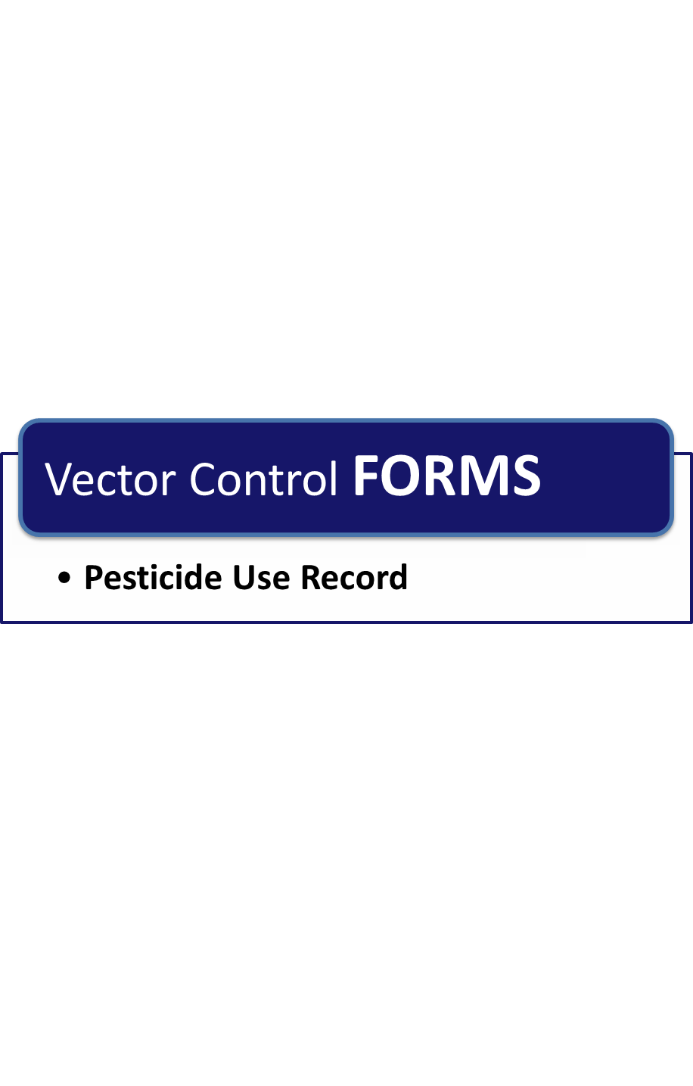

**Page Intentionally Left Blank**

##### Pesticide Use Record

**Business Name ________________________ Address ___________________________________**

|  |  |  |  |  |  |  |  |  |  |  |
| --- | --- | --- | --- | --- | --- | --- | --- | --- | --- | --- |
| Application Date | Time Started | Name of the person who applied treatment | Location of Land Treated | | Site Treated | | At time of treatment | | | |
| Wind Direction | | Wind Velocity | Air Temp |
|  |  |  |  | |  | |  | |  |  |
| Product Trade Name | | EPA Registration # | Target Pest | Rate of Product Per Unit | Equipment ID # | | | Spray Permit # | | |
|  | |  |  |  |  | | |  | | |
|  | |  |  |  |  | | |  | | |
| Licensed Applicator’s Name & License # | | | Unlicensed Applicator’s Name (If applicable) | | Total Acres or Volume of Acres Treated | Total Volume of Spray Mix, Dust, Granules or other Materials Applied Per Unit | | | | |
|  | | |  | |  |  | | | | |
| Additional Information | | | | | | | | | | |
|  | | | | | | | | | | |

**Page Intentionally Left Blank**

Chapter 1: Biosecurity Overview

Chapter 2: Biosecurity Assessment

Chapter 3: Employee Policies

Chapter 4: Crisis and Risk Communications

Chapter 5: Coordination with Animal Health Agencies and Local Government

Chapter 6: Visitor Control

Chapter 7: Foreign Travel

Chapter 8: Movement On and Off the Property

Chapter 9: Zoonotic Diseases

Chapter 10: Record Keeping

Chapter 11: Animal Handling and Contact

Chapter 12: Disease Detection and Surveillance

Chapter 13: Feral Animal and Wildlife Management

Chapter 14: Physical Security

Chapter 15: Vector Control

**Chapter 16: Cleaning and Disinfection**

**Page Intentionally Left Blank**

# Chapter 16: Cleaning and Disinfection

**Routine Biosecurity Considerations for Cleaning and Disinfection**

Cleaning protocols, when implemented correctly, can be a cost-effective means of reducing pathogenic organisms and are an important step in any biosecurity plan. Disinfection protocols further reduce the risk of pathogens entering and spreading through a feedyard. The decision to implement disinfection protocols may vary depending on the needs of the feedyard and the willingness to accept biosecurity risk in order to reduce costs and expedite vehicle movement. While it is accepted that feedyard management may opt not to implement disinfection protocols on a routine basis, it is recommended that, to the extent possible, the routine recommendations listed are followed. Reexamine any measures not undertaken routinely for implementation under heightened biosecurity status.

**Basic cleaning and disinfection (C&D)** of premises, equipment, vehicles, and personnel is recommended to be a part of routine operations for most areas of the feedyard. Increase C&D effort during an animal health emergency. Carry out C&D processes in a systematic manner to ensure efficacy and efficiency. Regardless of the situation, item, or area, effective C&D involves understanding the steps of the basic C&D protocol. The basic steps of C&D are listed in Figure 16.1.

#### Figure 16.1 – Basic Cleaning and Disinfection Protocol

**Cleaning** is one of the most important steps in the C&D process. When done correctly, cleaning alone can remove over 90% of microorganisms. The goal is to remove as much organic matter as possible. Organic material can harbor microorganisms for long periods of time. This step improves disinfection efficacy since most disinfectants are not as effective when organic material is present. The cleaning process involves 1) dry cleaning (removal of debris with a shovel, brush or broom), 2) washing, 3) rinsing, and 4) when possible, complete drying.

**Washing** further reduces the number of microorganisms in the area to a safer level. This is the most crucial step in the C&D process and will most likely eliminate the majority of remaining microorganisms if performed correctly. Soak the area with hot waterand detergent or other cleaning agent, and then wash by wiping, spraying, or scrubbing.

Allow areas to dry before application of the selected disinfectant to reduce potential dilution of the disinfectant upon application.

**Disinfectants** are physical or chemical agents that destroy vegetative bacteria (but not necessarily spores), viruses, and fungi. Use disinfectants that target a wide variety of organisms, work in any environment, and are non-toxic, non-irritating, non-corrosive and relatively inexpensive in routine biosecurity situations where no specific disease of concern is identified. Unfortunately, no disinfectant is ideal for all criteria. Therefore, careful consideration of the characteristics of a disinfectant is essential to select the most useful, effective and cost-efficient product. See Figure 16.2.

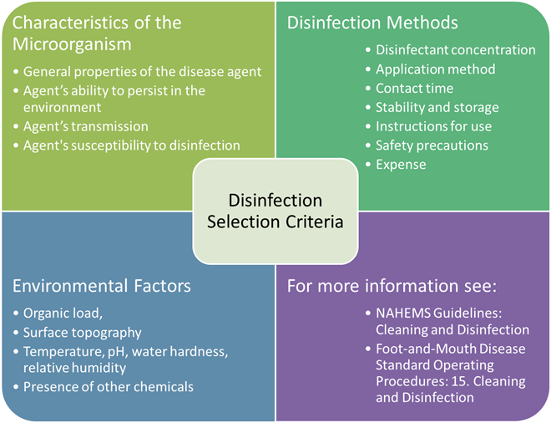

#### Figure 16.2 – Disinfectant Selection Criteria

**Disinfectant selection** will depend on the microorganism targeted, as well as environmental factors (e.g., temperature, pH), and disinfection methods. Table 16.5 shows the effectiveness of different types of chemical disinfectants on types of microorganisms. Use the table in Annex A to determine the targeted microorganism’s type and then Table 16.5 to determine which disinfectants kill the microorganism.

**Disinfectant labels** contain important information on the proper use and hazards of a chemical. Always read the entire product labeland explicitly follow dilution instructions to ensure the safest, most effective concentration is applied. **It is a violation of federal law to use a product in a manner inconsistent with its labeling.** Pay particular attention to the proper use of a product application, effectiveness, and associated hazards (human, animal, and environment). This information will assist in decisions for infection control efforts.

**Designated C&D areas** are locations set aside for staging and controlling C&D operations. Create a designated cleaning station containing equipment (e.g., tubs, scrub brushes) to aid in the removal of gross debris and application of disinfection products. Ensure designated cleaning station contains a water supply and runoff collection area. Ensure the wastewater and runoff collection plan is compliant with any EPA National Pollutant Discharge Elimination System (NPDES) permits the feedyard maintains. Runoff of infectious material or chemical solutions may be toxic to aquatic organisms or further spread disease.

**Waste management** is an important aspect of any C&D operation. Waste can be subject to different federal, state, local, and tribal regulations and requirements. Consult with the animal health authority and environmental regulating agency on how to handle waste generated by C&D procedures.

For more information on waste management, see the EPA’s [*Planning for Natural Disaster Debris Guidance*](http://www.epa.gov/wastes/conserve/imr/cdm/pubs/pndd.pdf)*.*

**Routine Biosecurity Plan for Cleaning and Disinfection**

| **Cleaning Equipment, Vehicles, and Premises:** | |
| --- | --- |
|  | Clean pens after each group of cattle, before introducing new animals  Scrape pens  Clean and repair (as necessary) water troughs and feed bunks |
|  | Ensure equipment brought in by outside contractors is cleaned before being brought onto feedyard property |
|  | Clean equipment in between processing of new/different groups of animals |
|  | Clean equipment that comes into contact with manure before using it for any other purpose |
|  | Clean up and dispose of spilled feeds promptly, particularly when adjacent to storage or feeding areas to prevent the attraction of vermin |
|  | Clean vehicles regularly, including wheel wells and undercarriage |
|  | Clean and disinfect all equipment, clothing, boots, etc. that come into contact with ill animals |
|  | Ensure that animal processing facilities and hospitals are cleaned regularly |
|  | Do not use the same facility for processing healthy animals as treating sick animals  If this is not possible, thoroughly clean and disinfect facility and equipment after treatment of ill animals; process healthy animals before treating sick animals |

| **C&D Equipment:** | |
| --- | --- |
|  | Create a designated cleaning station for movable equipment that contains C&D tools (e.g., tubs, scrub brushes)  Ensure designated cleaning station contains a water supply and runoff collection  Prevent runoff water from draining into “clean” areas  Locate area (and drainage from the location) away from sensitive areas, such as wellhead areas, livestock areas (e.g., down slope from animal areas) or driveway |
|  | Create a mobile cleaning set-up for C&D of areas such as hospitals and processing facilities  Develop a plan for ensuring the mobile equipment has a water supply  Develop a plan for runoff collection and disposal |
|  | Maintain C&D equipment |
|  | Train employees on how to operate C&D equipment |

| **Waste Management:** | |
| --- | --- |
|  | Comply with federal, state, local, and tribal regulations and requirements  For more information on waste management, see the EPA’s *Planning for Natural Disaster Debris Guidance* at:  http://www.epa.gov/wastes/conserve/imr/cdm/pubs/pndd.pdf |

**Heightened Biosecurity Considerations for Cleaning and Disinfection**

C&D procedures are a crucial part of any animal health emergency response situation. The potential for the spread or transfer of microorganisms, especially highly contagious pathogens, can occur from the direct or indirect contamination of premises, equipment, vehicles or personnel and the movement of animals or animal products. C&D procedures are used to inactivate or destroy microorganisms, thereby inhibiting or eliminating further spread. These efforts are vital for disease control and eradication measures.

During a heightened biosecurity situation, target efforts against the properties of the disease and organisms that cause it. As discussed in previous chapters, this includes knowing the route of transmission of disease so C&D procedures can be targeted toward contaminated areas. Select effective disinfectants working against the particular organism (see Table 16.5 and Annex A).

**Microorganisms** vary in survivability or persistence in the environment, and in susceptibility to disinfection. Be aware of the suspected or confirmed pathogen involved to select the most efficacious disinfection method. This includes understanding the disease agent’s 1) general properties, 2) persistence in the environment, 3) route of transmission, and 4) susceptibility to disinfection.

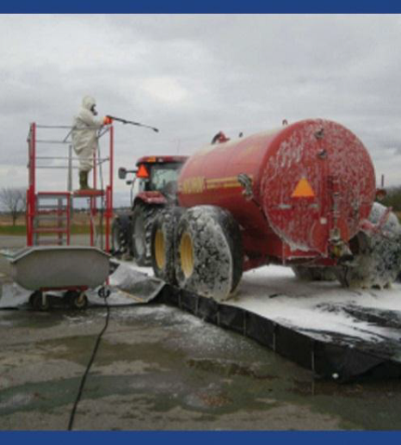**Vehicles** (trucks, trailers, etc.) used for transporting animals, products or by-products or contaminated equipment have the potential to spread disease. Contamination can occur directly by the vehicle or by transfer of material by wheels. During heightened biosecurity operations, limit the number of vehicles allowed to enter the feedyard. See Chapter 8: Movement On and Off the Property for more information about cross contamination.

Clean the vehicle first to remove as much organic debris as possible. Brush or scrape debris from the vehicle. Washing of the vehicle should follow. High pressure spraying equipment (i.e., 200 - 1000 psi) may help to clean wood pores, cracks and crevices. Clean the vehicle from top to bottom and wash the underside of fender wells and the vehicle frame. Apply an appropriate disinfectant with a low pressure sprayer and allow its proper contact time to elapse. Also, clean and disinfect the interior of the vehicle prior to leaving the feedyard.

#### Figure 16.3 – Vehicle Disinfection

**People** coming onto the feedyard can be a source of disease. Limit access to the feedyard during heightened biosecurity operation (see Chapter 6: Visitor Control).

Individuals visiting the feedyard must thoroughly wash hands with antibacterial soap before entering and leaving the premises. Be sure to provide warm water with antimicrobial soaps, scrubs, and hand cleaners for personnel decontamination following removal of disinfected PPE items.

Boot baths are an excellent means of preventing mechanical transfer of microorganisms by personnel. Figure 16.4 shows a photo of a boot bath being used. Boot baths must be maintained properly to be effective. Common problems with boot baths include 1) inadequate removal of organic debris prior to stepping into the disinfectant solution, 2) inadequate contact time allowed for the disinfectant, and 3) infrequent change of disinfection solution. Scrub and clean boots of all grossly visible debris prior to soaking in the disinfectant boot wash. Allowing the proper contact time for a disinfectant is as important for boot baths as it is when cleaning premises and equipment. Replace boot bath disinfectant solution daily, at a minimum; however, more frequent replacement will be needed in large or busy areas or when organic debris accumulates in the boot bath. Keep boot bath solutions from freezing and protect from rain to avoid dilution. Disinfectants are most effective on rubber boots. Porous materials like leather are more difficult to disinfect and may be ruined in the process.

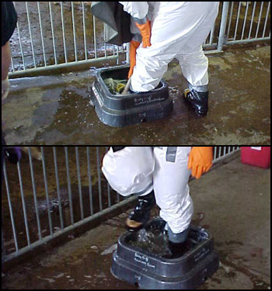

#### Figure 16.4 – Use of a Boot Bath

**Personal protective equipment** protects employees during C&D operations. This includes wearing coveralls, boots, and gloves. Wear face protection (e.g., goggles, mask, face shield) based on the product or application method (e.g., misting) used and when mixing disinfectant solutions. Wear masks in situations involving significant amounts of dust generation or zoonotic disease potential (see Chapter 9: Zoonotic Diseases). Additional personal protective hoods or respirators may be necessary for some situations (e.g., formaldehyde or acidic disinfectants).

For more information on PPE, see the *FAD PReP/NAHEMS Guidelines: Personal Protection Equipment (2011)*.

For more information on cleaning and disinfection see *FAD PReP/NAHEMS Guidelines: Cleaning and Disinfection* (2011)and the *FAD PReP FMD SOP 15: Cleaning and Disinfection* (2010).

Maintain heightened cleaning and disinfection protocols throughout the duration of the animal health emergency until animal health officials have eradicated or otherwise controlled the disease.

#### Table 16.5 – Effectiveness of Chemical Disinfectants of Different Types of Microorganisms

**Instructions:** Consult a veterinarian, or go to the [Annex A:   
Disease Table](#AppendixA) to look up the disease of interest. Use the table to identify what type of microorganism causes the disease (e.g., vegetative bacteria, enveloped virus, non-enveloped virus, bacterial spore, acid-fast bacteria or prion). Use the table below to determine what type of chemical disinfectant will kill that type of microorganism.

|  |  |  |  |  |  |  |  |
| --- | --- | --- | --- | --- | --- | --- | --- |
| **Chemical Disinfectants** | | **Microorganisms** | | | | | |
| **Vegetative bacteria** | **Enveloped viruses** | **Non-enveloped viruses** | **Bacterial spores** | **Acid-fast bacteria** | **Prions** |
| Acids | hydrochloric, sulfuric, acetic | **+** | **+** | **-** | **±** | **-** | **-** |
| Alcohols | ethyl alcohol, isopropanol | **++** | **+** | **-** | **-** | **+** | **-** |
| Aldehydes | formaldehyde, glutaraldehyde | **++** | **++** | **+** | **±a** | **+** | **-** |
| Alkalis | sodium hydroxide, calcium hydroxide, calcium carbonate | **+** | **+** | **±** | **±** | **+** | **-** |
| Biguanides | chlorhexidine | **++** | **±** | **-** | **-** | **-** | **-** |
| Chlorine Compounds | sodium hypochlorite | **+** | **+** | **+** | **+** | **+** | **-** |
| Oxidizing Agents |  | **+** | **+** | **±** | **+b** | **±** | **-** |
| Phenolic Compounds | o-phenylophenol | **++** | **±c** | **-** | **-** | **±** | **-** |
| Quaternary Ammonium Compounds |  | **++** | **±** | **-** | **-** | **-** | **-** |

|  |  |
| --- | --- |
| **++** highly effective  **+** effective | **±** limited or variable  **–** no activity |
| (a) formaldehyde is sporicidal, glutaraldehyde is not.  (b) hydrogen peroxide combined with peracetic acid, strong oxidizing agents, is sporicidal  (c) varies with composition of disinfectant  Adapted from NAHEMS Operational Guidelines: Cleaning and Disinfection, November 2011. | |

**Standard Operating Procedures for Cleaning and Disinfection**

*The procedures described below describe how to carry out cleaning and disinfection operations. The Routine and Heightened sections of the plan detail what, when and where to clean and/or disinfect.*

| **Cleaning Procedures:** | |
| --- | --- |
|  | **Wear personal protective wear**—gloves, long pants, long sleeves, and possibly a mask when cleaning an area that will generate dust |
|  | **Dry clean**—remove all visible material by brushing, scraping, sweeping and hauling to a disposal area. Handle waste material in such a way to prevent contamination of other areas such as feed, water or other animals. |
|  | **Soak**—soak the area with hot water and a detergent or cleaning agent, wash and soap down all equipment in the area- waterers, feed troughs, pails, etc. |
|  | **Wash**—wipe, spray or scrub the area, starting with the highest area (e.g., ceiling of feed mill or roof of truck), after it has soaked for a period of time  Use pressure washers when cleaning wood, cement, or other porous surfaces  Use caution when using high pressure washers (200-1000 psi) as they can aerosolize disease organisms and spread them to other areas or expose the person cleaning |
|  | **Rinse**—remove all detergent residue by applying a low pressure water rinse on all surfaces, starting with the highest area and working your way to the floor |
|  | **Dry**—allow the area to dry completely before applying a disinfectant so that it can work effectively and not be diluted |

| **Disinfection Procedures:** | |
| --- | --- |
|  | **Read the product label**—this is important to make sure the solution is handled correctly. Personal protective wear (gloves, mask) may be needed when mixing up solutions. |
|  | **Disinfect**—apply disinfectant at the correct dilution and let it “sit and work” for the suggested amount of time |
|  | **Final rinse**—remove all disinfectant by applying a low pressure water rinse on all surfaces, starting with the highest area and working your way to the floor |
|  | **Dry**—allow the area to completely dry before allowing animals to have contact with the area or item that was just cleaned and disinfected |

**Heightened Biosecurity Plan for Cleaning and Disinfection**

*Please review all recommended measures not implemented routinely and consider implementing them during heightened biosecurity operations*

|  |  |
| --- | --- |
| **General:** | |
|  | Select an appropriate disinfectant based on the microorganism targeted, environmental factors (e.g., temperature, pH) and disinfection methods |
|  | Request that all vehicles be cleaned before coming onto the feedyard |

|  |  |
| --- | --- |
| **People:** | |
|  | Provide clean protective clothing and footwear for visitors (e.g., booties for indoor areas or washable overboots made of non-porous material for outdoor and animal areas) |
|  | Require visitors to wear protective clothing and footwear when entering livestock areas |
|  | Require hands be thoroughly washed with antibacterial soap before entering AND leaving the premises. Wash hands even if gloves are worn |
|  | Provide boot baths at the entrance/exit of animal areas |
|  | Require visitors remove and leave behind protective outer clothing and footwear when departing the feedyard |

| **Personal Protective Equipment:** | |
| --- | --- |
|  | Provide personnel conducting C&D operations with proper PPE  Coveralls  Boots (that are waterproof and easy to clean and disinfect)  Gloves |
|  | Instruct personnel conducting C&D operations to wear face protection (e.g., goggles, mask, face shield) based on the product or application method (e.g., misting) used and when mixing disinfectant solutions |
|  | Instruct personnel conducting C&D operations to wear masks in situations involving significant amounts of dust generation or zoonotic disease potential |
|  | Follow any additional PPE instructions recommended by:  Disinfectant product label  Veterinarian or physician  Environmental regulatory authority |

**Page Intentionally Left Blank**

Glossary

**Aerosol transmission** refers to method of spreading disease through aerosols. Aerosol transmission occurs when disease agents contained in droplets pass through the air from between animals, or from animals to humans, or vice versa. Most pathogenic agents do not survive for extended periods of time within the aerosol droplets, and as a result, close proximity of infected and susceptible animals is required for disease transmission.

**Antibiotic** is a chemical substance produced by a microorganism that has the capacity, in dilute solutions, to inhibit the growth of or to kill other microorganisms.

**Antimicrobial residue** refers to the presence of an antimicrobial at a level in meat or milk that is higher than levels established by the FDA.

**Biological vectors** are vectors that support replication of the pathogen. Biological vectors are usually persistently infected with the disease agent and may even be a required part of the pathogen’s life cycle.

**Biosecurity** is a collection of management practices designed to minimize the risk of disease introduction and spread on an operation.

**Biosecurity Plan** is a plan or protocol that reflects biosecurity principles and procedures concerning the movement of personnel, vehicles, and equipment; examination of animals; visitor and employee policies; communication plans; disease detection and surveillance; feral animal and wildlife management; and physical security.

**Buffer Zone (BZ)** is a defined area that immediately surrounds an Infected Zone (IZ) or a Contact Premises (CP) with susceptible animals that may have been exposed to a FAD, either directly or indirectly, including but not limited to exposure to animals, animal products, fomites, or people from Infected Premises.

**Cleaning and disinfection** involves the use of physical or chemical processes to reduce, remove, inactivate, or destroy pathogenic microorganisms. For a more detailed explanation see U.S. Department of Agriculture (USDA), Foreign Animal Disease Preparedness & Response Plan, 2011, NAHEMS Guidelines: Cleaning and Disinfection.

**Closed herd** is an operation that does not introduce new animals from outside sources. Growth occurs through the addition of offspring born and raised on the operation. This practice decreases the potential for the introduction of new disease agents onto the operation.

**Control Area (CA)** consists of an Infected Zone and a Buffer Zone. It contains has individual premises under quarantine for Infected Premises, Suspect Premises, and Contact Premises and movement restrictions for At-Risk Premises and Monitored Premises.

**Direct contact transmission** refers to method of spreading disease through direct contact. Transmission by direct contact requires the presence of an agent or organism in the environment or within an infected animal. An animal becomes exposed when the agent directly touches open wounds, mucous membranes, or the skin through blood, saliva, nose to nose contact, rubbing or biting.

**Disinfectants** are registered by the Environmental Protection Agency (EPA) as “antimicrobial pesticides” and are substances used to control, prevent, or destroy harmful microorganisms (i.e., bacteria, viruses, or fungi) on inanimate objects and surfaces.

**Environmental transmission** refers to method of spreading disease through the environment. This disease agent can survive for extended periods of time in soil or other organic material like bedding, old feed, etc. Animals can then acquire the disease agent: from the environment through inhalation of aerosolized microbes, via oral consumption, or from direct contact. The routes the disease agent uses to get into the animal can be controlled if the animal's environment is controlled.

**Essential visitors** are people who need to come onto the yard in order to perform a function necessary to maintain feedyard operation and animal health. Examples of essential visitors include vendors, contractors, repairmen and veterinarians.

**Fomite transmission** refers to method of spreading disease through fomites. A fomite is an object that can carry disease agents from one susceptible animal to another. Examples of fomites include contaminated brushes, clippers, needles, balling guns, clothing, feed or water buckets, and shovels. Traffic transmission is another special type of fomite transmission in which a vehicle, trailer, or human spreads organic material to another location.

**Heightened Biosecurity Measures** should be followed when a confirmed or suspected highly contagious disease exists (e.g., FMD) in the region or even anywhere in the country. Heightened Biosecurity Measures should be followed when there is an increased risk of a highly infectious disease being brought into your feedyard.

**High-risk** visitors are individuals who have regular close contact with animals, their excretions, and secretions. Examples of this type of visitor include veterinarians, animal haulers, custom processors, and anyone with close contact to animals. Additionally, visitors who recently traveled to foreign countries should be evaluated as a potential high-risk visitor.

**Infected Zone (IZ)** is a defined area that immediately surrounds an infected premises (IP) where presumptive positive case or confirmed positive case exists based on laboratory results, compatible clinical signs, FMD case definition, and international standards.

**Integrated pest management** is the use of multiple tactics in a compatible manner to maintain pest populations at levels below those causing economic injury while providing protection against hazards to humans, domestic animal, plants, and the environment, (Arneson 2000). IPM strategies can be categorized as chemical, biological, cultural, physical, genetic, and regulatory.

**Low-risk** visitors are individuals with no recent livestock or poultry contacts prior to the visit. An example of this type of visitor is someone who lives in an urban area with no livestock or poultry contacts prior to visit.

**Mechanical vectors** are vectors that carry the pathogen but the pathogen is not altered while on the vector. Infection in mechanical vectors tends to be short-lived and a mechanical vector is considered little more than a flying fomite.

**Medium-risk** visitors are individuals who have limited animal contact due to the location of worksites on premises. Examples of this type of visitor include sales representatives, equipment repairpersons, and delivery people.

**N-95 Mask** is a respirator that is the most common of the seven types of particulate filtering facepiece respirators. This product filters at least 95% of airborne particles but is not resistant to oil. For more information see the [CDC NIOSH website](http://www.cdc.gov/niosh/npptl/topics/respirators/disp_part/n95list1.html).

**Non-essential visitors** are people who wish to visit the feedyard but whose visit is not required. Examples of non-essential visitors include someone wanting a tour, or salesmen.

**Office International des Epizooties (OIE)** an international organization created by an International Agreement of January 25, 1924, signed by 28 countries. In May 2002, the OIE totaled 162 Member Countries. OIE standards are recognized by the World Trade Organization as a reference for international sanitary rules.

**Oral transmission** refers to method of spreading disease through oral means. Pathogenic agents can be transmitted to animals orally through consumption of contaminated feed, water, or licking/chewing on contaminated environmental objects. Feed and water contaminated with feces, urine or saliva are frequently the cause of oral transmission of disease agents.

**Personal Protective Equipment (PPE)** is equipment used as a barrier between an individual and a hazard that could result in an injury or occupational illness.

**Premises** are a tract of land, including its buildings. Also, a building together with its grounds or other appurtenances.

**Restricted-use pesticides** will state “restricted use” on the product label as required by the EPA.They may only be purchased and used by certified pesticide applicators or people under their direct supervision.

**Routine Biosecurity Measures** are those activities that should be followed during normal day-to-day operations to help protect your operation and lower the risk of a disease being brought onto your facility.

**State-limited-use pesticides** contain certain active ingredients that have the potential to cause adverse effects to non-targeted vegetation and are classified as SLU when distributed in containers larger than one quart liquid or 2 pounds dry or solid. Also includes pesticides or devices for predation control.

**Surveillance Zone** **(SZ)** is the zone established within and along the border of a Free Zone, separating the Free Zone from the Buffer-Surveillance Zone within a Control Area. Surveillance in the Surveillance Zone focuses on premises determined to be at the highest risk of infection.

**Vector-borne transmission** refers to method of spreading disease through a vector. Vector-borne transmission occurs when an insect acquires a pathogen from one animal and transmits it to another. Fleas, ticks, and mosquitoes are common biological vectors of disease, and flies and cockroaches are a common mechanical vector.

**Zoonotic diseases** are transmissible between animals and humans. Human exposure to zoonotic diseases may occur through any of the five routes of transmission. Because of public health concerns, the zoonotic risk of a particular pathogenic agent should be considered in a biosecurity risk assessment.

References

Colorado Department of Agriculture. (2010). *Feedlot Emergency Disease Response Plan.*

American Feed Industry Association. (2001, November 20). *American Feed Industry Association Guide to Biosecurity Awareness*. Retrieved from http://www.aragriculture.org/biosecurity/producer/american_feed_industry.htm

Anderson, D. E. (2010). Survey of Biosecurity Practices Utilized by Veternarians Working with Farm Animal Species. *The Online Journal of Rural Research and Policy, 5*(7).

Asia Biobusiness. (2012, November 15). *Risk Communication & Biosecurity Strategy*. Retrieved from asia biobusiness: http://www.asiabiobusiness.com/?p=428

Association, E. J. (n.d.). *Beef Cattle Handbook.* Retrieved May 24, 2013, from http://www.iowabeefcenter.org/Beef%20Cattle%20Handbook/Leptospirosis.pdf

Beef Quality Assurance. (2009, June). *Feedyard Assessment Assessor's Guide.* Retrieved from Beef Quality Assurance Program: http://www.bqa.org/CMDocs/bqa/Feedyard_Assessment_062209_Blank.pdf

Beef Quality Assurance. (2010). *Master Cattle Transporter Guide National Beef Quality Assurance Guide for Cattle Transporters.* Retrieved from http://www.livestocknetwork.com/Master_Cattle_Transporter_Guide/Master_Cattle_Transporter_Guide.pdf

Bickett-Weddle, D. (2006). *Direct Contact Fomite Transmission - Beef.* Retrieved from The Center for Food Security & Public Health: http://www.cfsph.iastate.edu/BRMForProducers/English/RouteSpecificInformation/DirectContact_Fomite_beef_speakernotes.pdf

BMeyer. (2003). *Biosecurity in Practice Series - Beef Feedlots.*

Center for Food Security and Public Health. (n.d.). *General Prevention Practices for Beef and Dairy Producers.* Retrieved from http://www.cfsph.iastate.edu/BRMForProducers/English/GeneralPrevention/GenPrevPrac.pdf

Center for Food Security and Public Health Iowa State University. (2006). BRM Overview - Introduction to Biological Risk Managmenet for Beef and Dairy Producers. Iowa. Retrieved from http://www.cfsph.iastate.edu/BRMForProducers/English/GeneralPrevention/BRM%20Overview%20Speaker%20Notes.pdf

Centers for Disease Control. (2012). *Crisis and Emergency Risk Communication (CERC).* Retrieved from Centers for Disease Control and Prevention: http://emergency.cdc.gov/cerc/

*Checklist for Risk Communication and Public Involvement Fact Sheets*. (n.d.). Retrieved from US Air Force Air University : http://www.au.af.mil/au/awc/awcgate/army/risk_comm_factsheets.pdf

Dement, A. I. (n.d.). *General Biosecurity for Livestock and Poultry Producers.* Texas AgriLife Extension Service.

D'Midget, Joe Slunk at Texas Cattle Feeders Association. (2002). People Make the Difference. *Cattle Feed Country Booklet*.

Dvorak, G. (2008, May). *Disinfection 101.* Retrieved from The Center for Food Security & Public Health: http://www.cfsph.iastate.edu/BRM/resources/Disinfectants/Disinfection101.pdf

FAZD Center - National Center for Foriegn Animal and Zoonotic Disease Defense. (2008, 7 July). *Quick Facts about Foriegn and Endemic Animal Diseases.* Retrieved from http://fazd.tamu.edu/files/2012/02/quick3.pdf

FEMA. (n.d.). Retrieved from www.ready.gov.

Floron (Buddy) Faries, J. (2013, February 19). *Emergency-Animal-Management-During-Disasters.* Retrieved from http://vgyi.tamu.edu/files/2012/02/B-Faries-Emergency-Animal-Management-During-Disasters.pdf

Global Early Warning Sytem for Major Animal Diseases Including Zoonoses (GLEWS). (n.d.). *GLEWS Disease Events*. Retrieved from http://www.glews.net/disease-events/

Grandin, D. T. (2001). *Livestock Trucking Guide Livestock Management Practices that Reduce Injuries to Livestock During Transport.* Bowling Green: National Institute for Agriculture.

Grandin, T. (2010). *Recommended Animal Handling Guidelines & Audit Guide: A Systematic Approach to Animal Welfare.* American Meat Institute (AMI) Foundation.

Hall, M. (n.d.). Center looking to bring together two factions in biosecurity -- law enforcement and animal/plant health experts. Kansas. Retrieved from http://www.k-state.edu/media/webzine/safetyandsecurity/NABCsidebar.html

Heathfield, S. (n.d.). *Employment Ending Checklist: Checklist to Use in an Employee Ending Meeting*. Retrieved April 13, 2013, from http://humanresources.about.com/od/whenemploymentends/a/end_employment.htm

Hersom, D. M. (n.d.). *UF/IFAS Biosecurity and Biological Risk Management for Livestock Enterprises Handbook.* University of Florida IFAS Extension.

Iowa State University The Center for Food Security & Public Health. (2009, September). *Exotic Ticks.* Retrieved from http://www.cfsph.iastate.edu/Factsheets/pdfs/ticks_exotic.pdf

Iowa State University The Center for Food Security & Public Health. (n.d.). *Bovine Routes of Transmission.* Retrieved from http://www.cfsph.iastate.edu/pdf/bovine-routes-of-transmission

Iowa State University The Center for Food Security & Public Health. (n.d.). *Fly Control Measures.* Retrieved from http://www.cfsph.iastate.edu/BRMForProducers/English/RouteSpecificInformation/fly_control.pdf

Iowa State University The Center for Food Security & Public Health. (n.d.). *Tick Control Measures.* Retrieved from http://www.cfsph.iastate.edu/BRMForProducers/English/RouteSpecificInformation/general_tick_control.pdf

Lanzaro, S. P. (2005). *Managing Mosquitoes on the Farm.* Retrieved from http://anrcatalog.ucdavis.edu/pdf/8158.pdf

Lee, C. C. (2011). Haul Responsibly. *Hereford World*, 28-29.

Mapston, M. E. (n.d.). *Feral Hogs in Texas.* Retrieved from Texas A&M Agrilife Extension: http://feralhogs.tamu.edu/files/2010/05/B-6149-Feral-Hogs-in-Texas.pdf

National Cattlemen’s Beef Association. (2006). *Biosecurity Guidelines*. Retrieved from http://www.aragriculture.org/biosecurity/producer/biosecurity_guidelines.htm

Nations, F. a. (2007). *FAO Biosecurity Toolkit.* Rome.

North Dakota Beef Quality Assurance Program. (n.d.). *North Dakota Beef Quality Assurance Program Records Transfer Form*. Retrieved from North Dakota State University Agriculture: http://www.ag.ndsu.edu/bqa/documents/Records%20Transfer%20Form.pdf

Ontario Humane Transport Working Group. (2010, May). *Guidelines for Transporting Cattle, Sheep & Goats*. Retrieved from http://www.livestockwelfare.com/resources/09animalloaded.pdf

Purdue University. (n.d.). *Truck Washes*. Retrieved from National Biosecurity Resource Center for Animal Health Emergencies: http://www.biosecuritycenter.org/truckwash.php

Rutherford, B. (2012). Feedyard Emergency Preparedness: Are You Ready? *Beef*.

Sevin, C. (2012, December 17). Retrieved from https://www.usaintel.com/articles/how-to-do-a-background-check-on-a-potential-employee/

Taylor, J. D. (2005, March). *Beef Biological Risk Management*. Retrieved from http://www.cfsph.iastate.edu/BRM/resources/Beef/BeefBRMDocumentFinalMarch2005.pdf

Texas Animal Health Commission. (2012, December 14). *Cattle Identification Form.* Retrieved from Texas Animal Health Commission: http://www.tahc.state.tx.us/adt/13-03_CattleIdentificationForm.pdf

Texas Commission on Environmental Quality. (2005). *Disposal of Domestic or Exotic Livestock Carcasses.*

The CNA Corporation. (2007). *Operation Palo Duro: Policy and Decision-making in Response to an FMD Outbreak.*

The State of Texas - Texas Animal Health Commission. (n.d.). *Appendix 3 to Annex O Foriegn and Emerging Animal Diseases (FAD) Response Plan.* Retrieved from http://www.tahc.state.tx.us/emergency/StateFAD_Plan.pdf

U.S. Department of Agriculture Food Safety and Inspection Service. (n.d.). *Food Defense Plan Security Measures for Food Defense.* Retrieved from http://www.fsis.usda.gov/wps/wcm/connect/99f95182-0c9e-4214-9762-e98197f54ebf/General-Food-Defense-Plan-9-3-09+_2_.pdf?MOD=AJPERES

U.S. Department of Agriculture, Agricultural and Food Transporters Conference, Conference of American Trucking Associations. (2004). *Guide for Security Practices in Transporting Agricultural and Food Commodities.* United States Department of Agriculture.

U.S. Department of Agriculture, Agricultural Marketing Service, Transportation and Marketing Division. (1999). *Cattle and Swine Trucking Guide for Exporters.* Retrieved from http://www.ams.usda.gov/AMSv1.0/getfile?dDocName=STELDEV3008268

U.S. Environmental Protection Agency. (2012, November 15). *Hazardous Waste Identification.* Retrieved from http://www.epa.gov/osw/hazard/wastetypes/wasteid/index.htm

U.S. Food and Drug Administration. (2013, March 27). *Strategic Partnership Program Agroterrorism (SPPA) Initiative Second Year Status Report July 2006 - September 2007.* Retrieved from http://www.fda.gov/downloads/Food/FoodDefense/FoodDefensePrograms/ucm081014.pdf

U.S. Food and Drug Administration Center for Food Safety and Applied Nutrition. (2003, March). *Guidance for Industry: Food Producers, Processors, and Transporters: Food Security Preventive Measures Guidance*. Retrieved from http://www.fda.gov/Food/GuidanceRegulation/GuidanceDocumentsRegulatoryInformation/FoodDefense/ucm083075.htm

U.S. Government Printing Office . (2011, October 1). *49 CFR 105.5 - Definitions.* Retrieved from http://www.gpo.gov/fdsys/pkg/CFR-2011-title49-vol2/pdf/CFR-2011-title49-vol2-sec105-5.pdf

United States Department of Agriculture. (2006, March). *Pre-Harvest Security Guidelines and Checklist 2006.* Retrieved from http://www.usda.gov/documents/PreHarvestSecurity_final.pdf

United States Department of Agriculture Animal and Plant Health Inspection Service. (2010). *Foreign Animal Disease Preparedness & Response Plan (FAD PReP) Foot-and-Mouth Disease Standard Operating Procedures: 9. Biosecurity.* Riverdale: National Center for Animal Health Emergency Management.

United States Department of Agriculture Animal and Plant Health Inspection Service. (2011). *Foreign Animal Disease Preparedness & Response Plan (FAD PReP) National Animal Health Emergency Management System (NAHEMS) Beef Feedlot Industry Manual.* Riverdale: National Center for Animal Health Emergency Management.

United States Department of Agriculture Animal and Plant Health Inspection Service Veterinary Services. (2011). *Foreign Animal Disease Preparedness & Response Plan (FAD PReP) National Animal Health Emergency Management System (NAHEMS) NAHEMS Guidelines: Biosecurity.* Riverdale: National Center for Animal Health Emergency Management.

United States Department of Agriculture Animal and Plant Health Inspection Service Veterinary Services. (2011). *Foreign Animal Disease Preparedness & Response Plan (FAD PReP) National Animal Health Emergency Management System (NAHEMS) NAHEMS Guidelines: Cleaning & Disinfection.* Riverdale: National Center for Animal Health Emergency Management.

United States Department of Agriculture Animal and Plant Health Inspection Service Veterinary Services. (2011). *Foreign Animal Disease Preparedness & Response Plan (FAD PReP) National Animal Health Emergency Management System (NAHEMS) NAHEMS Guidelines: Health & Safety.* Riverdale: National Center for Animal Health Emergency Management.

United States Department of Agriculture Animal and Plant Health Inspection Service Veterinary Services. (2011). *Foreign Animal Disease Preparedness & Response Plan (FAD PReP) National Animal Health Emergency Management System (NAHEMS) NAHEMS Guidelines: Mass Depopulation and Euthanasia.* Riverdale: National Center for Animal Health Emergency Management.

United States Department of Agriculture Animal and Plant Health Inspection Service Veterinary Services. (2011). *Foreign Animal Disease Preparedness & Response Plan (FAD PReP) National Animal Health Emergency Management System (NAHEMS) NAHEMS Guidelines: Personal Protective Equipment (PPE).* Riverdale: National Center for Animal Health Emergency Management.

United States Department of Agriculture Animal and Plant Health Inspection Service Veterinary Services. (2011). *Foreign Animal Disease Preparedness & Response Plan (FAD PReP) National Animal Health Emergency Management System (NAHEMS) NAHEMS Guidelines: Surveillance, Epidemiology, and Tracing .* Riverdale: National Center for Animal Health Emergency Management.

United States Department of Agriculture Animal and Plant Health Inspection Service Veterinary Services. (2012). *Foreign Animal Disease Preparedness & Response Plan (FAD PReP) Foot-and-Mouth Disease Response Plan The Red Book.* Riverdale: National Center for Animal Health Emergency Management.

United States Department of Agriculture Animal and Plant Health Inspection Service Veterinary Services. (2012). *Foreign Animal Disease Preparedness & Response Plan (FAD PReP) National Animal Health Emergency Management System (NAHEMS) NAHEMS Guidelines: Continuity of Business.* Riverdale: National Center for Animal Health Emergency Management.

United States Department of Agriculture Animal and Plant Health Inspection Service Veterinary Services. (2012). *Foreign Animal Disease Preparedness & Response Plan (FAD PReP) National Animal Health Emergency Management System (NAHEMS) NAHEMS Guidelines: Disposal.* Riverdale: National Center for Animal Health Emergency Management.

United States Department of Agriculture Food Safety and Inspection Service. (2003). *FSIS Safety & Security Guidelines for the Transportation and Distribution of Meat, Poultry, and Egg Products.* USDA Agricultural Marking Service.

USDA APHIS Veterinary Services. (2007, February). *Foot and Mouth Disease Factsheet.* Retrieved July 2012, from http://www.aphis.usda.gov/publications/animal_health/content/printable_version/fs_foot_mouth_disease07.pdf

Welby, E. M., & McGregor, B. (2004). *Agricultural Export Transportation Handbook.* U.S. Department of Agriculture Agricultural Marketing Service.

World Organisation for Animal Health. (n.d.). *Disease Alerts*. Retrieved from http://www.oie.int/en/alerts-disease-information/

**Page Intentionally Left Blank**

Annex A: Disease Table

| **Disease / Pathogen** | **Zoonotic Potential** | **KDA Reportable\*** | **OIE Reportable** | **Mode of Transmission\*\*** | | | | | | **Endemic Areas\*\*\*** | | | | **Agent Type** | **Sanitary prophylaxis** | **Medical prophylaxis** |
| --- | --- | --- | --- | --- | --- | --- | --- | --- | --- | --- | --- | --- | --- | --- | --- | --- |
| **Aerosol** | **Direct Contact** | **Fomite** | **Oral** | **Vector** | **Environmental** | **United States** | **Canada** | | **Mexico** |
| Anthrax | Y | Y | Y | M | S | S | S |  | S | L | Y | | 2010 | Bacterial Spore | Decontamination of contaminated tissues, surfaces, and environments is difficult. | Vaccine; Antibiotics effective, but course of disease usually to quick |
| Aujeszky's disease (Pseudorabies) | N | Y | Y | S | M | S | M |  | S | L | N | | L | Enveloped Virus | Prevent Feral Pig population from interacting with cattle |  |
| Bluetongue (EHD) | N |  | Y |  |  | S |  | M |  | Y | 1988 | | 2010 | Non-Enveloped Virus | No efficient treatment; insect control | Vaccine |
| Bovine babesiosis Tick Fever, Cattle Fever, Texas Fever, Piroplasmosis, Redwater | Y | Y | Y |  |  |  |  | M |  | 1943 | N | | L | Protozoan | Reducing exposure of cattle to ticks | Vaccine |
| Bovine spongiform encephalopathy (BSE) | Y | Y | Y |  |  |  | M |  |  | Y | 2011 | | N | Prion | Do not use feed containing ruminant derived proteins; Decontamination of prion-contaminated tissues, surfaces, and environments is difficult | There is no treatment for BSE |
| Bovine tuberculosis | Y | Y | Y | M |  |  | S |  |  | L | ? | | L | Acid-fast bacteria |  | Treatment of infected animals is rarely attempted because of the high cost, lengthy time and the larger goal of eliminating the disease |
| Bovine viral diarrhea (BVD) | N |  | Y | M | M | S |  |  |  | Y | Y | | L | Non-Enveloped Virus | Control is achieved with a combination of removal of infected cattle, vaccination, and enhanced biosecurity | Vaccination should be used to decrease clinical disease and to reduce the risk of viral shedding within and between groups of stocker or feeder cattle |
| Brucellosis (*Brucella abortus*) | Y | Y | Y |  | S | S | M |  |  | L | L | | L | Vegetative bacteria |  | Surveillance; Vaccine only in endemic areas |
| *Campylobacter jejuni* | Y |  | Y |  |  | M | M |  |  | L | ? | |  | Vegetative bacteria | Campylobacter species are susceptible to many disinfectants | No vaccine; Treatment is often limited to fluid and electrolyte replacement therapy; Antibiotics are occasionally given |
| Contagious bovine pleuropneumonia (CBPP) | N | Y | Y | M | S |  |  |  |  | 1892 | N | | N | Vegetative bacteria | Quarantine, test, slaughter; CBPP bacteria do not survive for long in the environment and are inactivated by most common disinfectants. | Vaccine only in endemic areas |
| Crimean Congo haemorrhagic fever | Y |  | Y |  |  |  | S | M |  | N | N | | N | Enveloped Virus | Prevention depends on avoiding bites from infected ticks and contact with infected blood or tissues. | None |
| Cryptosporidiosis *(Cryptosporidium*  *parvum )* | Y |  |  |  | S | S | M |  |  |  |  | |  | Protozoan (Spore) | The protozoa are resistant to many disinfectants; Chlorine does not effectively kill the organism | No specific treatment is available; supportive therapy is usually effective as the disease tends to be self–limiting; Vaccines have not been developed |
| *E. coli* 0157:H7 | Y |  |  |  | S | M | M |  |  |  |  | |  | Vegetative bacteria | Prevention of shedding in domesticated animals, particularly ruminants, is expected to decrease the number of human infections |  |
| Echinococcosis/ hydatidosis | Y |  | Y |  |  |  | M |  | S | ? | Y | |  | Worm | Prevention of access of dogs to livestock carcasses or slaughter wastes from farms, households, abattoirs or butchers | Vaccine |
| Epizootic haemorrhagic disease (EHD); Ibaraki disease | N |  | Y |  |  |  |  | M |  | L | ? | |  | Non-Enveloped Virus | Insect control | No vaccine |
| Foot and mouth disease | N | Y | Y | M | M | S |  |  |  | 1929 | 1952 | | 1954 | Non-Enveloped Virus | Quarantine, test, slaughter, disinfect | Vaccine |
| Giardia | Y |  |  |  |  |  | M |  | S |  |  | |  | Protozoan | Concurrent cleaning and disinfection of the environment is expected to increase the effectiveness of treatment by reducing the parasite burden. | No drug is currently licensed to treat giardiasis in these animals |
| Haemorrhagic septicemia | N |  | Y | M |  | S |  |  |  | 1969 | N | | N | Vegetative bacteria | Hemorrhagic septicemia can be eradicated with quarantines, movement controls, tracing of contacts, euthanasia of infected and exposed animals, and cleaning and disinfection of the premises. *P. multocida* is susceptible to most common disinfectants, as well as to mild heat (55°C/131°F). | Vaccine only in endemic areas |
| Heartwater | N | Y | Y |  | S |  |  | M |  | N | N | | N | Vegetative bacteria | Control tick population | Tetracycline antibiotics are only effective if given EARLY in the course of the disease, by day 2 or 3 after fever appears and before nervous signs |
| Infectious bovine rhinotracheitis/infectious pustular vulvovaginitis (IBR, Red Nose) | N |  | Y | M | M |  |  |  |  | Y | Y | L | | Enveloped Virus | Management practices designed to reduce stress, isolate infected animals, and provide adequate food and water will limit disease transmission and severity | Vaccination prior to movement, commingling and exposure to infected cattle can be effective to prevent disease |
| Johne’s disease (Paratuberculosis) | ? | **Y** | Y |  | S | S | M |  |  | Y | Y | L | | Acid-fast bacteria | Screening tests for new animals to identify and eliminate infected animals and ongoing surveillance of adult animals | There is no known treatment for the disease |
| Listeria | Y |  |  | S | S |  | M |  |  |  |  |  | | Vegetative bacteria | Feeding good quality silage with a low pH; Rodents should be controlled. | Can be treated with a variety of antibiotics |
| Lumpy skin disease | N | Y | Y |  |  |  |  | M |  | N | N | N | | Enveloped Virus | Virus can survive for up to 35 days in desiccated scabs and for at least 18 days in air-dried hides. | Vaccine and antibiotics |
| New world screwworm (*Cochliomyia hominivorax*) | Y | Y | Y |  |  |  |  | M |  | 1982 | N | 2001 | | Parasitic Fly | Spraying or dipping with insecticides | Subcutaneous injections of ivermectin and related compounds; treatment with larvacides |
| Old world screwworm (*Chrysomya bezziana*) | Y | Y | Y |  |  |  |  | M |  | N | N |  | | Parasitic Fly | Spraying or dipping with insecticides | Subcutaneous injections of ivermectin and related compounds; treatment with larvacides |
| Q fever | Y |  | Y | M | M | S |  | S |  | Y | Y | | N | Vegetative bacteria | Prevent contact with wild animals; Control tick population | Vaccine only in endemic areas |
| Rabies | Y | **Y** | Y |  | M |  |  |  |  | Y | Y | | L | Enveloped Virus | Prevent interaction with wild animals | Vaccine not routine for cattle |
| Rift Valley fever | Y | Y | Y |  |  |  |  | M |  | N | N | | N | Enveloped Virus | Surveillance and vector control | Vaccine only in endemic areas |
| Rinderpest | N | Y | Y |  | M |  |  |  |  | N | N | | N | Enveloped Virus | Virus is inactivated rapidly in the environment, and decontamination is not difficult | Vaccine |
| *Salmonella spp.* | Y |  |  |  |  | S | M |  | S | Y | Y | |  | Vegetative bacteria |  | Can be treated with a variety of antibiotics |
| Surra (*Trypanosoma evansi*) | N | Y | Y |  |  |  |  | M |  | N | N | | N | Protozoan | Quarantines, movement control, and solation or slaughter; Trypanosomes cannot survive for long periods outside the host; controlling arthropod vectors is | Vaccination and antiparasitics in endemic areas |
| Theileriosis  (East Coast Fever) | N | Y | Y |  |  |  |  | M |  | N | N | | N | Protozoan | Controlling tick population | Vaccines and antiparasitic drugs available; Treatment is most effective in the early stages of the disease |
| Trypanosomosis (tsetse-transmitted);Nagana | N | Y | Y |  |  | S |  | M |  | N | N | | N | Protozoan | Quarantines, movement control, and solation or slaughter; Trypanosomes cannot survive for long periods outside the host; controlling arthropod vectors is | Antiparasitics in endemic areas |
| Tularemia | Y |  | Y | M |  |  | M | S |  | L | ? | | N | Vegetative bacteria | *F. tularensis* can survive for long periods in the environment. Good tick control programs can reduce the risk of infection. | Tularemia can be treated with various antibiotics including tetracyclines and quinolones. |
| Vesicular stomatitis | Y | Y | **N** |  | M |  |  | M |  | Y | 1949 | |  | Enveloped Virus | Quarantine and movement control; uninfected livestock should kept away from any animals that could be infected | Treatment is symptomatic. Animals with mouth lesions should be provided with softened feed. |
| West Nile fever | Y |  | Y |  |  |  |  | M |  | Y | Y | |  | Enveloped Virus | Implement mosquito control measures | No specific treatment, other than supportive care, is available. |

*This list is not comprehensive. Certain zoonotic diseases (those with the ability to cause illness in both animals and people) are also reportable to the Kansas Department of Health and Environment

**M – Major source of organism; S – Secondary source of organism

***Y- disease present, L – Disease limited to one or more zones,? - suspected but not confirmed, N - never reported and under active surveillance; date indicates last reported case (Data obtained from 2012 annual reports to OIE)

Disease information was compiled from the Technical Disease Fact Sheets on The Center for Food Security and Public Health [Animal Disease Information Website](http://www.cfsph.iastate.edu/DiseaseInfo/index.php?lang=en).

**Page Intentionally Left Blank**

Annex B: Sample Disease Assessment Reports

Sample Foot and Mouth Disease (FMD) Report

Sample Rift Valley Fever (RVF) Disease Report

Sample Contagious Bovine Pleuropneumonia (CBPP) Disease Report

**Page Intentionally Left Blank**

Foot and Mouth Disease (FMD) Disease Report

Outbreak History

Laboratory confirmation of an outbreak of Foot and Mouth Disease (FMD) in _________________ was reported by OIE on ________. Clinical signs of FMD appeared in ____________________ on a feedyard in the __________________, about _____ miles from the border with the United States. As of _________, the outbreak included ________ infected ________ dead, and _______ depopulated. ________________ is now depopulating all susceptible animals within _________________ of the outbreak.

Signs and Symptoms of Disease

Cattle

The most common sign of foot-and-mouth disease in cattle is the formation of sores on the tongue, mouth, feet, and teats. Infected cattle are depressed, reluctant to move, not able to eat which can lead to a decrease in production. They also drool, and in many cases, make a loud smacking sound. The FMD virus is considered the most highly contagious disease agent of livestock.

Humans

Foot and mouth disease (FMD) **does not** cause disease in humans. Foot and mouth disease affects cloven-hoofed animals, including domestic and wild bovids. It should not be confused with Hand, foot and mouth disease (HFMD) which is a human syndrome caused by intestinal viruses and commonly infects children.

Mechanism for Spread of Disease

FMD is spread by **direct contact** such as when a healthy animal licks an animal that is sick. It can also be spread when healthy animals eat (**oral**) from a feed trough where an infected animal has eaten or drooled saliva. The virus can also travel through the air (**aerosol**) when an animal coughs or sneezes. Finally, people can be an unexpected means of transmission (**fomites**). FMD can be carried on clothes, shoes, and even the nasal passages of people that have had contact with infected animals.

Aerosols

FMD can be spread through aerosol transmission. Aerosol transmission occurs when disease agents contained in droplets are passed through the air from one animal to another or from an animal to a human, or vice versa. The virus that causes FMD can survive for extended periods of time within the aerosol droplets.

Direct Contact

FMD can be spread through direct contact. Transmission by direct contact requires the presence of an agent or organism in the environment or within an infected animal. A susceptible animal becomes exposed when the agent directly touches open wounds, mucous membranes, or the skin through blood, saliva, nose to nose contact, rubbing or biting.

Fomite

FMD can be spread through fomites. A fomite is an object that can carry disease agents from one susceptible animal to another. Examples of fomites include contaminated nose tongs, squeeze chutes, needles, balling guns clothing, feed or water buckets, and shovels. Traffic transmission is another special type of fomite transmission in which a vehicle, trailer, or human spreads organic material to another location.

Oral

FMD can be spread through oral means. Pathogenic agents can be transmitted to animals orally through consumption of contaminated feed, water, or licking/chewing on contaminated environmental objects. Feed and water contaminated with feces, urine or saliva are frequently the cause of oral transmission of disease agents. In addition, feed and water can be contaminated with other infectious agents as well such as ruminant protein.

Environmental Transmission

FMD can be spread through the environment. This disease agent can survive for extended periods of time in soil or other organic material like hay, old feed, etc. Animals can then acquire the disease agent: from the environment through inhalation of aerosolized microbes, via oral consumption, or from direct contact with an animal or with fomites. The routes the disease agent uses to get into the animal can be controlled if the animal's environment is controlled.

Medical Countermeasures

Vaccines are available to control the spread of FMD; however, to maintain U.S. trade status they are only authorized by the USDA for use in emergency situations.

Vaccination of cattle against FMD can be used to decrease the severity of disease or prevent further spread of disease during an outbreak. However, certain limitations of vaccination, in terms of immunity, should be acknowledged.

* Vaccines provide only serotype-specific protection. Vaccination that protect against one strain may fail to protect fully or at all against other strains.
* Onset of immunity is not immediate. Inactivated FMD vaccines may decrease viral shedding and clinical signs in cattle and sheep in challenge studies as early as 4 days after vaccination with protection improving for the next 2–3 weeks.

Sanitary Countermeasures

Movement restrictions, quarantine, strict biosecurity, and vaccination are often used in combination to control outbreaks of FMD, especially in areas where the disease is endemic. In areas that are not endemic for FMD, eradication of outbreaks is traditionally achieved through depopulation of all infected animals and those in contact with infected animals, followed by burial or other appropriate disposal of the carcasses (i.e., stamping out strategy).

The virus can persist in contaminated feed and the environment for up to 1 month, depending on the temperature and pH conditions.

Rift Valley Fever Disease Report

Outbreak History

Laboratory confirmation of an outbreak of Rift Valley Fever (RVF) in _________________ was reported by OIE on ________. Clinical signs of RVF appeared in ____________________ on a feedyard in the __________________, about _____ miles from the border with the United States. As of _________, the outbreak included ________ infected ________ dead, and _______ depopulated. ________________ is now depopulating all susceptible animals within _________________ of the outbreak.

Signs and Symptoms of Disease

Cattle

RVF can affect many species of animals including sheep, cattle, goats, buffalo, camels, and monkeys, as well as gray squirrels and other rodents. The primary amplifying hosts are sheep and cattle. In adult cattle, fever, anorexia (stop eating), weakness, excessive salivation, and fetid diarrhea have been reported. Icterus (yellowing of skin and whites of eyes) may also be seen, particularly in cattle.

Humans

Humans can become infected with the RVF virus. Most people infected will not have any symptoms or only a mild to moderate, non-fatal, flu-like illness with fever and liver abnormalities. Most people recover spontaneously within two days to a week.

However, a small number of people can develop hemorrhagic fever two to four days after the initial symptoms. The symptoms may include jaundice (yellowing of skin and whites of eyes), hematemesis (vomiting of blood), melena (bloody stool), a purpuric (purple-colored spots and patches that occur on the skin) rash, petechiae and bleeding from the gums. Hemorrhagic fever frequently progresses to frank hemorrhages, shock and death.

Mechanism for Spread of Disease

Vector-Borne Transmission

RVF is transmitted by mosquitoes and is usually amplified in ruminant hosts. In endemic regions, cases can occur sporadically or in epidemics. The virus appears to survive in the dried eggs of *Aedes* mosquitoes; epidemics are associated with the hatching of these mosquitoes during years of heavy rainfall and localized flooding. Once it has been amplified in animals, the RVF virus can also be transmitted by other vectors, including many mosquito species and possibly other biting insects such as ticks and midges. The virus can be transmitted *in utero* to the fetus. It has also been found in semen and raw milk.

Zoonotic

RVF is a zoonotic disease. Zoonotic diseases are transmissible between animals and humans. Humans do not seem to be infected by casual contact with infected animals, but can be infected by aerosols or direct contact with tissues during parturition, necropsy, slaughter, laboratory procedures or meat preparation for cooking

Medical Countermeasures

**Cattle:** Vaccines are generally used to protect animals from RVF in endemic regions. During epidemics, vaccination of susceptible animals can prevent amplification of the virus and protect people as well as animals.

Sanitary Countermeasures

Mosquito repellents, long shirts and trousers, bednets, and other arthropod control measures should be used to prevent transmission by mosquitoes and other potential insect vectors. Outdoor activities should be avoided, if possible, during periods of peak mosquito activity. Insecticides may be helpful. During epidemics, vaccination of susceptible animals can prevent amplification of the virus and protect people as well as animals.

Barrier precautions should be used whenever contact may occur with infectious tissues or blood from animals; recommended measures include personal protective equipment such as protective clothing, gloves and goggles. Diagnostic tissue samples should be processed by trained staff in appropriately equipped laboratories.

Contagious Bovine Pleuropneumonia (CBPP) Disease Report

Outbreak History

Laboratory confirmation of an outbreak of CBPP in _________________ was reported by OIE on ________. Clinical signs of CBPP appeared in ____________________ on a feedyard in the __________________, about _____ miles from the border with the United States. As of _________, the outbreak included ________ infected ________ dead, and _______ depopulated. ________________ is now depopulating all susceptible animals within _________________ of the outbreak.

Signs and Symptoms of Disease

Cattle

After cattle are exposed to the bacteria, signs of illness can appear 1 to 3 months later and include fever, cough, labored breathing, outstretched neck, wide stance of the front legs, loss of appetite, loss of body condition, and decreased milk production. The disease can cause death in 10-70% of the cases. Some animals may have no signs of disease yet are still infectious to other cattle (carrier animals). Calves are more likely to show signs of arthritis and lameness than respiratory illness.

Humans

People **cannot** become infected with the bacteria that cause CBPP.

Mechanism for Spread of Disease

CBPP is mainly transmitted from animal to animal in aerosols. The bacterium causing the disease is also found in saliva, urine, fetal membranes and uterine discharges. Carrier animals, including subclinically infected cattle, can retain viable organisms in encapsulated lung lesions (sequestra) for up to two years. These animals may shed organisms, particularly when stressed.

Close, repeated contact is generally thought to be necessary for transmission; however, disease might be spread over longer distances (up to 200 meters) if the climatic conditions are favorable. Although there are a few anecdotal reports of transmission on fomites, this organism does not survive for long periods in the environment and indirect transmission is thought to be unimportant.

Aerosols

CBPP can be spread through aerosol transmission. Aerosol transmission occurs when disease agents contained in droplets are passed through the air from one animal to another or from an animal to a human, or vice versa.

Direct Contact

CBPP can be spread through direct contact. Transmission by direct contact requires the presence of an agent or organism in the environment or within an infected animal. A susceptible animal becomes exposed when the agent directly touches open wounds, mucous membranes, or the skin through blood, saliva, nose to nose contact, rubbing or biting.

Medical Countermeasures

Vaccines are used to control CBPP in endemic areas. Antibiotics are ineffective in chronically affected animals. For these reasons, antibiotic treatment is discouraged, even in endemic regions.

Sanitary Countermeasures

Outbreaks are eradicated with quarantines, movement controls, depopulation of infected and in-contact animals, and cleaning and disinfection. Many routinely used disinfectants are effective.

**Page Intentionally Left Blank**

Annex C: Seven Cardinal Rules of Risk Communication

The following fact sheets can printed be distributed to employees as necessary.

**Direct Source: Adapted for a feedyard from EPA’s Seven Cardinal Rules of Risk Communication.**

1. **Accept and involve the public as a legitimate partner**
   1. Clarify that decisions about risks will be based not only on the magnitude of the risk but on factors of concern to the stakeholders
   2. Involve all parties that have an interest or a stake in the particular risk in question
   3. Recognize that people hold leaders accountable; follow the highest moral and ethical standards
2. **Listen to the audience**
   1. Do not make assumptions about what people know, think, or want done about risks
   2. Listen to all parties that have an interest or a stake in the issue
   3. Identify with audience and try to put yourself in their place
   4. Recognize people’s emotions
   5. Let people know that you understand concerns and are addressing them
   6. Understand audiences often have hidden agendas, symbolic meanings, and broader social, cultural, economic, or political considerations that complicate the task
3. **Be honest, frank, and open**
   1. State credentials, but do not ask or expect to be trusted by the public and stakeholders
   2. Express willingness to follow up with answers if the question cannot be answered at the time speaking
   3. Make corrections if errors are made
   4. Disclose risk information as soon as possible, emphasizing appropriate reservations about reliability
   5. Do not minimize or exaggerate the level of risk
   6. Lean toward sharing more information, not less, to prevent people from thinking something significant is being hidden
   7. Discuss data uncertainties, strengths, and weaknesses, including the ones identified by other credible sources
   8. Identify worst-case estimates and cite ranges of risk estimates when appropriate
4. **Coordinate and collaborate with other credible sources**
   1. Devote effort and resources to the slow, hard work of recovery, partnerships, and alliances with other feedyards
   2. Use credible and authoritative intermediaries
   3. Consult with others to determine who is best able to answer questions about risk
   4. Try to release communications jointly with other trustworthy sources, such as:
      1. Industry groups
      2. University scientists
      3. Physicians
      4. Local or national opinion leaders
      5. Citizen advisory groups
      6. Local officials
5. **Meet the needs of the media**
   1. Remain open with, and accessible to, reporters
   2. Respect deadlines
   3. Provide information tailored to the needs of each type of media, such as sound bites, graphics and other visual aids for television.
   4. Agree with the reporter in advance about specific topics and stick to those during the interview
   5. Prepare a limited number of positive key messages in advance and repeat the messages several times during the interview
   6. Provide background material on complex risk issues
   7. Do not speculate
   8. Say only those things that you are willing to have repeated. Everything you say in an interview is on record.
   9. Keep interviews short and follow up on stories with praise or criticism, as warranted
   10. Establish long-term trust relationships with specific editors and reporters
6. **Speak clearly with compassion**
   1. Use plain language
   2. Remain sensitive to local norms, such as speech and dress
   3. Strive for brevity, but respect people’s needs and offer to provide more information if needed
   4. Use graphics and other pictorial material to clarify messages
   5. Personalize risk data by using anecdotes that make technical data come alive
   6. Acknowledge and respond to emotions that people express, such as anxiety, fear, anger, outrage, and helplessness
   7. Recognize and respond to what the public deems as important in evaluating risks
   8. Use comparisons to help put risks in perspective
   9. Avoid comparisons that ignore distinctions that people consider important
   10. Include a discussion of actions that are either underway or can be taken
   11. Promise only what can be delivered
   12. Follow through with promises and commitments
7. **Plan carefully and evaluate performance**
   1. Begin with clear, explicit objectives

* Provide information to the public
* Offer reassurance that something is being done
* Encourage protective action and behavior change
* Stimulate emergency response
* Involve partners, businesses, and colleagues in dialogue and joint problem solving
  1. Assess technical information about risks. Know its strengths and weaknesses.
  2. Pretest messages
  3. Identify important organizations and subgroups within the audience
  4. Aim communications at specific groups and subgroups in the audience
  5. Recruit spokespersons with effective presentation and human interaction skills
  6. Train staff, including technical staff, in communication skills
  7. Recognize and reward outstanding performance
  8. Evaluate efforts and learn from mistakes

**Page Intentionally Left Blank**

Annex D: Foot and Mouth Disease Fact Sheet

The following fact sheet can printed be distributed to employees as necessary.

Foot and Mouth Disease (FMD) Fact Sheet

**What is FMD?**

FMD is a highly contagious viral disease of cloven (divided) hooved animals with significant economic impact, in cattle and swine as well as sheep and goats. FMD causes painful sores and blisters to develop on the feet and teats of animals and in their mouth. The FMD virus is highly contagious and easily spread among susceptible animals by wind, animals, people and vehicles. Dogs, cats, horses and other animals without cloven hooves are not susceptible to FMD.

**What animals get FMD?**

FMD affects cattle, pigs, sheep, goats, deer, and other cloven-hooved animals. Cattle are the indicator hosts of the disease because they become very sick and usually develop the well-known mouth and feet sores. Pigs are amplifiers of the disease, meaning when infected with FMD they make large amounts of the virus that can infect other species. Sheep and goats are considered maintenance hosts. They get sick, but the disease is mild and often goes unnoticed, thereby giving it a chance to spread to other cloven hooved animals.

**How do cattle get FMD?**

The disease is spread by **direct contact** such as when a healthy animal touches, rubs, or licks an animal that is sick. It can also be spread when healthy animals eat (**oral**) from a feed trough where an infected animal has eaten or drooled saliva. The virus can also travel through the air (**aerosol**) when an animal coughs or sneezes. Finally, people can be an unexpected means of transmission (**fomites**). FMD can be carried on clothes, shoes, and even the nasal passages of people that have had contact with infected animals.

**How does FMD affect Cattle?**

The most common sign of foot and mouth disease is the formation of sores on the tongue, mouth, feet, and teats. Infected cattle are depressed, reluctant to move, not able to eat which can lead to a loss in weight. They also drool, and in many cases, make a loud smacking sound. The disease causes severe production losses and while the majority of affected animals recover, the disease often leaves them weakened and debilitated.

**Can I get FMD?**

No. FMD is not readily transmissible to humans. FMD is not related to Hand, Food and Mouth Disease (HFMD), a common viral illness of infants and children.

**How can I protect my Cattle from FMD?**

FMD is considered a foreign animal disease and has not been found in the United States since 1929. The best approach to prevention is proven biosecurity practices. Becoming aware of the signs of the disease (sores in the mouth, on the feet, teats) and the conditions resulting in the transmission of the disease (the introduction of infected animals into the herd, or contaminated feed or objects from unknown sources) is the best way to protect your animals. The best defense in a FMD outbreak is to limit all contact with animals and visitors and quarantine all newly introduced animals for a period of time established with your herd veterinarian.

For More Information

CFSPH Technical Fact Sheets. Foot and Mouth Disease at http://www.cfsph.iastate.edu/DiseaseInfo/

Foreign Animal Diseases. The Gray Book. http://www.aphis.usda.gov/emergency_response/downloads/nahems/fad.pdf

OIE Foot and Mouth Disease Portal. http://www.oie.int/en/animal-health-in-the-world/fmd-portal/