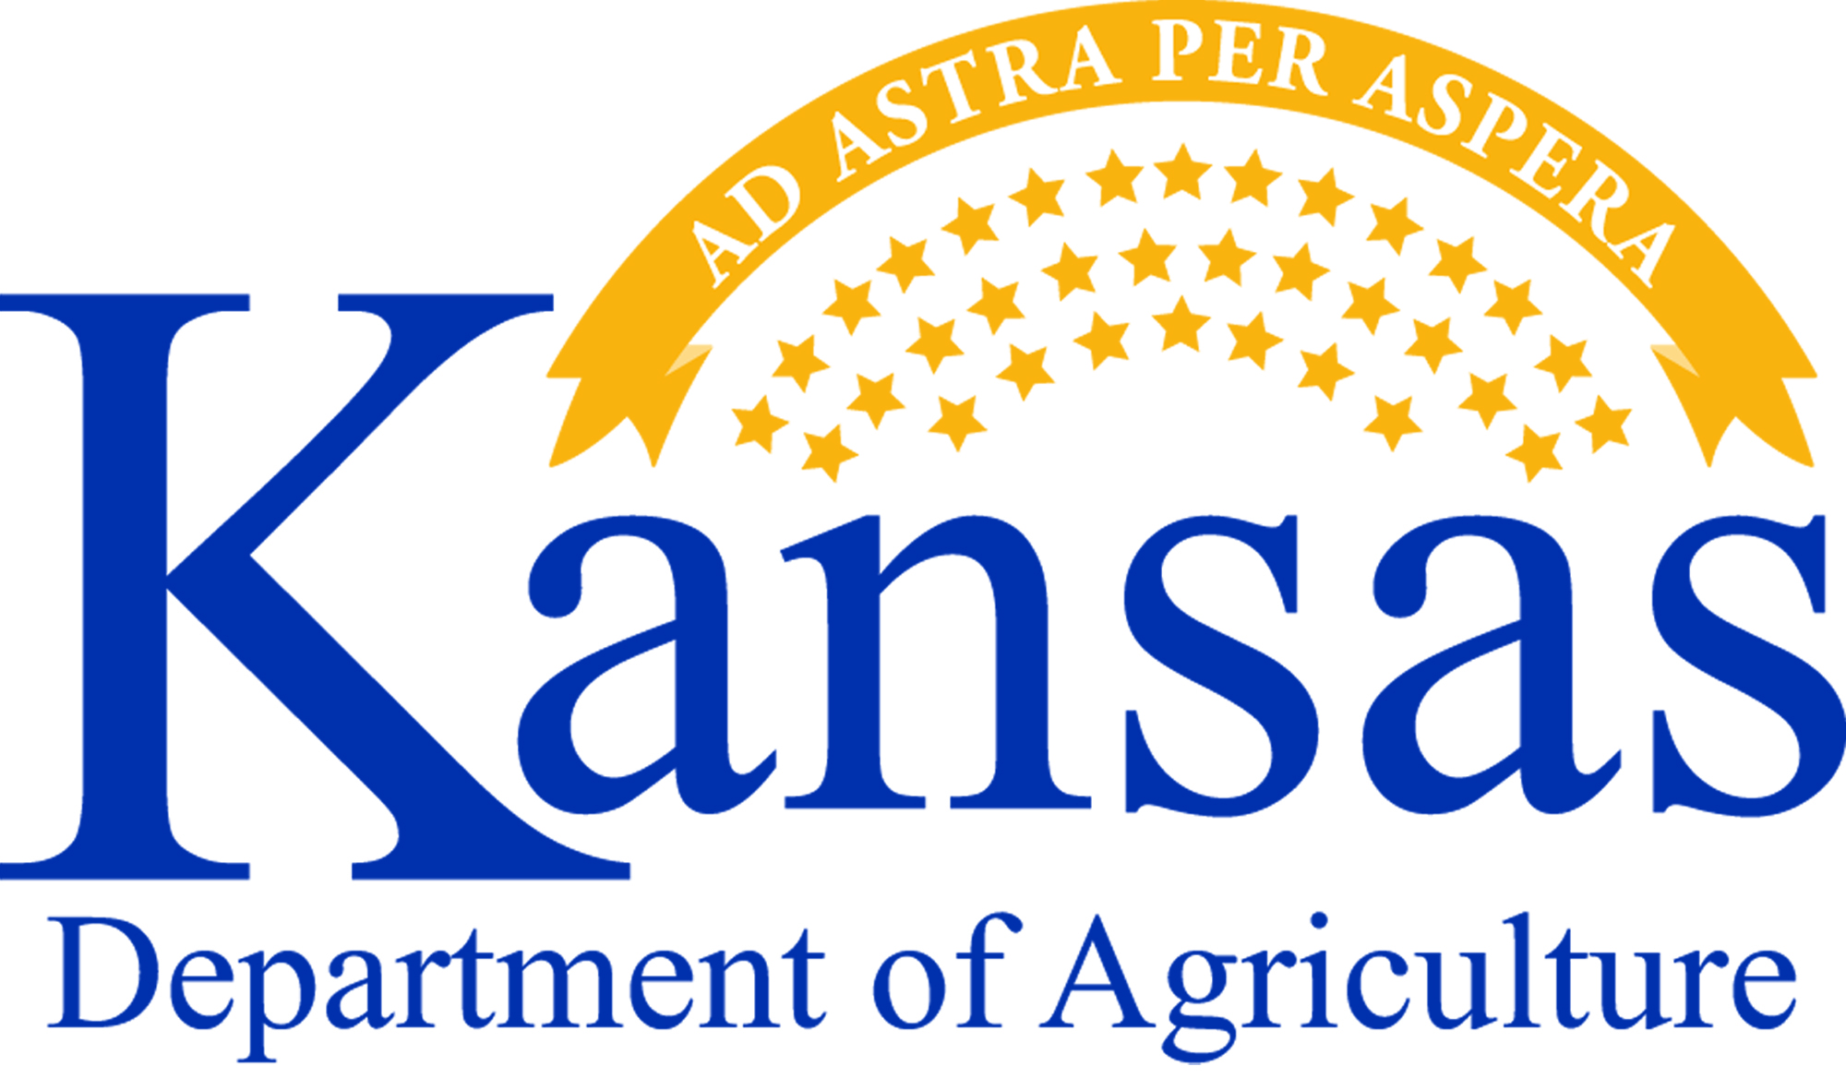
Free Food Safety Class
January 14th in Topeka
Food Safety Handling Class Offered in Topeka
A food safety handling class will be hosted by the Kansas Department of Agriculture. These classes are designed to teach Kansans how to properly store and prepare food in order to reduce food safety risks. Attendees will learn about cooking and cooling foods, hand washing and hygiene.

- January 14th at 1:30 p.m. Marvin Auditorium Room 101C
- At the Topeka and Shawnee County Public Library 1515 SW 10th Avenue in Topeka
- FREE 90-minute instructional program
- Open to all, from the home cook to full-service restaurants
- Reservations required
- Contact the Kansas Department of Agriculture’s Division of Food Safety & Lodging at 785-564-6767 to RSVP

Kansas Department of Agriculture | 1320 Research Park Drive | Manhattan, KS 66502 | (785) 564-6767 www.agriculture.ks.gov

Free Food Safety Class
January 14th in Topeka
Food Safety Handling Class Offered in Topeka
A food safety handling class will be hosted by the Kansas Department of Agriculture. These classes are designed to teach Kansans how to properly store and prepare food in order to reduce food safety risks. Attendees will learn about cooking and cooling foods, hand washing and hygiene.

- January 14th at 1:30 p.m. Marvin Auditorium Room 101C
- At the Topeka and Shawnee County Public Library 1515 SW 10th Avenue in Topeka
- FREE 90-minute instructional program
- Open to all, from the home cook to full-service restaurants
- Reservations required
- Contact the Kansas Department of Agriculture’s Division of Food Safety & Lodging at 785-564-6767 to RSVP

Kansas Department of Agriculture | 1320 Research Park Drive | Manhattan, KS 66502 | (785) 564-6767 www.agriculture.ks.gov

